Hannah’s Song: 1 Samuel 2 by Silvia Purdie, June 2018

Hannah was Samuel’s mother. Read her story in 1 Samuel chapter 1; chapter 2 records her mighty psalm of praise, The Song of Hannah. Here’s my version:

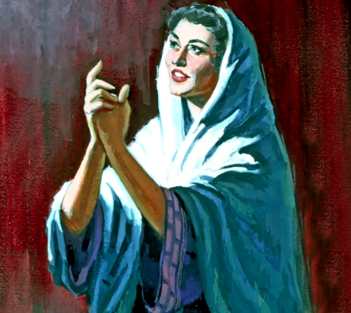
My heart sings in the Lord, who lifts me high!
My mouth boasts, my enemies fall!
Joy is mine! Salvation is here!
Nothing is holy but the LORD,
No one comes close,
No solid rock but our God!

In the Lord …
All words and actions are judged
Powerful weapons get smashed
The vulnerable get clothed with strength
Those who have stuffed themselves get to beg for food
Those who starve get to eat their fill
Those desperate for a child are given seven children
while those with plenty fade away.

Yahweh is Lord of life and death
he opens the way to the grave
and he opens the way to life.
Some he makes poor, some he makes rich.
Some he throws down, some he lifts up.
The Lord has a heart for the poor;
he raises them from the dust,
pulls them from the rubbish dump,
invites them to sit in the place of honour.

The Lord cares for his faithful people; he lights their steps;
we do not succeed by our own strength.
Those who oppose him will be silenced,
shattered, scattered, stumbling in the dark.

Yahweh is Lord of the universe;
he set the earth on its foundations,
he thunders through space
and judges to the ends of the earth.
The Lord gives power to his king; he will raise up his Messiah.

What’s with the horns?
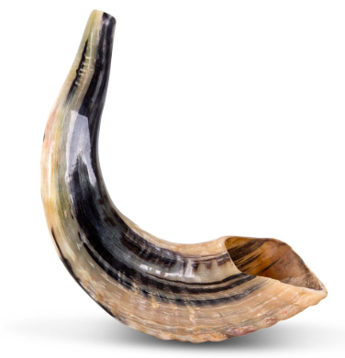

It never ceases to amaze me how the words and symbols of the Bible speak with a modern relevance, although they were first written thousands of years ago.
However, there are occasionally words and symbols that don’t translate so easily. One of these is the horn. When Hannah sings of her own triumph, and the future victory of the Messiah, she uses the phrase “my horn is lifted up” (1 Sam 2:1, also verse 10). What does this mean?

Have you ever seen deer or bulls fighting? Their horns are their weapons, and when the battle is done the victor lifts up his horn and struts around declaring his territory.

People from the dawn of time have used animal horns as trumpets. If you’ve ever been to Africa or Israel you will have seen their long horns, or maybe you’ve blown a ram’s horn. A trumpet was blown in victory after human battles, a sound of triumph.

One more meaning: horns were also used as containers. Verse 10 says that God “will lift up the horn of his anointed”; the oil for anointing a king would have been carried in a horn, then lifted up and poured out onto his head. This is the meaning of the word ‘Messiah’ (or ‘Christ’ in Greek): anointed one.

So, three levels of meaning, none of which are very obvious to us in NZ in 2018. What are the symbols of victory in our day? I think of All Blacks winning a big silver cup, or a winning cyclist punching the air after a race. But maybe we are not that great at celebrating truimph. We are taught to be humble, self-contained. But the Bible teaches us to celebrate the victory of our God, even when it’s not obvious in our broken world. Hannah sings of joy and salvation. She sees a divine reality in which the poor are fed and justice done, despite the continuing inequalities around her. Symbolically, she raises her horn and gives a loud trumpet blast that rings out through the centuries.

A thousand years after Hannah, another woman picks up her song and makes it her own: Mary of Nazareth, filled with the Spirit, sings “My soul magnifies the Lord”. Mary also sees the world flipped upside-down by God, so that the poor are lifted up and the hungry fed (Luke 1:46-55).

