Let’s Say a Psalm

The Psalms re-worked for children,
all-age worship, and family devotions


Silvia Purdie

August 2017
Christchurch, New Zealand
www.conversations.net.nz

Introduction
Psalm 1 A tree by a stream
Psalm 2 You are my child
Psalm 3 The shield around me
Psalm 4 I rest in you
Psalm 5 Sing for joy
Psalm 6 Weary with moaning
Psalm 7 In the lion’s den
Psalm 8 Out of the mouths of babes
Psalm 9 With all my heart
Psalm 10 Why, Lord, why??
Psalm 11 The XBox Psalm
Psalm 12 Pure Silver (verse 6)
Psalm 13 How long??
Psalm 14 “There is no God”
Psalm 15 Truth telling
Psalm 16 A goodly heritage
Psalm 17 The apple of your eye
Psalm 18 The Volcano Psalm (verses 7-15, 46)
Psalm 19 Song of the Stars
Psalm 20 God bless you!
Psalm 21 Thank you for Jesus
Psalm 22 Don’t leave me!
Psalm 23 The Shepherd Song
Psalm 24 Lift up the ancient doors!
Psalm 25 Teach me your ways
Psalm 26 True North
Psalm 27 Take courage, my heart!
Psalm 28 Are you listening?
Psalm 29 The Hurricane Psalm
Psalm 30 Joy in the morning
Psalm 31 My hiding place
Psalm 32 The mad donkey
Psalm 33 Rejoice today!
Psalm 34 Always praising!
Psalm 35 Trapped and slandered
Psalm 36 Far reaching Love
Psalm 37 The meek shall inherit the earth
Psalm 38 All my pain
Psalm 39 A crisis of purpose
Psalm 40 Stuck in the swamp
Psalm 41 Bad friends
Psalm 42 As a deer
Psalm 43 A walk of faith
Psalm 44 A formal complaint
Psalm 45 A royal wedding!
Psalm 46 We will not fear!
Psalm 47 A Shout of Praise
Psalm 48 Jerusalem, Jerusalem
Psalm 49 Who can pay the ransom?
Psalm 50 The courtroom drama
Psalm 51 The Washing Psalm
Psalm 52 God sees through
Psalm 53 No God?
Psalm 54 Help me now as you’ve helped me before
Psalm 55 Betrayed by your best friend
Psalm 56 Being trod on
Psalm 57 Wake up the day!
Psalm 58 The Snake Psalm
Psalm 59 The pack of dogs
Psalm 60 The Earthquake Psalm – for Christchurch
Psalm 61 Can you hear me, God?
Psalm 62 My rock of salvation
Psalm 63 Hide and Seek
Psalm 64 It’s not OK!
Psalm 65 He’s got the whole world in his hands!
Psalm 66 Come and hear!
Psalm 67 All you peoples praise!
Psalm 68 Gifts for his people
Psalm 69 The Mud Psalm
Psalm 70 Hurry up!
Psalm 71 All our lives long
Psalm 72 Long live the King!
Psalm 73 The Jealous Psalm
Psalm 74 Destruction and persecution
Psalm 75 The pillars of the earth
Psalm 76 Weapons of war
Psalm 77 The Sleepless Psalm
Psalm 78 Tell our story to the children
Psalm 79 The terrible prison
Psalm 80 God’s shining smile
Psalm 81 Honey from the rock
Psalm 82 The Nobodies’ Psalm
Psalm 83 The enemies of Israel
Psalm 84 How lovely is your house
Psalm 85 Good gifts
Psalm 86 An undivided heart
Psalm 87 The Census Psalm
Psalm 88 The Rejection Psalm
Psalm 89 The Chosen One
Psalm 90 A puff of dust
Psalm 91 The Trust Psalm
Psalm 92 Saying thanks at bedtime
Psalm 93 Water rising
Psalm 94 Praying for a world in trouble
Psalm 95 Come let us sing for joy
Psalm 96 Words run out
Psalm 97 Rejoice, the Lord is King!
Psalm 98 Sing along a new song
Psalm 99 If you shake us
Psalm 100 The joyful parade
Psalm 101 Call me loyal
Psalm 102 The time has come!
Psalm 103 Bless the Lord, O my soul
Psalm 104 A Psalm for Aotearoa
Psalms 105, 106, 107: The History Psalms
Psalm 108 A wake-up call
Psalm 109 SO ANGRY!!
Psalm 110 All about Jesus
Psalm 111 Praise the Lord, now and forever!
Psalm 112 Welcome to the good life!
Psalm 113 From the rising of the sun
Psalm 114 Skipping mountains
Psalm 115 Toy gods
Psalm 116 Death could not hold me down
Psalm 117 The Shortest Psalm
Psalm 118 Pointing to the risen Lord
Psalm 119 The Longest Psalm
Psalm 120 Watch your mouth!
Psalm 121 I lift my eyes to the hills
Psalm 122 The Peace of Jerusalem
Psalm 123 Asking for help
Psalm 124 If it wasn’t for God
Psalm 125 Good balance
Psalm 126 A harvest of joy
Psalm 127 The Lord builds the house
Psalm 128 Live long and prosper
Psalm 129 Attacked and whipped
Psalm 130 Out of the depths
Psalm 131 Calm and quiet
Psalm 132 The Forever King
Psalm 133 Live in unity
Psalm 134 A circle of blessing
Psalm 135 Come on, people, praise!
Psalm 136 Endless love
Psalm 137 By the rivers of Babylon
Psalm 138 Thank you for your love!
Psalm 139 The Omniscience Psalm
Psalm 140 Our God saves
Psalm 141 The Goody-good’s Psalm
Psalm 142 The prison escape
Psalm 143 A Psalm for Easter Saturday
Psalm 144 Blessed are God’s people
Psalm 145 We will tell your praise
Psalm 146 Will you praise the Lord?
Psalm 146 God at work
Psalm 147 Who is this God of ours?
Psalm 148 Calling all creation!
Psalm 149 Find joy here
Psalm 150 Everything praise!
End Notes and Photos
Introduction

There are 150 Psalms in the Bible, written about 3,000 years ago, including some of the most famous and beautiful poems ever. Psalms are about real human life, full of feelings. They sing about fears, fights and celebrations, and bring it all to God. Psalms teach us how to pray, in the hard times and the good times, in church and alone and with the people we love. I hope that my versions ring true with each original Psalm and also translate some of the word pictures into images that kids can relate to and find God in. I also hope that you explore other translations and enjoy ‘saying the Psalms’ together in lots of different ways.
Some of these poems are prayers for home, perhaps for bedtime. Some are for church, for all-age worship.
Psalms were originally songs; these versions are to be read aloud. Many are formatted to encourage reading by different people, which works well in church for involving children.
I have interpreted the Psalms through a ‘Jesus lens’, assuming: a) that Psalms include prophecy about Christ,
b) that Jesus re-interpreted Psalms and challenged some earlier understandings about God, and
c) that through his Spirit all of scripture breathes the living Word of Christ.
Most Psalms I have tackled as a whole, others just a few verses.
These poems and prayers for worship are my re-working of the Psalms, which are a great treasure house for faith. I write from Aotearoa New Zealnd, and I offer these in the conviction that the Holy Spirit speaks to all ages and all cultures, opening up ancient scriptures to us afresh in every time and place.
All material in ‘Let’s Say a Psalm’ may be reproduced for local church use, with acknowledgement.
Enjoy! - Silvia
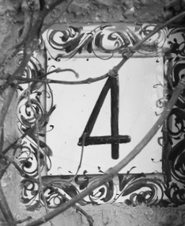
Psalm 1: A tree by a stream

Happy are those who choose their path -
I will follow Jesus.
Be careful where you put your step -
God will be your guide.
I will be a tree growing by a stream -
God’s Spirit like fresh water.
I will grow good fruit and grow strong
and God will watch over me.

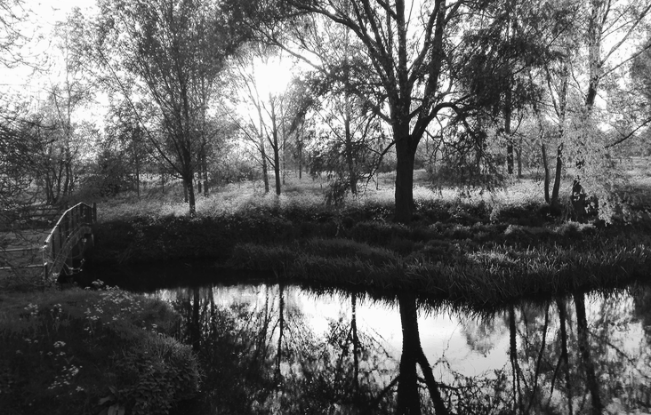

Psalm 2: You are my child

Hear God’s word to you:
“My dear, my beloved, you are my child
and I am your Father.
I will give you more than you could ask or imagine.
You can trust me completely.”

Psalm 3: The shield around me

I’m sick of hearing it!
I get it at school, on TV and online,
people saying “Don’t be stupid!
You’re dumb to believe in God!”

I know they are wrong
I know that you are real, God!
You are strong and solid under my feet
You fill my heart up to the top with love
You hear my voice and answer me
When I feel down, you lift up my head
When I am tired, I curl up and rest
safe in you.

Hey, world! I’m not afraid of you!
Say what you like, think what you like -
I know who I am
I belong to Jesus Christ
I belong to the Father of all
I belong to the great Spirit
my blessing, my shield, my glory!

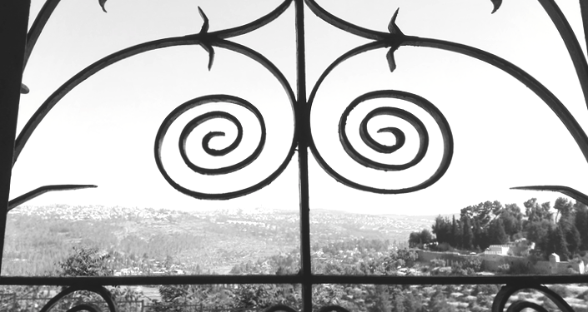
Psalm 4: I rest in you
A night prayer

I rest in you, O God,
I am in your safe keeping,
body and soul held in peace.

My heart cries out to you, my God.
All that upsets me you see,
all that disturbs me you understand.
Only here in your presence
am I fully known.
I am wrapped in grace.
I rest in you, O God,
I am in your safe keeping,
body and soul held in peace.

I try to relax but anger rattles me
I try to relax but my failings niggle at me.
Be still, be silent.
Put your trust in the Lord.
I rest in you, O God,
I am in your safe keeping,
body and soul held in peace.

In the stillness the light of your face shines.
My heart turns to thankfulness and is glad.
I have more than enough.
You, Lord, are more than enough.
I lie down to sleep, safe and sound.
I rest in you, O God,
I am in your safe keeping,
body and soul held in peace.

Psalm 5: Sing for joy

Hide inside the Lord God,
come into his glory
and you will sing for joy
dance with delight
and rest safe under his covering.

Psalm 6: Weary with moaning

Save me, Lord, save me!
I’m sick, I’m weak, my bones hurt
Every night I flood my pillow with tears
Every day I shake with fear
Remember your love for me, O Lord!
Make me well again, answer my prayer!

Psalm 7: In the lion’s den

They chase me, they hate me
they will rip me apart like lions!
Get up, Lord, get angry with them,
defend me, save me, rescue me!
Their shots will rebound on them
they’ll fall into their own evil traps.
And I will come out singing -
Thank you Lord! Praise you Lord!

Psalm 8: Out of the mouths of babes

God, our living God,
you are amazing!
You are higher than I can look,
You are wider than I can see.
But I can hear you –
Listen!
We can hear you in the laughter of a little child,
We can hear you in the babbling of a baby.
You don’t need words to tell us of your power.

Why do you need us at all?
We are so small, and the world is so big,
the stars are so many and space is so enormous.
God, our living God,
you are amazing!
You made everything.
Why do I matter?

But we do matter!
God cares for us most of all,
and through us God cares for all the world.
You put everything into our care,
all the animals, all the birds, all the fish,
everything that creeps or flies or runs or swims,
even the land and the air and the sea.
It is all ours to look after.
God, our living God,
you are amazing!

Psalm 9: With all my heart

With every bit of me I give you thanks, O Lord
With every breath I tell how good you are
With all my heart I love you.
Psalm 10: Why, Lord, why??

Why, Lord, why is our world so troubled!?
Where are you when we need you?
Let me tell you what’s wrong with the world …
So many people are trapped in poverty
while other people are full of riches,
but they always want more, more, more.
People are so proud, saying to themselves,
“We don’t need God”, and even “There is not God”!
They don’t give a stuff about anyone else.
They build mansions with high fences to keep everyone out
and don’t care who gets hurt so that they can get richer.

People these days laugh at the truth
and make up all sorts of lies.
They curse and gossip and steal.
If they see something they want they swoop down and grab it.
They are so sure that they can get away with anything!

Step in, Lord, step up and act in our world!
Show that you care about the poor and the orphans.
You do see what is going on,
you do feel their trouble and pain.
They have no help except for you.
Stand up against the bullies,
stop bullies from taking over and terrorising everyone!

You are the true King, for ever and ever,
the King of justice for the people who don’t matter in our world.
You will make their hearts strong,
you will hear them and lift them up.
You are always here when we need you!

Psalm 11: The XBox Psalm

Bang! Bang!
Lights flash in the dark.
They are shooting at me again!
I duck down behind the rubble
but shots come from behind me -
Bang-bang-bang!
I’m not safe here
and I’m out of ammo.
Frantically I look around -
there must be somewhere to hide!
There must be someone to cover me
while I make a dash for it!

All good fun in an X-Box game
but life gets like this sometimes.
When it does, you’d better know who has got your back!
And sorry, people might do their best
to protect and care for you, but they will fail.

Strong people, strong in a deep solid useful way,
know that no matter what
they are safe inside,
because the battle for their life
has long ago been won!
Strong, safe people know that God is their refuge
so they can be a refuge for others.
And there, as we care for one another
we see the face of God
and know the power of love.

Psalm 12 (verse 6): Pure Silver

The promises of God are pure
pure like silver
silver melted and poured
melted and poured
until it shines so perfect.

Psalm 13: How long??

How long, O Lord?
How long must we wait?
It’s taking too long!
It’s wearing me down
this crying and waiting!
I do trust in you, I do, yes I do!
But it’s hard to hang on,
so answer me, God!

Psalm 14: “There is no God”

“There is no God!” everyone says.
“I can do what I like!” everyone thinks.
“Who cares about God?” everyone asks.
“I’m here for me, I don’t answer to anyone!”
God looks for faith, will he find it anywhere?
God looks for care for the poor.
God looks for love, will he find it in me?

Psalm 15: Truth telling

If you want to walk tall in the ways of the Lord
you have to hold on to what matters the most.
The truth is the truth, there’s no getting round it,
the truth can’t be twisted, invented or fudged.
If you want to be trusted, admired and respected
then do what is right and say what is true.



Psalm 16: A goodly heritage

I know who I am and I know where I come from:
God is my home, God is my heritage.
My heart is glad, my soul sings for joy!
I know who I am and I know what I’ve chosen:
God is my cup and his Spirit fills it.
My heart is glad, my soul sings for joy!
I know who I am and I know where I’m going:
Christ is my guide, he shows me the path of life.
My heart is glad, my soul sings for joy!

Psalm 17: The apple of your eye

Guard me as the apple of your eye.
Hide me in the shadow of your wings.

Can you see me, God?
Do you know who I am?
See into the dark, see my every secret,
watch the path I walk, see my every step -
I do my best to follow you.

Guard me as the apple of your eye.
Hide me in the shadow of your wings.

Can you hear me, God?
Do you hear my cries for help?
Listen to the whispers of my enemies
as they plot to bring me down,
like lions they lurk waiting to pounce on me!

Guard me as the apple of your eye.
Hide me in the shadow of your wings.

I call out to you, for I know that you are near.
I pray to you, for I know that you protect me.
In your love I am safe, in your steadfast love.
You are my savior, my wonderful Saviour.
With the eyes of my heart I will see you,
I will see your face and be filled with joy.

Guard me as the apple of your eye.
Hide me in the shadow of your wings.

Psalm 18 Part B): The Volcano Psalm verses 7-15, 46

The mountain shook
the rock cracks open with a roar
smoke blasts out
filling the sky with black
and look! – fire is shooting up, exploding out
rocks on fire flying through the air
as the ground rumbles
stones fall from cloud
ash drifts over everything.
When night comes the glow can be seen from far away
When day comes all is grey.

We like the earth to keep still
and our God to be predictable
but sometimes things erupt
the foundations of the earth
burst open to be seen, on the move,
exploding with God’s power!
Ours is not a pet god
He has a molten core.
His passion blasts into our lives
if we dare!

The Lord lives! Blessed be my rock –
even if the rock is on fire!?

Psalm 19: Song of the Stars

The universe shouts your Word!
What language do stars speak?
Words of vast emptiness and infinite distance,
words of brilliant light and constant explosion,
whirling words, ancient words, alien words.

Around one Word we spin -
the Sun, light of our world,
cruising in glory across the sky;
colours all things, warms all things.

Around God’s Word we gather -
the Son, light of the world.
His way finds the lost
his truth opens blind eyes
his life conquers death
his bread feeds our hunger
his Spirit fills hearts with joy
his desire burns away greed
his touch is sweeter than honey.

May our lives shout your Word
in all we say, in all we do,
out in the open or hidden in the dark.
May our lives sing your Word
in the secrets of our soul,
in trouble, in shame, in confidence.
Shine brightly, Lord
and hold us in your orbit.
Amen.

Psalm 20: God bless you!

May God bless you and keep you.
When you cry for help
God will answer.
When you are in trouble
God will be there.
When you are lost
God will find you.
When you are afraid
God will support you.

May God bless you and keep you.
In the plans you make,
in all that you hope for,
in the deep desires of your heart,
God is alive and at work.
When you ask for help for other people
God works through you.
When you do great things
God cheers you on
and all God’s people
shout for joy!

May God bless you and keep you.
Some people rely on guns and fast cars
but we trust in God.
Everything else will crash to the ground
but we will stand tall.
Be strong in the Lord,
Be proud of our God.
God is proud of you!
May God bless you and keep you.

Psalm 21: Thank you for Jesus

Thank you God for giving us your Son,
your promised Messiah and King.
His strength is you, his joy is you.
You raised him to life, and he shares it with us,
life never ending, life everlasting!
You gave him your blessing, and he shares it with us,
the joy of your presence, the trust in your goodness,
your love, your great love, Jesus opened for us!

Psalm 22: Don’t leave me!

My God, my God, how could you leave me?
Just when I needed you most, you are gone!
I am eaten up by pain,
my life is pouring down the drain
Around and around rage the forces of hate.
Is this the end? Is this my fate?
The answer bursts open the grave -
Christ, who died, is alive!
Tell the world, for all time -
death is defeated, Christ is alive!
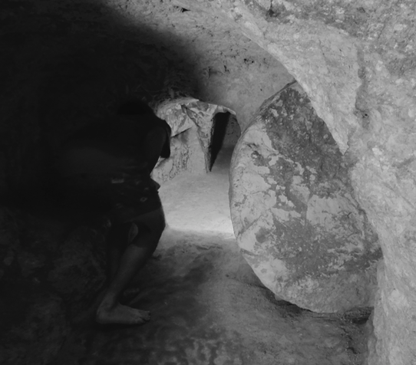
Psalm 23: The Shepherd Song

You, Jesus, you are my shepherd
and me, I am your sheep.
You lead and I will follow.
You lead me to quiet water
you lead me through the dark valley
you lead me to a wonderful feast
and you lead me home.
With you with me I will not be afraid;
how could I fear? for you are right here!

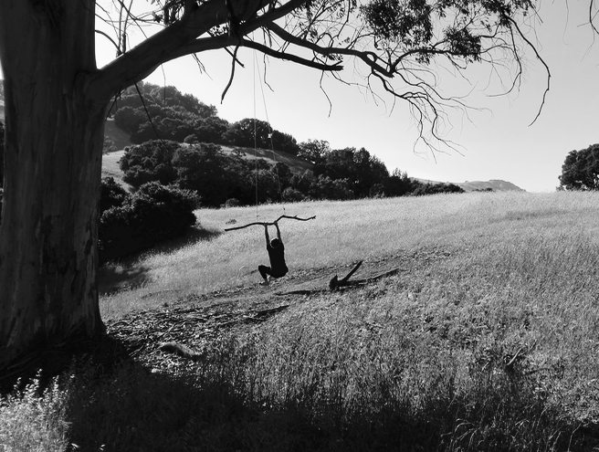
Psalm 24: Lift up the ancient doors!

Lift up your heads, ye gates!
Lift up the ancient doors!
- that the King of Glory may come in -
Who is the King of Glory?

The universe is his, and all that is in it
The whole earth is his, and all that lives on it
He formed the foundations of everything
Creator King, come in, come in!

Lift up your heads, ye gates!
Lift up the ancient doors!
- that the King of Glory may come in -
Who is the King of Glory?

Who wants to see this King?
Who dares to come close to this glory?
You could stand on the street outside
and snap photos as he passes
Or you could come in and stand in his presence!
But be warned – you cannot enter his gates
in your own power or goodness
for look, there he kneels, this King of Glory
with a bucket of water and a towel.
You must let him wash you.
Lift up your heart to the Servant King!

Lift up your heads, ye gates!
Lift up the ancient doors!
- that the King of Glory may come in -
Who is the King of Glory?
The LORD – Father, Spirit, Jesus -
magnificent in power, Lord of all,
He is the King of Glory!
Psalm 25: Teach me your ways

Walk with me, my friend
let me follow in your footsteps.
We’ve come a long way already, but I still need you.
My pride says “I don’t need help! I can do this on my own!”
but I know I’ll be lost in no time without you.
All the paths of the Lord are steadfast love and faithfulness
for those who walk close with him.

Psalm 26: True North

I trust you O Lord
by you I set my bearings.
You are my true North
and I will walk in confidence
in the right direction –
towards you!
Even when I close my eyes
I can feel the warmth of your love
shining on my face.

There is plenty that could distract me
and knock me off course:
gossip and stupid chatter
puffed up self-importance
getting rich no matter what
bloodthirsty need to control.

I won’t go there!
I won’t sit in evil dens
or waste my time with people going nowhere.

I am walking tall, walking free!
I love your presence, living God,
your glory shines around.
I sing for all to hear,
songs of freedom and thanks,
praise for all you have done and all you are.
I’m on solid ground, my path is clear.
Bless the Lord!

Psalm 27: Take courage, my heart!

My God is my light
My God is my savior
Why be afraid?
My God is my safety
My God is my home
I won’t be afraid!

Sure, I might get teased,
I might get hurt,
but I don’t need to be scared.
OK, people will call me names
and will try to bully me,
but I will stand tall!

Some days are bad days - that’s OK.
Some people say nasty things - that’s OK,
because I am hidden with Jesus
in the safest place,
in the arms of God,
like sleeping in a tent,
like standing high on a tall rock
where nothing can get me.

With God’s care around me
I will sing and dance
and shout for joy!
With God’s face shining on me
I will be patient though bad days.
I will be strong.
Take courage, my heart,
lean on God.
Psalm 28: Are you listening?

I am calling you, Lord, can you hear?
I am crying out to you, do you care?
I listen for you and stop complaining.
I feel your arms around me, carrying me.
The Lord is my strength and my shield.
Thanks be to God!

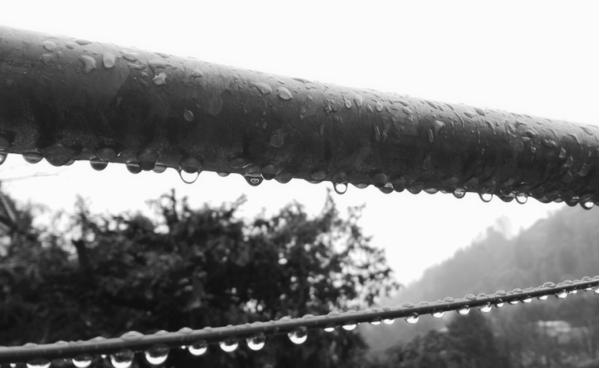
Psalm 29: The Hurricane Psalm

Batten down the hatches, secure the sails!
Bring in the picnic chairs and shut all the windows!
A storm is coming!!

The Lord our God is strong and mighty!
All glory belongs to our God!
His name is magnificent,
His voice echoes with power!

Dark clouds gather.
The wind picks up and tosses the waves.
Lightning flash, thunder rolls, rain blasts,
air whips, trees strain, branches crack,
flying rubbish, bursting streams …

The Lord our God is strong and mighty!
All glory belongs to our God!
His name is magnificent,
His voice echoes with power!

Even in our terror we marvel.
Even as the windows whistle we cry “Glory!”
Ours is not a tame God.
Our world gets tossed and tumbled,
blowing away our illusion of security.
Lord, give us strength.
Lord, bless us with peace.

The Lord our God is strong and mighty!
All glory belongs to our God!
His name is magnificent,
His voice echoes with power!

Psalm 30: Joy in the morning

The night was dark, but joy came with the morning.
I was so sick I thought I would die,
but you healed me, you helped me, you saved me!
You turned my sadness into dancing!
You took off my weeping and dressed me in joy!
O Lord my God, I will give you thanks forever.

Psalm 31: My hiding place

Where can I hide?
I cannot find anywhere that feels safe.
Everywhere there are traps set for me.
Everywhere people whisper about me.
Be my safe place, O God.
Be my hiding space, my refuge, my shelter.
I put myself in your hands.
Be strong! Fill your heart with courage!

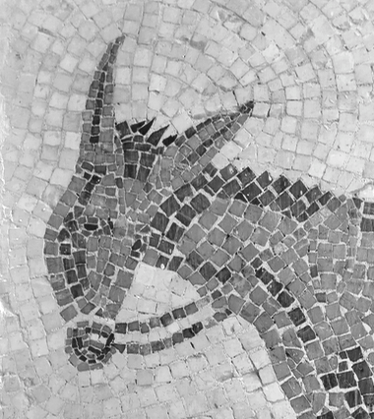
Psalm 32: The mad donkey

Will you buck against God,
kick and fight what is right
like a mad donkey??
True happiness happens
when you let God be in charge.
So say sorry when you stuff up.
Say sorry when you hurt people.
You are forgiven and adored
more than you know,
so start over, fresh each day.
Rejoice in the Lord and stand tall.

Psalm 33: Rejoice today!

Rejoice today in the Lord!
Sing a new song, play a good tune
for the earth is full of God’s great love
as the waters cover the sea.
Believe today in the Lord
who sees all things and knows all thoughts.
Trust today in the Lord
who shaped us and formed us
Put down your weapons and your plans
for God alone has our victory.
Wait today in the Lord
our help, our shield, our joy
for the earth is full of God’s great love
as the waters cover the sea.

Psalm 34: Always praising!

I will bless the Lord all the time!
We’ll never stop praising our God!
Magnify the Lord with me.
Together we’ll lift his name high.
Taste and see - the Lord is good!
Relax and rejoice - you are safe in him.
When trouble comes, cry out to God.
He is always around you, protecting you.

The Lord is near to the broken,
He saves those who are crushed.
God sees us, God hears us, God knows us.
He rescues us from all our fears.
Listen everyone – this is the way to live:
speak truth, speak kindness,
walk away from what is wrong,
choose to do what is right,
seek peace and follow peace.
We’ll never stop praising our God!

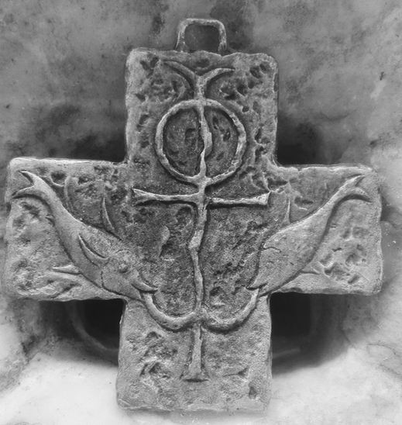
Psalm 35: Trapped and slandered

It is so not fair! I didn’t do it!
I am not the person they say I am!
Those people have it in for me
they are saying the most terrible things
about me – why pick on me?!
I’m terrified of them
I’ll trip and fall into their traps
I hear them laughing at me.
I cry out to God – save me!
You stand up for the weak
you rescue those in need
you work justice, you win over evil!
Clear my name, wipe away my shame
and I will shout your praise.

Psalm 36: Far reaching Love

Your love, O God, reaches up, up beyond the sky,
Your goodness goes higher than the clouds,
Your power is bigger than the tallest mountains,
Your truth goes deeper than the ocean.

O God, we treasure your infinite love.
All people can hide in the shadow of your wings.
O God, we celebrate your mighty river of joy.
All people can feast together in your house.
O God, you are the fountain of life.
All people can find light in your light.

So why do people turn away from you?
Some people choose to be bullies,
they don’t care about anyone except themselves.
They think they can get away with anything.
They don’t give a stuff about what others.
We turn away from what is wrong,
We choose you, O God.
Protect us from anything which tries to harm us.
You have the victory over evil,
it is crushed under your feet.

Your love, O God, reaches up, up beyond the sky,
Your goodness goes higher than the clouds,
Your power is bigger than the tallest mountains,
Your truth goes deeper than the ocean.
Hold us in your amazing love, now and forever.
With loving hearts we will live in you. Amen.

Psalm 37: The meek shall inherit the earth

Trust in the Lord, and do what is right
and you will live in safety.
Delight in the Lord, and he will give to you
what your heart desires.

Everywhere we see wrong being done -
the poor get poorer,
people in power fight for more power,
children are hurt by those who should love them.
You wait and see – bad people come to a bad end,
greed and violence will not win.
God lifts up those who seek peace
God protects those who seek justice
God loves those who are humble and kind.

“Blessed are the meek, for they shall inherit the earth.
Blessed are those who hunger and thirst for what is right.”
said Jesus (Matthew 5:4-5)

Psalm 38: All my pain

Sick – I’m sick all over
heavy – my body feels so heavy
crushed – I feel beaten down
weak – I can hardly move, I’m so tired!
Lord, all my pain is known to you
all my sighs are heard by you.

My mind goes round and around
with all the things I could have done or should have done
and all the bad things that other people have done to me
My strength fails
everything looks black and sounds black

Lord, all my pain is known to you
all my sighs are heard by you.
Don’t leave me!
I need you near
I cling to you
O Lord, my salvation.

Psalm 39: A crisis of purpose

What’s it all for?
What is life all about?
I sit in silence and ask and ask …
Why do bad things happen to us?
What’s the point? Why bother?
The questions sting and burn.

Hear my prayer, O Lord!
I cry without a sound but you can hear me.
I’ll live for a while and then I’ll die -
Will my life have mattered at all?
All I know is – you see what I cannot.
You are good and I hope in you.
Psalm 40: Stuck in the swamp

I was stuck, stuck in mud
up to my knees in it, sinking down
Help! I yelled, Hurry!
and help came, strong hands
pulled me out to safety.
Solid ground never felt so good!
What a great God we serve!
You inspire new songs
you multiply your awesomeness!
I love to live your way,
your law is in my heart.

Psalm 41: Bad friends

I thought I had good friends
but now when I need them most
they have turned against me.
To my face they pretend to be nice
but behind my back they lie about me,
whisper and spread rumours about me.
Even my best friend – we shared so much!
my very best friend – Lord, it hurts so much!
Dear God, be my friend now, hold me up.
Forgive me, for sometimes I’m a bad friend too.
But you are always there, always loving me.
Blessed be God, from everlasting to everlasting.

Psalm 42: As a deer
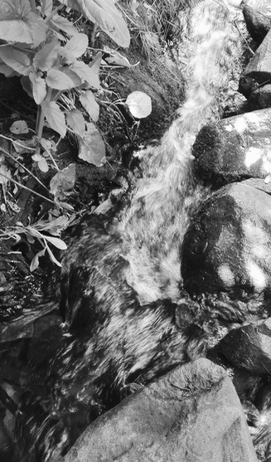
As a deer longs for flowing streams
so longs my soul for you, my God.
My heart is trampled down,
crushed and broken.
Tears fall, throat dry,
I thirst for you.
Deep calls to deep
as waves crash over my head.
I am lost and alone.
The enemy calls
“Where is your God?!”
Why are you down, my heart?
Every day God’s grace surrounds
you,
every night God’s song sings in you.
Hope in God, my help and my God!
Praise will rise again.

Psalm 43: A walk of faith

I was wandering around pointlessly,
frustrated with all the wrong that’s done.
God of light, send out your light!
God of truth, be a beacon of truth!
You lit my path and I walked toward you.
I came to worship,
and I found the greatest joy of all.

Psalm 44: A formal complaint

Dear God, we wish to complain!
We are doing our best to please you,
we are trying our hardest to do what we should,
but it’s not working -
we are losing battles, we are getting smaller,
we are exhausted.
It feels like you have abandoned us.
Come on, Lord, we can’t do this without you!
If you aren’t fighting for us we might as well give up.
Get up! Come and help us!
We hold you to your promise, for your love never fails!
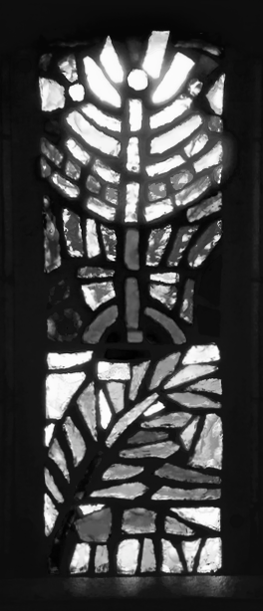

Psalm 45: A royal wedding!

Today is a glorious day
– our King is marrying
a beautiful new Queen!
The crowds gasp at her beauty.
We all cheer our magnificent King.
Christ is God’s chosen King,
ruler of all earth for all time.
His bride is us, his church, his love.
Celebrate in awe and praise
the majesty of our God!

Psalm 46: We will not fear!

1: God is our safe space, our hiding place
2: a very present help in times of trouble.
All: God is our safety, we will not fear!
1: The mountains shake, the oceans roar,
2: the nations rage, the world changes.
All: God is our safety, we will not fear!
1: Flowing like a river through the city,
2: in the middle of his people, God is there.
All: God is with us, his power wraps us round.
1: Come! See our God at work:
2: God breaks our weapons and destroys our defences.
All: God is our peace, we will not fight.
1: All wars are coming to an end.
2: God’s voice thunders through a world in chaos:
All: Be still! Know that I am God!
1: Through all the earth, God be praised!
2: Through all the world, God is with us!
All: God is our safety, we will not fear!

Psalm 47: A Shout of Praise

Come in, come in,
come one, come all!
Lift your heart, clap your hands.
Shout praise, sing joy,
to our God, the Highest One,
to the Majesty of Majesties!

Come, see the world from God’s point of view –
In him the victory has already been won,
all that troubles us is overcome, under our feet.
In him we are at home.
Come, claim your inheritance.
Come home to his love.

So lift God higher!
Let thanks and praise lift the roof!
All that has been, is, or shall be
belongs to our God.
Come, give honour!
Come, give praise,
here and everywhere, amen!

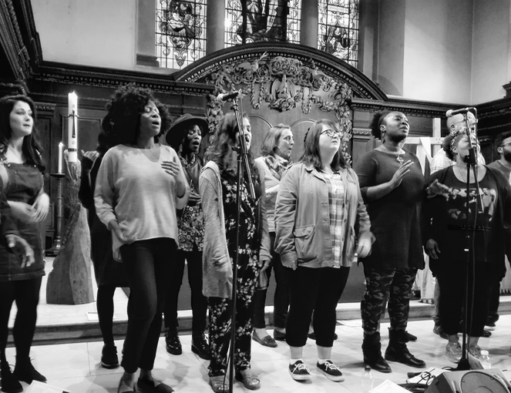
Psalm 48: Jerusalem, Jerusalem

Jerusalem, Jerusalem
the holiest of holy places
mountain of the Lord most high!

For centuries your towers stood,
strong defence against attack,
your people safe within your walls -
those ancient walls, those holy walls.

I long to see it for myself,
to walk where Jesus walked.
He said that walls cannot protect you;
Only God is strong to save.

So tell your children, “God is with us
not in walls of stone.
The living Lord is walking with us.
We are safe in him!”

Jerusalem, Jerusalem
the holiest of holy places
mountain of the Lord most high!
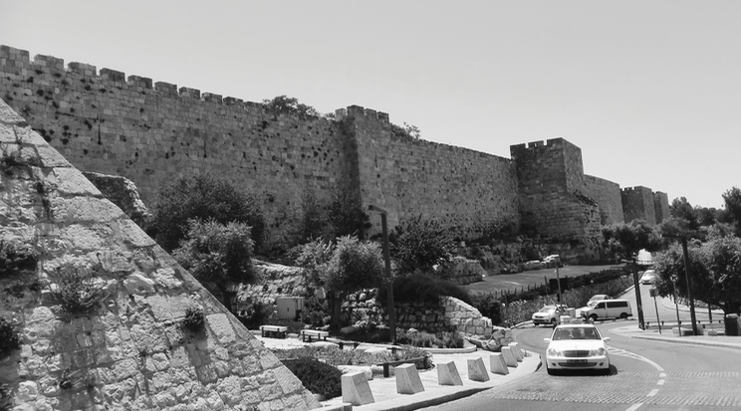
Psalm 49: Who can pay the ransom?

Sorry, I have bad news for you
no matter how rich you are
how much cash you have
one day it will be no good to you
one day you will die!
Death will kidnap you,
and demand more ransom money
than anyone can pay.
Only one man paid the price for you
Only Jesus, dying on the cross,
was the ransom
to rescue us from death.
As for fancy cars and big bank balances
they’re no use to you in the end.

(Mark 10 verses 25 and 45)

Psalm 50: The courtroom drama

The Judge takes his seat and the court falls silent.
God is the Judge and all people are Accused.
The Judge is not happy, in fact he is angry!
He is angry with us, all of us!
He thunders, “You people, you know how I love you.
Everything you have is a gift from me
and what do you give in return?
A little of this and a little of that.
Do I need more money? No, it’s all mine!
Everything is mine, but what I really want
is you! all of you! everything you have and are!
Don’t muck around with me.
Following Christ is not a hobby, it is all or nothing!
You can live in prison or live free –
you have to choose!”

Psalm 51: The Washing Psalm
(a Psalm of confession)

Be kind to me, O God
Be gentle with me.
I am clogged up with sin
dirt has dried around my heart
I feel terrible about myself
I am not a good person
I have hurt people
and let you down.

Be kind to me, O God
Be gentle with me.
Reach into your deep store of age-old love.
Get out your scrubbing brush
and wash me clean.
Scrape away my guilt
and scrub me on the inside.
You delight in truth,
so teach me to be wise.
Clear out my lies
and soak me in truth.
Create in me a clean heart
and renew your Spirit within me.
Then I will sing of your freedom
and praise your great kindness
with a fresh voice and a light heart.

Psalm 52: God sees through

Who are you kidding?
You spout lies and pretend it’s true.
You do dreadful things and boast about it!
You cut people to shreds.
Just because you’re rich you think
you can get away with anything!
Watch out! God is watching
and we can see through you.
Sooner or later your greed will collapse
onto your own head.
The money you trusted will betray you.

As for me, I choose the way of love, not the way of greed.
I want the truth, not lies.
I trust in God, not money.
I give thanks for everything I have,
for nothing is really mine.
I stand with friends, never alone,
like a tree in a forest, and it is good!

Psalm 53: No God?

Fools say to themselves “There is no God”
And if there is no God then you can do what you like
Why bother being good if there is no Good God?
Jesus came calling sinners.
He didn’t care if you were good or not.
He just loves you anyway.
People, rejoice, for there is a God!
Salvation has come!

(Romans 5:6-10)
Psalm 54: Help me now as you’ve helped me before

You’ve done it before
and you’ll do it again -
Answer my prayer, O God!
You’ve helped me before
and you’ll help me again –
Save me, O God!
This has happened before
and will happen again –
I’m trapped, I’m attacked,
I’m sorry for myself.
Many are those who don’t know you -
they twist the truth
and work against your ways.
But then I remember
who I am to you.
I remember how you work
in me and through me
And so I praise you now
as I have praised you before
and will praise you again
for you are Lord
and you are good
and I am yours.

Psalm 55: Betrayed by your best friend

Trouble, trouble, all around,
noise and bother and strife!
Help me, God! I am stressed out!

I wish for wings! How I wish I could fly
up into the quiet air, far away from all of this.
I would soar until I find a safe place
to hide from the storm.

I could handle being attacked by my enemies
but this is my best friend who has turned against me.
We used to love being together
but now her heart is hard, and it hurts.
She spoke sweetly but she stabbed me in the back!
So much for promises! So much for friendship!

Help me, God, I let all my troubles fall on you.
I trust in you, for you are my security,
my saviour and my truest friend.

Psalm 56: Being trod on

When I was being trod on, you came to my rescue.
When my tears fell, you caught them in a bottle.
When I complained to you, you wrote it all down.
When fears lay in wait to attack me, I was not afraid.
When I was falling, you caught me.
When death almost had me, you held me tight.
So I will walk with God in the light of life.
This I know: God is on my side!
You, God, I will praise. You, God, I will trust!

Psalm 57: Wake up the day

Wake up, my soul!
Wake up, people of God!
Our singing will wake up the day.
Our praise will echo around the world.
Be lifted high, O God,
above the stars!
Pour out your glory
over all the earth!

Have mercy, O God, we run to you
Shelter us from the storms.
Hide us under your wings, safe and warm.
Protect us from all harm.
Be lifted high, O God,
above the stars!
Pour out your glory
over all the earth!

Psalm 58: The Snake Psalm

Hate is like a snake, poison in its bite,
hissing lies that twist the truth.
It will not listen to the snake charmer
but lashes out with violence.
God will break its fangs
and it will slither away in a trail of slime.

So tame your tongue, writes James.
Use your words to bless, and speak with love.
(James 3:8-10.
For more on the snake read Revelations 12 & 20)

Psalm 59: The pack of dogs

Help! My enemies are after me!
They hide and wait for me to walk past
and then they jump out and surround me.
Just like a pack of dogs,
drooling as they prepare to bite
yowling and howling to frighten me
nipping at my ankles.
They want me to run so they can chase me
but I stand my ground
for you are with me, Lord God.
I can hear you laughing at them.
My enemies think they are laughing at me
but really the joke is on them!
I stand strong and look them in the eye.
Let them curse and lie all they like –
what is it to me!?
My song is of God’s powerful love
No one can stop me singing.
My strength is in the Lord my God
my refuge and my fortress.

(Psalm 59 is an important Psalm for anyone who is being bullied. Read it in various translations and write your own version.)
Psalm 60: The Earthquake Psalm – for Christchurch

O God, have you rejected us??
Are you angry with us??
You have broken down our walls, our homes, our churches.
The earth shook, and shook, and shook some more.
The ground cracked and opened up,
hard ground turned to rivers of sludge.
The earth jumped and rocks flew through the air.
The land rolled and people staggered like they were drunk.
Our lives were broken, our children were terrified.

You brought us to this land, you set your city here,
named with your name,
your church in the centre.
Now it is smashed, a crumbling ruin, an eye-sore.
Have you rejected us, O God?
How can we fight against the ground we stand on?
Human help is useless when the land leaps.

All the earth is yours, and all the forces that shape it.
We are in your hand, even when it shakes.
We know that you love us - show it!
We know that you save us - help us through this.
We look to you for courage.
We trust you with our lives.

Psalm 61: Can you hear me, God?

I’m calling out to you, my God -
can you hear me?
I feel like I’m miles away from you.
I feel like my heart is sore.
Take me by the hand and lead me.

I am safe with you,
safe and lifted high
where nothing bad can reach me.
I am safe with you,
safe and warm,
wrapped in soft feathers
like a baby bird tucked under its mother’s wing.
I know that you hear me,
and you bring me into a loving family of God.

So I will lift high the name of Jesus
the King for ever and ever,
the King of mighty love and strong faith.
So I will always praise you, my God,
every day and every day.

Psalm 62: My rock of salvation

For God alone I wait,
I wait in silence,
for God alone is my rock,
my rock of salvation.

When you feel that the world is against you
and you can’t tell the lies from the truth -
Put your trust in the Lord,
for he is your strong safety.
Pour out your heart to the Lord,
for he is your true hope.

For God alone I wait,
I wait in silence,
for God alone is my rock,
my rock of salvation.

If you’re rich, or if you’re poor -
it matters not a bit to God.
Don’t try to take what isn’t yours -
your value is not in what you own.
All love flows from the heart of God,
All power belongs to God.

For God alone I wait,
I wait in silence,
for God alone is my rock,
my rock of salvation.

Psalm 63: Hide and Seek

O God, my God, my friend,
I am looking for you, I need to find you!
I need you like I get desperate for a drink
on a boiling hot day.

I need you when I am hiding
from people who are trying to hurt me.
Save me from lies, rescue me from danger!

I have seen you sometimes out of the corner of my eye -
you are light and kindness and glory.
I have felt you sometimes in church as love fills the air,
it’s great to sing and praise and celebrate!
All my life I will love you,
O God, my God, my friend.

And now you are here, you found me!
You lead me to a party, all my friends waiting for me,
plenty to drink and eat, a feast of my favourite food -
I am full of joy!

And when it is time for bed
I snuggle up with you, like you were soft as soft,
gentle wings over me through the night.

And tomorrow, and every day, I will hold on to you
and you will hold on to me,
O God, my God, my friend.

Psalm 64: It’s not OK!

Listen up, God -
It’s not OK, it’s just not fair!
They’re out to get me, I know they are.
Behind my back they plot ways to hurt me.
They’ve got nothing better to do
than make plans to trip me up.
They use cruel words like arrows
that come at me out of nowhere.
They ambush me, I hate it!
They think nobody knows and nobody cares
that they make my life hell.
They’re so sure they will get away with it.
Why are people so mean?

Stick up for me, God!
Shoot them back, make them pay!
Make an example of them,
see how they like being laughed at for a change!

God, I know that you don’t work like that,
but I wish everyone could see your justice done.
What I will do is choose to find joy in you
even when I don’t feel very happy.
I will choose to feel safe in you
even when I feel afraid.
For you love me
and that love is so much bigger and more amazing
than anything anyone can do to me.
Thank you God. Amen.
Psalm 65: He’s got the whole world in his hands!

We who live at the ends of the earth,
at the farthest reaches of the sea;
with hills and fields and oceans,
we shout and sing to praise the Lord! …

He’s got all of the people in his hands,
He’s got all our regrets in his hands,
He’s got all of our hopes in his hands,
He’s got the whole world in his hands!

He’s got the ends of the earth in his hands,
He’s got the crashing of the waves in his hands,
He’s got the high mighty mountains in his hands,
He’s got the whole world in his hands!

He’s got the dawning of the morning in his hands,
He’s got the last rays of sunshine in his hands,
He’s got the sweet falling rain in his hands,
He’s got the whole world in his hands!

He’s got the planting of the seed in his hands,
He’s got the gathering of harvest in his hands,
He’s got the sheep and the farmers in his hands,
He’s got the whole world in his hands!

Psalm 66: Come and hear!

Come, everyone, come and sing!
This is our story, this is our song,
praising our Saviour all the day long!
Sing the glory of his name, let’s hear of his greatness!
Say to our God, “How awesome you are,
how amazing is your power!
All the earth worships you!”

Come, everyone, come and see!
Here we are, God’s people,
here because of what the Lord has done for us.
Remember how he brought the people of Israel
out of slavery, through the sea, safe and sound?
It’s the same for us – we too have been lead into freedom.
God did not let our feet slip or our enemies overtake us.
Mind you, it was not always easy:
we have been tested to the limit,
carried heavy burdens on our backs.
God has led us through fire and through water
and out again into wide open space.

Come, everyone, come and hear:
cry aloud to God, shout your praise!
Here we make our vows,
promises that we will keep.
Here we bring our offerings,
together with our prayers.
Bless the Lord who hears us,
his everlasting love will never leave us.
Psalm 67: All you peoples praise!

God, our God, be good to us and bless us
make your face to shine upon us
make your ways known in all the earth
show your saving power in all the nations.

God, our God, has been good to us and blessed us
God is blessing us now and will keep on blessing.
All you peoples – praise our God!
All you nations – be glad, sing for joy!
For God rules with justice and peace
and guides all the nations
God brings forth goodness on the earth.
All you peoples – praise our God!
To the very ends of the earth –
honour and rejoice in God!

Psalm 68: Gifts for his people
(Ephesians 4:1-16)
Paul was reading Psalm 68 when he wrote Ephesians.
He was thinking about how the Holy Spirit is poured out on people in ways never seen before, and how God gives different gifts to build up the whole community.
Rain in abundance O God you showered on us.
In your goodness you’ve provided for those in need.
Paul liked the bit in Psalm 68 where the Lord climbs up to the highest place and is given gifts to celebrate his victory. But Paul turns it around. Instead of the Lord taking the gifts, Paul says, the Lord hands out gifts! And before the Lord was raised up, Paul says, the Lord had to first go deep,
down into death and there he won the battle
and won for us the new life of the Spirit.
Blessed be the Lord who each day lifts us up.
His is the escape from death! Awesome is our God
who gives power and strength to his people.
Psalm 69: The Mud Psalm

Save me, God! I am slipping deeper in the mud.
I am sinking under the water!
Don’t let me go down. Do not give me up to death!
My hope is almost gone, and pain is everywhere.

The crowd has turned against me,
they want me to be killed.
I’ve done no wrong but they yelled insults at me.
I cry out in thirst and they gave me vinegar to drink.
I have become a sign of shame.
For your sake I go through this humiliation.

For you will save me! I will thank you, worship you,
praise you with all of heaven and earth!
This is the sacrifice that you accept.
Come to life, all who seek God!
Praise God, all who love him!

Psalm 69 is a brilliant example of Jesus fulfilling the prophecy of the Psalms but also turning it around
and making it his own.
When the Psalmist is attacked unjustly he responds:
“Add guilt to their guilt. Never let them off the hook.
Blot them out of the book of life!” (verse 27-28)
When Jesus is being killed he responds:
“Father, forgive them for they don’t know what they do.”
(Luke 23:34)

Psalm 70: Hurry up!

Hurry up, God, I need your help!
NOW would be good!
Come on, God, get a move on!
I’m in trouble, I’m under attack,
people are out to get me!

I want everything that’s been thrown at me
to bounce back in their faces,
see how they like that!
Hurry up, God! Save me! Protect me!

I feel small, poor and needy,
but you are my help and my saving power.
I trust you no matter what.
With all your people I will say “God is great!”
Everyone who loves you will find joy in you.
But right now …
I wish you would hurry up and do something!

Psalm 71: All our lives long
(for a child and an old person to read - child’s voice in bold)

In you, O Lord, do I live
In you, O Lord, I grow
You are our God, our rock and refuge
You are my rock, like a rock to dive off into the river
You are my rock, like a home well fenced and protected
Hear us when we call, O God, lift us into your arms.

All my life long you have been with me
When I was born and took my first breath,
you held me
All through the years I have leaned on you
Through all the years ahead I will lean on you.
When I was young you taught me
When I grow old you will bless me
I remember all you have done for me
I will tell everyone how great you are!

It hasn’t always been easy. People have attacked me.
It isn’t always easy. Some problems seem really big.
But I hope continually. I trust and keep on trusting.
I sing and keep on singing
My lips will shout for joy, my soul also,
for you have rescued me
I will play the guitar and the drums,
to praise you loudly!
I will put your love into words for anyone who will listen.

Your power and glory reaches from high above
to deep below
Your saving grace reaches from before we were born
to our very last breath, and beyond.
Holy One, wonderful God, we praise you!
Holy One, marvelous Lord, we praise you!

Psalm 72: Long live the King!

Praise to the King! Long live the King!
Our King is full of grace and truth,
from him come springs of living water.
He brings peace and justice, good news to the poor.
He lifts up the broken and takes down the proud.
He will out-shine the sun and out-live the moon.
And he shall reign for ever and ever
his kingdom will have no end.
from sea to sea, from nation to nation.
From his fullness all peoples are blessed.
His is the name above all names, King above all kings
Blessed is the Lord who does wonders!
To the end of time his majesty fills the universe!

Psalm 73: The Jealous Psalm

I hate to admit it, but I’m jealous,
I really am, I envy them.
I’d love to have that much money
I’d love that car and those clothes!
It’s hard to do what you know is right
when people who do what is wrong
get all the best stuff and have it so easy.
They treat people so badly and get away with it!

God, don’t let me get bitter and twisted!
Show me the big picture.
I know that hate just makes more hate
and that doing evil will destroy them in the end.
Forgive me for being jealous.
I trust you totally – who else is worth trusting?
I cling on to you – you hold my hand in yours.
I want you and only you – you are my strength.
Everything else will fade away
but God is the stuff of my heart
and all I need forever.
Psalm 74: Destruction and persecution

O God, don’t throw away the church!
Remember us, your people -
we need you now more than ever!
Your church is being attacked,
holy places are burned to the ground
and people are arrested for their faith.
Even here in this ‘Christian’ country
churches are destroyed by earthquake or fire,
or sold off when no one comes anymore.
Our society is embarrassed by the cross.
Come on, Lord, don’t hold back!
Yours is the mighty earth-making power!
Yours are the oceans, the rivers and the lands
Yours are the days and nights, winters and summers.
Don’t let your name be spat on!
Come to the help of the poor and needy.
Rise up O God, and raise up your people!

Psalm 75: The pillars of the earth

Scientists say that the universe is balanced precisely
on just a few key numbers: the force of gravity,
the power that holds atoms together
and keeps everything both moving and stable.
We know that God is this power
and we give thanks – Thank you, God!
God is the designer, carefully planning all things
and holding up the balance of life.
We humans like to boast of how important we are,
how much we can do and make and control.
But God is the judge, and greed has consequences.
When we destroy God’s creation there is a price to pay.
So we give thanks – Thank you, God!
And we lift our praise to our great Creator!
Psalm 76: Weapons of war

God, all our weapons are useless to you
You snap arrows in half
Shields and swords are nothing to you
You disable guns and tanks and bombs
Hate and anger you twist back on itself
Violence comes to an end
People at war are shocked into stillness
People under attack are safe at last
This is the greatness of our God
The Prince of Peace!

Psalm 77: The Sleepless Psalm

It is late but I can’t sleep
I toss and turn in my bed
Troubles crowd in on me
I cry out to you but I’ve nothing to say
I try to pray but all I can do is moan
Around and around in my mind
spin questions with no answers …
Don’t you love me anymore?
Was I foolish to trust God?
Don’t I deserve your kindness?
It helps to remember
the times I knew for sure that God was with me.
It helps to remind myself
of what I know about you, O God.
You are good and you are great!
The rain falls heavy on the roof
Lightning flashes in the dark and thunder crash
I know that you made the storm
and you are Lord of all, even my troubles.

Psalm 78: Tell our story to the children

Gather round, everyone, for I have a story to tell.
It is a story from long ago, all the way up to right now.
Listen up, children, for this is your story too.
Listen up, everyone, hear of the glorious deeds of God
and the wonders he has done for us.
Parents, grandparents, tell your children about our God
so that this new generation will put their hope in the Lord, and follow the ways of God, hopefully better than their ancestors did!

This story I have to tell is a ‘Yes But’ story.
Yes, God chose a people for his own, but they kept rejecting him.
Once, this people were slaves in a foreign land, but God rescued them. Through plagues and hail and death God pulled them out of slavery, safely through the sea and into the wilderness. But the people got thirsty in the desert and grumbled to God. So God split open a rock and fresh water poured out. Then the people got hungry in the desert and complained to God, so he rained down birds for them to eat, and bread onto the desert ground. But still the people whinged and grumbled. He brought them to his holy mountain, he showed his power and glory, but soon they chose their own tame gods. No sooner did they repent and ask for forgiveness than they turned away again and did their own thing. But God kept taking them back, finding ways to draw them to his heart and lead them into truth.

Our story is like this, too. Our ancestors in the faith came to this land full of faith and hope and the desire to share the good news with the Maori people; and many Maori people received it eagerly, becoming agents of change for their own people. But the church soon sided with those who wanted more land, and the Maori people felt abandoned. We went to war, us against them, and broke God’s heart.
Our ancestors came to this land looking for a new start, hoping to be faithful to God here, but they soon just tried hard to make money and fit in. Our church was planted in a time when it was normal to be Christian, but since then many people have turned away from God. We want to grow into the future, but we keep getting stuck in the past.
And still, despite everything, God is faithful.
God keeps choosing us no matter what we do wrong.
God keeps on leading his people as a good shepherd,
tender and strong, wanting only the best for us.
This is our story, learn it well.

God is good, all the time!
All the time, God is good!

Psalm 79: The terrible prison

586 years before Jesus was born, Israel was defeated, Jerusalem destroyed and the people taken as prisoners to Babylon. Many were killed. It was a terrible time. Psalm 79 was written in prison. It cries out to God:
Hear your people groaning, Lord!
See your holy temple, ruined!
Feel our hearts break with grief.
Everyone says, “Where is their God?”
How could you let this happen?
What did we do to deserve this terrible punishment?
How long will we rot here?
Will we die so far from home?
Save us, Lord! Somehow, soon!
Blaze your anger against these terrible people!
Rescue us from this terrible prison
so that we can praise you again.

God did save his people. The Babylonians were themselves defeated, by the Persians, and the people of Israel were allowed to go home to make a new start.

We are your sheep and you are our Good Shepherd.
We give thanks to you from generation to generation.

Psalm 80: God’s shining smile

We’re here, Lord, calling to you -
Shine out, God of love!
How long, O Lord,
how long will your people suffer in the dark?
Our only food is the bread of tears.
We have become a laughing stock.
Are you angry with us?
May your light break through!
May your smile shine on us!

Remember how you carried us
and planted us in the land
like a vine, brought from far away.
It grew strong and deep and wide
but now it has been cut down!
May your light break through!
May your smile shine on us!

Open our eyes to new possibilities.
Give us new hope, Lord!
Give us strength from your right hand
and we praise you for ever more.
May your light break through!
May your smile shine on us!

Psalm 81: Honey from the rock

Come, let me feed you
with honey from the rock.
Come, let me love you
and never never stop!

Hear the Lord, he’s calling you,
listen to his voice:
People, O my people –
Don’t you know? I carried you!
Remember how I rescued you.
You were trapped in slavery
until I came and set you free.

But now your lives are crowded
there’s little space for me.
I long to bless you every day
and fill you with good things
but I need room to be your God!
You can’t have lots of others.
I’m not a bonus add-on.

Turn to me, my people!
Let me in and let me lead.
Come, let me feed you
with honey from the rock.
Come, let me love you
and never never stop!

(Revelation 3:20)
Psalm 82: The Nobodies’ Psalm

Everyone who is given a job
to lead or be boss or even be President
will one day stand before the Lord
and answer the question when he asks:
“When you were in charge,
did you care for the poor?
Did you lead with fairness?
I don’t care how important you were
how much everyone loved you
or how much money you made.
What matters to me are the people
that no one cares much about
who can’t pay you back
or make you more popular.
What did you do to look after them?”

And the leaders will say,
“but who cares about the nobodies?”
And Jesus will answer:
“When you cared for the least of these, you cared for me.”
(Matthew 25:40)

Psalm 83: The enemies of Israel
(Matthew 5:43-44)

Jesus said:
“It’s easy to love your friends and hate your enemies. Anyone can do that! But I say to you, Love your enemies
and pray for those who are out to get you.”
It’s easy for us to say. No one is throwing rocks at us
let alone hand grenades and bombs.
No one has sworn to destroy us, here in lovely NZ.
But many many people have sworn to destroy Israel.
The nations that surround Israel made a promise together
to wipe Israel off the face of the earth.
God in your anger, make the enemies of Israel
crumble and blow away in the wind
like the dust of the desert.
Set a fire through them until they burn with shame.
God in your mercy, bless the enemies of Israel.
Bless their leaders and their families with all good things.
Bless them with peace and justice,
until all the world can see that you are God Most High. Amen.

Psalm 84: How lovely is your house

A How lovely is your house, amazing God!
I want nothing more than to live close to you.
B Just like the sparrow builds a nest for her chicks,
you make your home in our hearts.
A We love to know that you are with us -
we will sing your praise!
B We get stronger because you are in us -
we will know your ways by heart.
A You see us every day and you hear us when we pray -
we will go from strength to strength.
B Just one day knowing you are near
is better than a thousand days without you.
A Like the warm sunshine
you pour your love into our lives.
B You bless us with all good things
when we turn to you and trust you.
A How lovely is your house, amazing God!
I want nothing more than to live close to you.

Psalm 85: Good gifts

Lord, you are so good to us!
You forgave our sin and gave us a new beginning.
You sent your Word, and you pour out your Spirit.
Love is your message and Kindness is your style
Peace greets Patience with a kiss
Gentleness walks hand in hand with Self-control
Joy bursts up out of the ground
Right-ness goes ahead to show the way
and Generosity showers us from above.
These are the gifts of God for the people of God.
(Galatians 5:22)

Psalm 86: An undivided heart

Bend your ear to us, O God; we need you!
We cry to you and keep on calling.
We know that you will answer us!
Is there another god greater than you?
Is anything greater than what you have made?
Certainly not! You alone are God!
Teach me your ways, so I walk a true path.
Give me an undivided heart, so I love fully.
With my whole heart I honour you forever.
Give me strength to serve you every day
Like my mother served you with all her heart.
You comfort and help me in everything I do.
You, O Lord, overflow with mercy and grace!
You are slow to anger and quick to love -
you love and keep on loving!

Psalm 87: The Census Psalm

Every person living in our country is recorded
in a big list of everybody
and it says where each person was born.
I was born in Fiji. My husband was born in Wellington.
Where were you born?

The Christian faith was born in Jerusalem,
where Jesus died and was raised to life.
In Jerusalem the ancient city on Mt Zion
had springs of fresh water inside the city wall.

No matter where you were born,
you are counted, you are home
inside the heart of God.
Dancers dance and singers sing:
“The Spring of Life is in you!”

Psalm 88: The Rejection Psalm

One day Jesus met a man who had leprosy.
This was his prayer:

O God, my God, listen to my cry!
I’ve been thrown out of town
I’ve become so gross and disgusting
No one will touch me or even talk to me
I only have you and I cry out to you
I’m no good to you dead, Lord!
So come to me, remember me
I know that your love can win over anything!

The man saw that Jesus had the power to heal him.
“Please make me clean” he said, and Jesus did.
Jesus touched him and hugged him
and his friends and family welcomed him home.
(Luke 5:12-15)

Psalm 89: The Chosen One
Psalm 89 is a ‘game of two halves’. The first half tells us about the Covenant between God and his Chosen One, to raise him up as King forever. Then – WHAM – suddenly the Covenant is busted and the Chosen One is road-kill! Psalm 89 helps us understand why the cross was “foolishness to the Greeks and a stumbling block to the Jews” (1 Corinthians 1:23). Here it is in two voices: one is the Father’s voice, the other a witness to the crucifixion.

I have made a covenant with my Chosen
My promise will outlast time
I crown him as King forever!
Him? King forever? His crown is made of thorns!
He is whipped and bleeding, spat on and laughed at.
I have blessed him mightily
poured out oil on his head
so all will know that I am with him and I am the Lord!
So where are you now? Have you deserted him now?
Are you hiding? Your Messiah is dying!
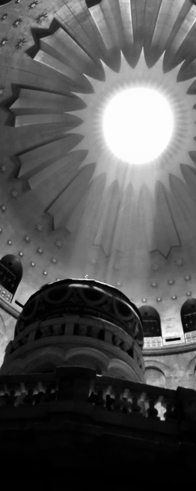
My promise cannot be broken!
His kingdom will shine like the sun
and outlive the moon.
He is carrying in himself all the insults,
all the wrong of all the people.
How could you let this happen, God!?
My Chosen One, my Son -
He will break the power of death!
My love is greater! My promise stands!
Blessed be the Father of Love
and the Crucified King,
with the Spirit, forever and ever!
Amen and amen!

Psalm 90: A puff of dust

Lord you have been our home
from generation to generation.
From age to age, infinity to infinity
before mountains or stars
you are God!

Ours lives are tiny, just a fraction of a second
in your vast time frame -
a breath, a puff of dust, here then gone.
Our lives are tough, hard work and pain, guilt and anger -
be kind to us, Lord!
Wake us in the morning with your joy
Carry us through the day with your love.
Bless our hands so our work is good
Bless our lives so your glorious power shows in us.

Psalm 91: The Trust Psalm

Trust! Trust in God!
God is our shelter,
we are safe in his shadow.
God is our refuge,
we are protected in his power.
God is like a mother bird and we are like chicks,
tucked warm under her wing.
God is our shield and our armor
nothing can strike us down.
God is with us all the way
our guard and our guide.
You may trip on a stone
but angels will catch you.
So don’t be afraid of snakes and spiders,
don’t be afraid of evil attack.
In God’s love we are safe, no matter what.
In God’s strength we are saved!

Psalm 92: Saying thanks at bedtime

It is good to give thanks to God
at the end of the day
as I snuggle down into bed.
Thank you for your love, with me all day.
Thank you for the touch of your hand
in lots of ways today.
Thank you for when I felt happy.
Thank you for the things that went well.
Thank you for getting me on track
when I got stressed and upset.
Every day you are with me.
You grow me up, to stand tall like a great tree.
I will grow fruit and be strong
all the days of my life
for you are my rock and I thank you.

Psalm 93: Water rising

In a storm the rain falls heavy and the rivers flow higher
and higher, brown water everywhere!
In a storm the wind blows wild and the waves crash higher
and higher, spray flying everywhere!

This is nothing compared to God’s power!
God our King rules over all the earth.

Psalm 94: Praying for a world in trouble
(as Prayers for Others)

Lord our God, shine out in every corner of our world.
Rise up and bring justice for all in need of help.
We hate to see children being hurt and families destroyed.
Who hears the cry of the poor?
It breaks our heart when people die from violent attacks.
Who can break the power of evil?
Leaders tell us whatever they want us to believe.
Who knows what is true any more?
You, O Lord, you see! You hear! You are at work!
Who will stand against the wrong in our world?

We pray for people who have been treated unfairly.
Rise up, O God, and bring your justice!
(silence)
We pray for people who are attached because of their faith.
Bless and protect your people everywhere.
(silence)
We pray for people who are sick or afraid.
Our hearts are full of troubles, but your love reaches in.
(silence)
The Lord is our rock of refuge,
our safe place in a troubled world.

Psalm 95: Come let us sing for joy

Come, let us sing for joy to the Lord!
Let us shout aloud to the rock of our salvation!
Come, make a joyful noise!
Come, bring all your “thank you”s
For in God’s hand are the mountain tops
and the ocean floors.

Come, let us sing for joy to the Lord!
Let us shout aloud to the rock of our salvation!
Come, bow down and worship
Come, kneel and be humble
For in God’s hand are all his people
we are his sheep and he is our Shepherd.

Psalm 96: Words run out

What words can we find?
How can we describe our mind-blowing God?
We have heard words in church:
worship and praise
glory and majesty,
honour and awe …
but what are our words
to tell of God’s greatness?

Maybe we need to shut up
and let the trees say it better …
the waves and the flowers,
the rocks under our feet
and the stars over our head,
they all know how to praise the Lord!

What words will you choose
to be your truth this day?
Sing to the Lord a new song!
Sing to the Lord, all the earth!
Psalm 97: Rejoice, the Lord is King!

Rejoice! The Lord is King!
Lift up your heart,
lift up your voice; rejoice;
again I say, rejoice.

Power! All the forces in the planet
are powered by the Lord.
Love! All the love in the universe
flows from the Lord.
Joy! All the happiness in the world
is given by the Lord.
Thanks! All our thanks we give back to you.

(I grew up a Methodist, with the hymns of Charles Wesley. In his hundreds of hymns he did the same thing I’m doing – but way better, obviously - reading Psalms with Jesus in mind and giving them a fresh voice for everyday life.
Listen to good recordings and teach your kids these magnificent hymns.)

Psalm 98: Sing along a new song

Sing to the Lord a new song!
Marvelous is all he has done!
Victory has been won
and all the earth has seen!
Break out with songs of joy!
Trumpets blast and waves crash
Guitars play and rain claps the beat
Music fills the air and hills cheer!
The Lord is coming, he’s nearly here!
He will set things right
and all will be well.
Sing to the Lord a new song!
Marvelous is all he has done!
Psalm 99: If you shake us
(as a prayer of confession)

O God, how incredible you are!
How ordinary we are.
The earth shakes with your power
and we tremble, afraid
that if you shake us we’d fall apart.
We see your brilliance
and we hide in the dark.
We know how pure you are, pure love,
and we know that we are a mess.
Forgive us, God.
We stuff up.
We forget to live in your light.

All the prophets told us about Christ,
that all our failing would be forgiven
in his name.
Come, Spirit of God, come.
(Acts 10:42-44)

Psalm 100: The joyful parade

It’s a parade! a joyful parade!
All people, from every nation,
joined in a noisy parade -
shouting loud, singing louder,
coming to the Lord our God,
coming in through his gates.
Hear as they call: “We are God’s people!
We belong! God is good!”
Young and old, join in!
One and all, bless the Lord!

Psalm 101: Call me loyal

Call me loyal, I’ll hold you loyal too.
Call me faithful, I’ll hold you faithful too.
Let’s sing in our worship and our work,
sing of God’s love and justice.
Let’s study God’s truth and holiness,
so that in all our ways, through all our days,
we’ll hold true and do right.

Here in this family we will build each other up
and know nothing of evil.
We won’t tear each other down with lies or complaints.
We will think others better than ourselves.
We will enjoy God’s favour,
and delight in our differences.
We will minister to each other,
from the youngest to the eldest.
We will welcome all God brings us,
no matter who they are or what they’ve done,
for all have sinned and fallen short of the glory of God
but in Christ we are set right by grace!
So I need you and you need me,
and together we belong.

Psalm 102: The time has come!
(Luke 4:16-22)

The time has come! The time is now!
This Jesus announced when he read from the Bible:
“God has sent me
to bring good news to the poor
to set free those trapped in prison”
You, eternal God, rise up! Have a heart for us!
The time has come!
Hear the prayer of the poor, the groans of the prisoners.
We are doomed to die, come and save us!
The time has come! Jesus has come!
The Holy Spirit has come!
People, come together to worship the Lord!

Psalm 103: Bless the Lord, O my soul

Bless the Lord, O my soul
and all that is in me bless his holy name!
Bless the Lord, O my soul
and never forget all that God does -
our sins he forgives
our wounds he heals
our energy he renews
our death he changes into life!
Bless the Lord, all the earth
and see what he is doing -
like a Father he cares for his kids
like a Judge he protects those in need.
See the stars so high above?
God is higher and bigger!
See the flowers growing by the road?
We are like grass, here today and gone tomorrow
but God is from everlasting to everlasting!
Bless the Lord, O my soul!
Psalm 104: A Psalm for Aotearoa
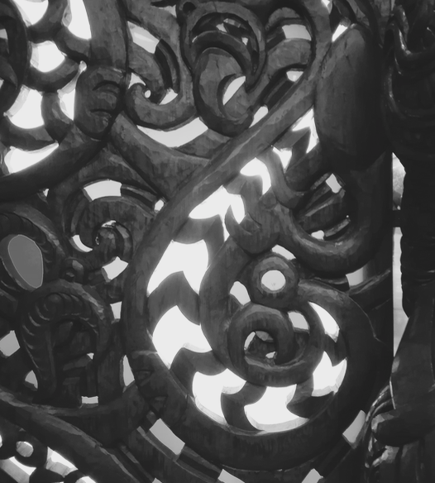
Bless the Lord, my soul.
Kororia ki te Atua!
You are wrapped in light,
in a korowai of glory.
You made Rangi, Father Sky,
infinite space stretched out above us.
You made Papatuanuku,
Mother Earth,
resting strong beneath us.
At you command Tangaroa rose and fell;
the seas once covered the mountains of this land
but now tides swirl around us,
drawn by Marama, the moon, in her monthly dance.
Each day the sun, Ra, walks his path through the sky.
Rain falls, springs gush up out of the earth,
nga awa, rivers flow through our islands,
water for bush and bird and cattle.
I nga ra o mua, before Maori and Pakeha,
great forests ruled this land, Tane Mahuta: totara, rimu,
filled with birds from the smallest fantail to the giant eagle,
from the shy kiwi to the long-legged moa.
The sea was filled with life: whale, kahawai.

Aotearoa, cloaked with cloud, shaped by water and wind.
Nga hau e wha, winds from four directions,
brought people to these islands
and you made them a home here,
fed them from your abundance;
though sometimes you hid your face and the people were sad.
When you take away the breath of life your creatures die
and return to the dust. Aue, aue!
Haere, haere, haere …
we mourn the loss of so many creatures, so much beauty.
Send forth your Spirit again on Aotearoa,
Haere mai, Wairua Tapu, renew the face of this whenua,
care for this land,
re-make us who call this our home, nga iwi o te motu.
May the glory of the Lord shine forever!
Kororia ki te Atua!

Psalms 105, 106 and 107: The History Psalms

Psalms 105 and 106 are a twin set, one sweet, the other bitter. Both are liturgies for worship, calling the people of God to remember who they are and where they came from. Both tell the same Exodus story and both honour the Lord God for his ongoing decisive acts in this history, but they have different points of view. 105 is a song of harmony between God and the people (“They asked and he gave them food”, 105:40), while 106 tells of conflict (“They had a wanton craving in the wilderness and put God to the test”, 106:14).
Psalm 107 is a more general, reminding people of how God has acted in their community life in various ways.

The fascinating thing about these psalms is the way in which the history continues to shape the identity of the people, through its retelling in worship. Brueggemann describes this as “a powerfully present past”, which must be retold in every generation to link people across time and space to the God who is at the centre. It is a history of relationship, at heart a covenant between a people and their God, each active participants in an ongoing open-ended interaction. “Each party is shaped by and destined for the other”.

What is amazing about this God, in these histories, is that he continually intervenes to surprise his people. Psalms 105, 106 and 107 are songs of wonder, stories of a God who acts: “Sing to him, sing praises to him; tell of all his wonderful works.” (105:2). Martin Buber describes this as “an abiding astonishment”; as the people remember key events in their shared past they name these as miracles and they name God as the cause. This doesn’t mean the events are necessarily supernatural, they could have logical, ‘natural’ explanations, but what matters is that at our time of need God provided; into our crisis God acted to save. Retelling the story keeps alive our sense of astonishment and grounds our present experience in the old old story.
(Walter Brueggemann, Abiding Astonishment: Psalms, modernity and the making of history, 1991, John Knox Press)/

What are the stories in your family that tell of relationship …
promises kept or broken …
surprises …
rescue …
blessing?

Where do you spot the action of God in your family life?

Tell these stories to your children.



Psalm 108: A wake-up call

Get up, wake up, come on everyone!
Today has begun, don’t miss a thing!
The music rises in our hearts
feel the beat, join the rhythm.
Sing! dance the wonder, sing the rhyme
We’ll call the sun into the sky
We’ll raise the roof with our praise
We’ll shout our thanks for all to hear!

Up, up, up, we lift you high, O God
Up through the stars and out the other side!
All of space and time sings your love
Through clouds and cities your glory rings.

Up, up, you lift us up,
out of our troubles, out of our pain.
We call for help and you answer, again and again:
“I love you. I will never leave you.
Where ever you go, I will lead you.
All the earth is mine,
everywhere you go, I’m there already
Everything you go through, I’m there at work
Nothing stands against me.”
O God, you are our help and our hope,
our power and our victory!
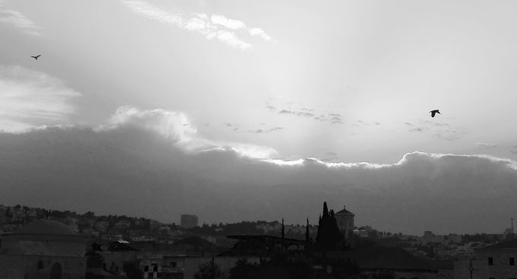
Psalm 109: SO ANGRY!!

All I am is angry today
Rage burns in me
All I can see is how badly I’ve been treated -
how unfair, how wrong, how utterly despicable!!
They turned my love into hate
they turned everyone against me.
All I want is for them to hurt as much as they hurt me.
Turn their hate back onto them!
But you - you turn curses into blessing
you died for me, and for them
and so I trust you in this, yes even in this.

Psalm 110: All about Jesus

When Peter got up to talk, after the Holy Spirit came on the day of Pentecost, he told everyone that Jesus was raised by God to rule with God, just like it says in Psalm 110
(Acts 2: 34-26)
The LORD says to my Lord, “Sit at my right hand
and I will make your enemies into your footstool”
Peter re-read Psalm 110 in a whole new way:
It was about Jesus! All about Jesus!
Jesus is Lord, one with the Lord God!
Jesus is Priest, bringing us to the Father.
Jesus has the victory, with power, over evil.
Jesus is King, and his kingdom will have no end.
Jesus is risen, drinking living water
and pouring it out in a mighty flow of Spirit,
on the day of Pentecost
and on you and me.
Psalm 111: Praise the Lord, now and forever!

Praise the Lord
now and forever!
I will say to God with all my heart – THANK YOU!
Together with all God’s people we say – THANK YOU!
Everything God has done is great
Everyone who learns about God delights in him.
God is full to overflowing with grace and mercy
God is generous to his people and never forgets us.
Everything God does is good and true
Everything God teaches is good and true.
We can put our trust completely in our God
Standing tall on his everlasting word.
His covenant of salvation lasts forever
Holy and awesome is his name!
Wisdom begins here, by honouring God
Praise the Lord, now and forever!

Psalm 112: Welcome to the good life!
(Read Romans 12:9-21)

Welcome to the good life!
Come, follow Jesus, you won’t regret it!
Life will be an adventure, guaranteed!
You will stand strong and do great things.
You will know much joy, that’s a promise.
You will be rich, that’s for sure,
but it’s not for you, it’s to give away,
and it might not be in money.
You’ll be rich in love and rich in friends,
you’ll be rich in peace, so you’re not afraid,
not afraid of what people think of you,
not afraid of what happens around you.
Strong inside, you get to be who you are made to be!
Life with Jesus is a wonderful life.

Psalm 113: From the rising of the sun
(Song in the Songs of Praise chorus book)

From the rising of the sun
to the going down of the sun
the Lord’s name is to be praised! (x2)
Praise ye the Lord!
Praise ye all ye servants of the Lord!
Blessed be the name of the Lord
from this time forth and forever more!

All the hungry and the poor
on the rubbish dumps of the world;
the Lord cares and lifts them up!
All the lonely and the lost
with no friends or children to love;
the Lord longs to bless each one.
Praise ye the Lord …

Psalm 114: Skipping mountains

When the people of Israel escaped from Egypt
God lead them out into freedom
and gave them a new home.
But on the way crazy things happened:
the sea took one look and ran away!
the mountains skipped like lambs,
jumping up and down!
the rock split open and sweet water sprang out!
What an awesome God!

Psalm 115: Toy gods

Back in the day people used to keep statues
of gods and goddesses, at home for good luck.
This Psalm pokes fun at them:
“Odd” it says “This toy god of yours -
it has a mouth, but can it talk?
It has eyes and ears, but can’t see or hear!
What’s it got legs for? It can’t walk!”

Don’t bother with imitations – our God is real!
Don’t trust in what you own.
Don’t worship what is made.
Think bigger than that –
the Lord of the universe, maker of all,
far beyond us and our toys,
who remembers us and blesses us
at home and everywhere.

Psalm 116: Death could not hold me down
(Luke 24)

When Jesus walked the road to Emmaus
with Cleopas and his friend
on the day he rose from the dead
he opened the scriptures to them
and told them why he had to die.
I bet he read from Psalm 116:
“Death wrapped itself around me
Terrible pain pulled me down.
I cried to the Father “SAVE ME!!”
and he did!
No way could death hold onto me!
I walk in the land of the living!”
And then Jesus broke bread with Cleopas and his friend
gave thanks to God
lifted up the cup of salvation
and they knew who he was.
Halleluia! He is risen!

Psalm 117: The Shortest Psalm

If you count every chapter in the Bible
from beginning to end,
Psalm 117 is right in the middle.
And right in the middle of this,
the shortest Psalm,
is the greatest word –
LOVE.
Great is God’s love for us!
Unstoppable is God’s faithfulness!
All people in every land, honour God!
Praise the Lord!!

Psalm 118: Pointing to the risen Lord
(Read Acts 4)

This is the day that the Lord has made
Let us rejoice and be glad in it!
The Lord is my energy and my strength
He has become my salvation!

The stone that the builders rejected
has become the corner stone,
the foundation on which everything is built.
Blessed is he who comes in the name of the Lord!

O give thanks to the Lord, for he is good
His steadfast love goes on forever!

Psalm 119: The Longest Psalm

How I love your law!
Psalm 119 goes on and on -
176 verses full of desire to keep the law of God.
With my whole heart I seek you, teach me your ways.
I treasure your word, stop me from doing wrong.
I trust your commandments, I will always keep them.
But our faith is not about keeping rules
or staying out of trouble.
It’s good to be good, but that’s not what Jesus asked of us.
Jesus got most angry with those who kept all the rules
but missed the point.
“This is my commandment” said Jesus, “Love each other”
Your word is a lamp to my feet and a light to my path
… not the rules, but Jesus himself,
the living Word, light of the world.

(John 13:34. Also read Romans 13:8-10)

Psalm 120: Watch your mouth!

Like a bullet from a gun is a cruel word.
Like arrows shot sharp are lies.
People say the meanest things.
People attack with their tongue.
I want my words to speak peace.
I want my mouth to be always true.

Psalm 121: I lift my eyes to the hills

I lift my eyes to the hills;
who is coming to help me?
The Lord! Jesus has come to help me!
He is right here, all the time.
Every step I take is a step with him.
He has promised to take care of me,
and he never sleeps on the job!
The Lord will keep you safe.
The Lord will keep your going out
and your coming in
from now on and always and always.

Psalm 122: The Peace of Jerusalem

Jerusalem, O Jerusalem,
the home of the Lord,
the house of David,
the gates of Israel,
the Holy Land.
Jerusalem, O Jerusalem,
we pray for peace inside your walls,
peace between your peoples,
peace through your land.
We will seek your good
and pray for the peace of Jerusalem.

Psalm 123: Asking for help

Jesus said “Ask me, and whatever you ask
I will do for you, to glorify the Father.” (John 14:13)
And so we come to you, Lord,
like kids asking their Dad for help,
and we ask …
for the needs of our friends,
for the troubles of our world,
and for ourselves.
Have mercy on us, O Lord!
Be at work in every situation.
Send out your Spirit to bless and to lead.
Have mercy on us, O Lord!
Psalm 124: If it wasn’t for God

If it wasn’t for God
we’d be a wreck!
If God wasn’t on our side
we’d be wiped out by our enemies.
If God had not been there for us
anger and fear would have swept us away.
If Christ had not saved us
we would be totally lost.
Thank you, thank you Lord
for you rescued us from the trap we were snared in.
Our help is in the name of the Lord
who made heaven and earth
and is on our side!

Psalm 125: Good balance

When we trust in God we will not be shaken,
we will not be thrown off balance.
The mountains stand tall and strong around us,
and around the holy hill in Jerusalem -
so God is all around us.
He protects us from falling.
Evil will not knock us down,
we won’t get twisted and do what is wrong.
Dear Lord, be good to people who are good;
bless people who have upright hearts,
who stand tall and strong for what is true.
We trust you, ever-lasting God.
Grow our hearts up right in you.
Dear Lord, give us peace.
Amen.

Psalm 126: A harvest of joy

Remember feeling amazing!
Remember a time of celebration –
that was the Lord God at work!
Laughter rang out,
everyone was happy,
everyone laughed till they shook with joy!
The Lord has done great things for us
and we reply with shouts of joy!

Remember feeling sad?
Remember tears running down your face –
God was with you then.
Your pain planted seeds
and your tears watered them.
The seeds grew in the tender mercy of God
growing fruit of wisdom
fruit of kindness.
Gather the fruit, and celebrate
that all things work for good in God’s ways.
Those who go out weeping
shall come home rejoicing.
The Lord has done great things for us
and we reply with shouts of joy!

Psalm 127: The Lord builds the house

Jesus as a boy trained to be a carpenter,
taught by his Dad on earth.
Jesus as our risen Lord is the master builder,
taught by his Father in heaven.
He builds us up,
he builds his church,
he builds our homes and families.
He draws the plans,
he provides the tools and timber,
he works beside us.
No need for us to get stressed,
to work too hard or get too tired.
We build in God’s power,
we rest in God’s peace.

Jesus as a boy loved his brothers and sisters.
Jesus as our risen Lord loves every child, everywhere.
Children are the most precious gift of all.
Children are our pride and joy.
Young and old we build God’s house.
We grow in God’s power,
we rest in God’s peace.

Psalm 128: Live long and prosper

May you live to be old
May you live well with God
May love fill your home and your family
May you enjoy your work and do well
May you live to enjoy your children’s children
May happiness find you, and peace rest upon you.
The Lord bless you!

Psalm 129: Attacked and whipped

When Jesus walked to the Place of the Skull,
the cross over his shoulders,
did the crowd call out to him: “Bless you!
The blessing of God be upon you!”? No!
They spat on him and laughed at him.
When Jesus walked with the cross -
his back whipped and bleeding,
his body punched and kicked -
good people turned away in shame.
But it was Jesus who called out blessing,
Jesus who asked God to forgive,
Jesus who loved so much that he died for you and me.

Psalm 130: Out of the Depths

I cry out to you, O God
I’m in too deep, I’m out of my depth
Save me!
I wait for you, O God
The night is long, too long
and I wait for the light of dawn.
I hope in you, O God
for your love breaks through -
great power to save,
great power to save!

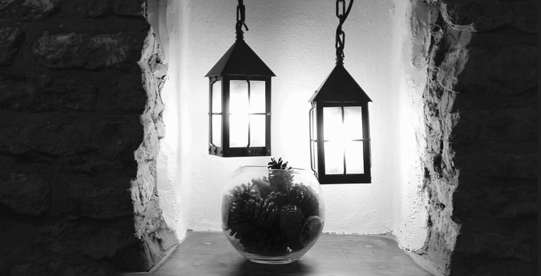

Psalm 131: Calm and quiet

Shush, my heart –
rest in the Lord.
Close, my eyes –
rest in the Lord.
Thoughts – stop rushing.
Body – relax!
Oh my soul – be calm and quiet.
Breathe in and out
and be still.

Big ideas and important jobs
can wait.
Yesterday’s hurts and tomorrow’s worries
can drift off,
for here and now
I am held
in the arms of God
like a little child
half asleep in her mother’s arms.

Trust in the Lord
in this moment
and for ever more.
Amen.

Psalm 132: The Forever King

Once upon a time, God made a promise
to a king called David.
“One of your great great grandsons
will be King forever.
He will be the light of the world
His will be the greatest victory
In him I will be,
in him I will live.
In him I will show my love to the world.”
Psalm 133: Live in unity

It’s good, it’s great, it’s wonderful
when friends are friends
and family is family.
It’s good, it’s great, it’s wonderful
when people get on well
and everyone belongs.

Living in unity,
enjoying each person,
sharing common ground –
this is God’s precious gift,
like sweet rain after a hot day,
like laughter bubbling up,
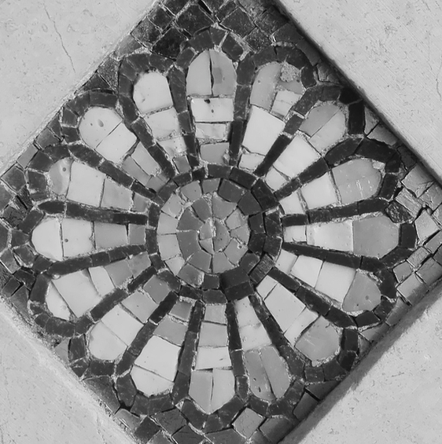
like coming home.

God’s life is life together.
God’s blessing is love,
now and forever.

Psalm 134:
A circle of blessing

Lift up your hands and bless the Lord!
Lift up your hearts, even in the dark of night.
God is here, at home in this house.
God made the universe, and knows even you.
God lifts you up and is blessing you!

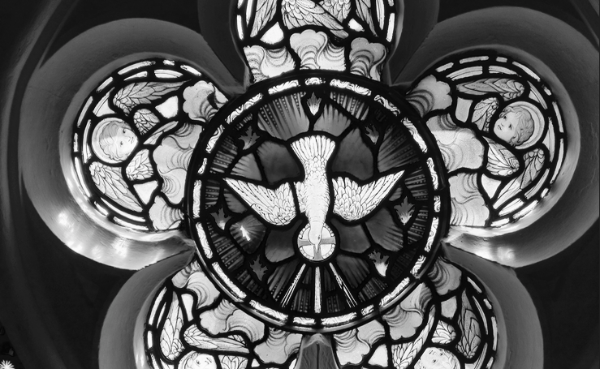

Psalm 135: Come on, people, praise!

Praise with me the name of God,
everyone in the house, praise the Father,
praise Jesus, praise the Spirit!
Our God has chosen us for his very own,
so sing and praise the Lord of grace.

The world worships silver and gold,
the mighty dollar rules.
The world worships fame,
plastic copies of people …
pictures everywhere - but who really sees?
sounds, beats, music - but who really hears?
billions of words - but who really speaks?

Our God, and only our God, is truly real.
Our God made the sea, wide and deep.
Our God makes the clouds and blows the wind,
even lightning and pouring rain.
Our Lord, and only our Lord, is good and great,
and mighty and supreme and powerful and free.

Come on, people, bless the Lord!
Come on, family, bless the Lord!
Come on, church, bless the Lord!
Psalm 136: Endless love

We’ll say it again and again and again:
the faithful love of God never ends
the mighty love of God never dies
the friendly love of God lasts forever
the strong love of God can’t be broken
the kind love of God never quits!
So tell of God’s story and live in God’s goodness
for ever and ever and ever, amen!

Psalm 137: By the rivers of Babylon

By the rivers of Babylon, there we sat down
and there we wept when we remembered Zion.
Our enemies have dragged us far away.
‘Cheer up!’ they say, ‘sing for us!’
but how could we sing the Lord’s song
in a strange land??
We remember everything about our home
We will never forget where we belong.
We ache with missing our home
and feel that we will never sing again.
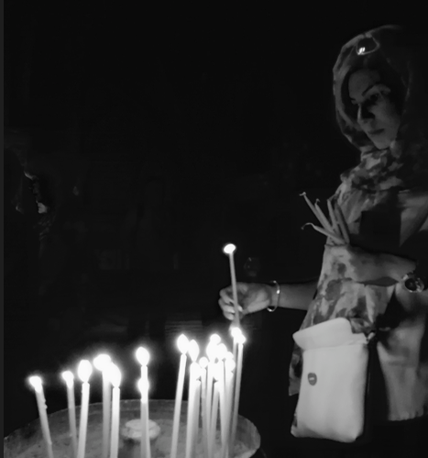

Psalm 138: Thank you for your love!

I give you thanks, O Lord,
with all my heart.
I sing you praise, O Lord,
with all my soul.
Thank you for your love,
your amazing love lasts forever!
Thank you for your love,
your solid love cannot fail!
You speak and your word is power!
You call and your name is glory!
When we cry out in our trouble
you answer us.
When we stumble and fall
you lift us up.
Your mercy cares for the weak.
Your touch pours out strength.
Thank you for your purpose
for each you have a plan.
Thank you for your promise
to hold us in your hands.
Your steadfast love, O Lord,
endures forever!

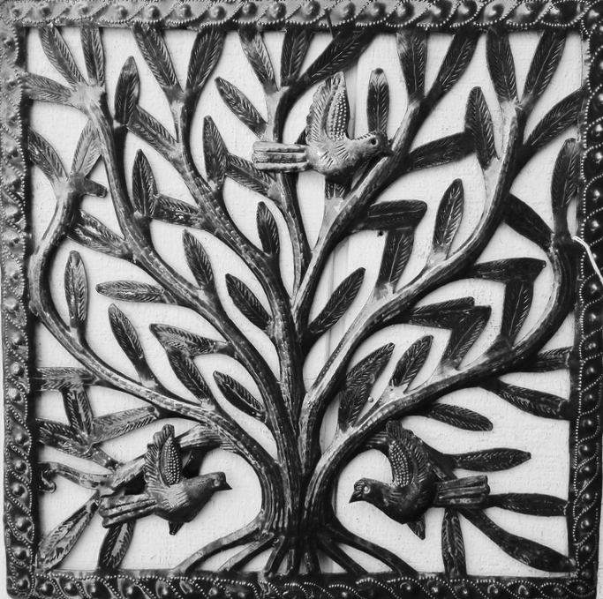
Psalm 139: The Omniscience Psalm

My child, I have searched you and I know you.
I see you, when you get up and go out,
where you go, what you do, when you go to bed.
I hear you, every word you say,
even your secret thoughts.
Lord, such knowledge is too much for me,
it’s mindblowing!
I feel your invisible touch, it’s over me, under me
it goes in front of me and it wraps behind me.
Could I run away from you? Where could I hide?
Where could you hide? I can see in the dark!
If I fly to the other side of the world
or zoom in a rocket into space?
I would be there!
And when I die?
I will run to embrace you!
I knit you together in your mother’s womb
I wove you in the dark before you were born.
I am wonderfully made – you did a good job!
You’re welcome!
How vast are your thoughts, O God!
I try to count them but numbers run out.
I come to the end of everything
and there you are, still there, waiting for me.

Psalm 140: Our God saves

I know that our God hears the needs of the poor.
I know that the Spirit is active for justice.
It’s hard when there’s so much bad news in the world,
but I know that Christ is alive, his Spirit is with us!
Our God is for us, our God hears us, our God saves!
Psalm 141: The Goody-good’s Psalm

“Why be such a goody-good?” they say.
“Rules are there to be broken!
If you want something, take it.
If it feels good, do it!
See what you can get away with!”
I want to fit in but I want to be good.
What is right? What is wrong?
Do I do what I should?
They promise me wealth but I know it is stolen
They promise me friendship but I know it is false.
Help me, God! Protect me, God.
Be a guard on my mouth so I say what is true
Be a guard on my life as I choose what to do.

Psalm 142: The prison escape
One of the problems with Psalms is that they can get a bit repetitive. Try reading Psalm 142 alongside Acts 12; that brings it to life in a fresh way. Psalm 142 is David’s voice, hiding in a cave, but it can also be Peter’s voice, stuck in prison afraid for his life. And it can also be our voice when things go badly and we can’t get through in our own strength.

“Save me from those who falsely accuse me!
I am trapped, alone, hopeless -
Bring me out of prison!
I have more work to do among your people.
Be good to me, rescue me!”

Peter escaped from prison, walking through locked doors in a daze. After he came to he said: “Now I am quite sure that the Lord sent an angel and rescued me!” (Acts 12:11)

Psalm 143: A Psalm for Easter Saturday

Father, hear our prayer this black day.
Bring life out of death, we beg you.
Your servant is gone, and our souls faint with grief.

His enemies surrounded him, beat him,
crushed the life out of him.
He cried out, “Father, into your hands I commit my spirit.”

We call to you with a terrible thirst,
our hearts dry and desolate.
He cried out, “I am thirsty.”

No one is innocent, except for him,
but he died under the sins of all of us,
crying, “Father, forgive them.”

We remember all he did and all he said
and we put out trust in you.
He cried out, “It is finished.”

O for good news! O for a new day!
O that we might hear of your loving power in the morning!
He said he would lead us into life.
He said that love would conquer death;
your Son, your servant.

Psalm 144: Blessed are God’s people

Blessed are you, Father, Son and Spirit,
our rock and our refuge,
our home and our salvation.
Come, Lord, shape us, your people.

The mountains smoke at your touch,
lightning flashes with your brilliance.
What are we to you -
we mere mortals, we weak and foolish people,
here one minute, gone the next -
What are we to you?
Come, Lord, shape us, your people.

You call us and set us free.
You send us out to fight for what matters,
well trained, well equipped,
powered up with truth in a world of lies.
Come, Lord, shape us, your people.

Singers, sing new songs!
Musicians, play your best!
Our God goes ahead to claim the victory.
Our God undermines violence,
overcomes cruelty with mercy and truth.
Come, Lord, shape us, your people.

Boys, grow tall and strong,
bearing fruit of goodness.
Girls, grow tall and strong,
holding up the house of God.
Church, be blessed!
May your wallets and cupboards fill and overflow,
may blessings shower on you
and on others through you.
Church, be confident!
May your walls be strong
and your doors be open.
May all be welcome.
Come, Lord, shape us, your people.

Blessed are you, our God!
Blessed are we, as you pour your blessings on us.
Happy are the people who know you, Lord.
Come, Lord, shape us, your people.

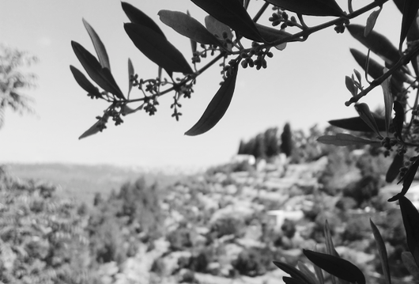

Psalm 145: We will tell your praise

Great is the Lord, and greatly to be praised!
One generation tells the next generation
about the awesome things that you have done.
We look for words to tell of how amazing you are -
glory, splendor, magnificent, mighty -
but all our words are too small.
You burst out of them!
You are made of grace and mercy,
unbreakable promises, tender affection,
powerful love that goes on and on.
All the universe speaks about you;
we join in as best we can.
Great is the Lord, and greatly to be praised!
(I’ve included two versions of Psalm 146,
and challenge you to write your own!)
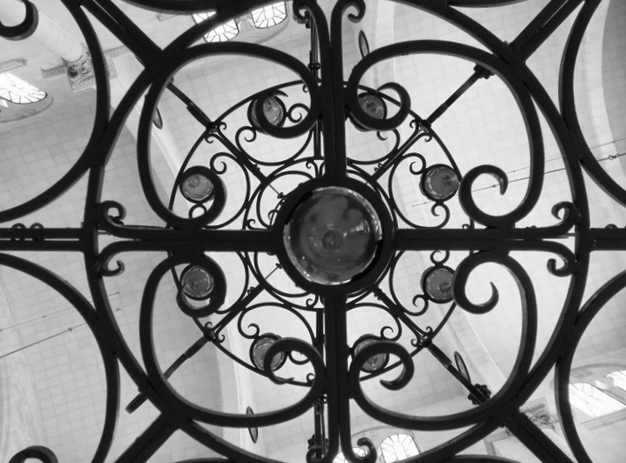

Psalm 146: Will you praise the Lord?

Will you praise the Lord?
Yes! With every breath, every day I’m alive!
Who will you trust?
Not in politicians and celebrities –
they’re here one minute, gone the next,
their fame and power will crumble and blow away.
Who will you trust?
God is our help, and God is our hope
Only the Lord keeps all his promises.
Who made the universe?
The Lord made earth, sea and sky, and all that lives.

Who cares for the poor and feeds the hungry? Jesus!
Who frees prisoners and opens blind eyes? Jesus!
Who lifts up those who are bent over and alone? Jesus!
Who teaches the way of fairness and truth? Jesus!

Who is the Lord?
Our God - Father, Jesus, Holy Spirit -
lives and rules for ever and ever.
Praise the Lord!
Psalm 146: God at work

I praise you, my God
I praise you, Lord Jesus
I praise you, great Spirit
today and every day
in this moment and with every breath.

I give this day to you
May it sing with you
May you whisper through everything I say and do.

You made all things
everything we can see
everything we can’t see -
earth and sea and sky
and all that lives -
You keep faith with us forever.

You are at work in the world –
you set things right -
food for the hungry
sight for the blind
welcome for the stranger
care for the poor.
Make these be true for me today
as I live in you and you in me.
Be Lord of this day and every day.
Yes! Be praised! Amen!

Psalm 147: Who is this God of ours?

Who is this God of ours?
Why do we sing?
Why get excited?
Number 1: God made every star
and every atom.
He can count to infinity and beyond!
Number 2: God cares for those who are broken,
and heals our wounds.
God lifts up those who get stood on
and delights in each of his children.
Who is this God of ours?
Why should we sing?
Why get excited?
Number 3: God cares for us,
feeds us, looks after us, gives us good things;
the gift of peace, the gift of love.
Number 4: God creates life
and gives rain, rivers, snow and ice,
warm and cold, wind and sun.
This God of ours is greater than great,
so we sing with joy
and overflow with praise!

Psalm 148: Calling all creation!

Hey, you! Give praise to God!
You angels in heaven, sing out glory.
You stars, sun and moon, shine bright with praise!
God dreamed you and called you and here you are!
You fish and whales and squid, sing praise in the deep.
You elements of nature, fire, rain, wind,
cold and heat, stone and mountain - praise!
God dreamed you and called you and here you are!
You plants and forests, praise God as you flower and fruit.
You mammals, insects, reptiles and birds - praise!
God dreamed you and called you and here you are!
You people, Presidents and nobodies, rich and poor,
women and men and girls and boys,
in every corner of planet Earth,
God dreamed you and called you and here you are!
So listen out for the Name that is above every Name,
sing out with all the love and joy you can find
for all you are is made by God,
all you have is gift from God.
Calling all creation – come and be found in praise!
Psalm 149: Find joy here

Praise to the Lord!
Sing to the Lord a new song
Sing his praise in the company of friends
Find joy here, celebrating the one who made us
Find joy here, praising God!
Praise with your body, move and dance
Praise with your voice, your drums and guitars
Find a place here,
for God is delighted with you
Be you broken or lost
be you fragile or sad
God delights in you
Glory grows as we praise God
and God lifts up our heads
Praise the Lord with joy!

Psalm 150: Everything praise!

Have you heard? Our God is great!
Galaxies - spin with praise.
People - dance and sing.
Play the music, louder, louder!
Trumpets, organ, cymbals, guitar.
Creatures, everything that lives -
Praise the Lord! Praise the Lord!
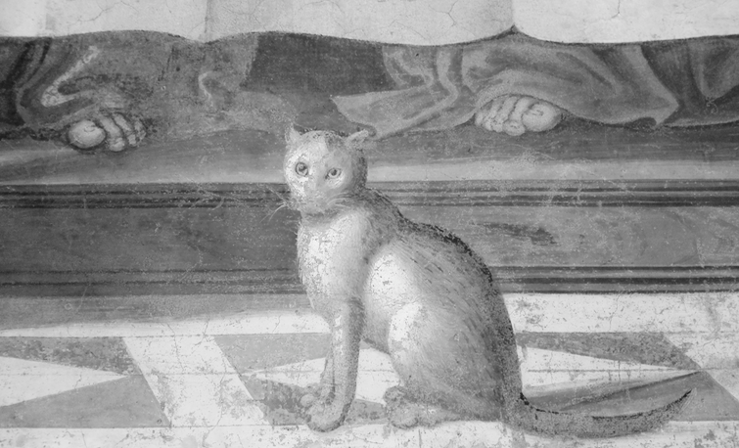

Note on involving kids in worship

Reading Psalms together is one of the best ways of including children and young people in worship. Whether you read from the Bible, or use mine versions, or write your own, it is easy and accessible for kids to share in leading worship. Some children love to stand up the front and lead the people. Some hate that idea but can read along with others. Either way they are learning the faith with every word, far better than just sitting and listening (or doing colouring in sheets!). Words can be on the screen or printed out, or not. I find it works best if an adult stands beside a child at the microphone. Young children can have a simple repeated phrase, while more confident kids can lead on their own. Try adding a repeated line or response into a Psalm or prayer.

The alternating lines works well at home also, for two people to take turns reading aloud. This also honours the basic format of the Psalms, which are written in paired lines, and were written to be sung or read together.

Note on the name of God “the Lord”

The evolution of God’s name is totally fascinating. When the Psalms were written, God was known as Yahweh, based on the Hebrew for “I Am”. Later on, the priests stopped people from saying this holiest of names out loud, so they said “The Lord” instead. This is written in the Old Testament as “The LORD”. Then after Jesus rose from the dead the church decided to call him “The Lord”, and the God who used to be called Yahweh they called “The Father”. So it’s complicated. And it’s a problem because no one is called “Lord” in our society so it doesn’t translate very well. Basically it means “the boss”. “President” perhaps? – though God can’t be voted out! “Executive Director”? – what a mouthful!

Note on the violent bits

Psalms include some of the worse lines in the Bible (e.g. Psalm 21:9-10, 40:10, 58:10, 109:8-10, 110:6, 139:19). We might not read these to our kids, but we cannot delete them; it matters that God knows how terrible humans can be. Kids need to know that even when we are in a violent rage we are still known and loved by God. Nothing is outside of God’s purposes. Nothing is too terrible to bring to God.

Art and photographs

All photos are my own, mostly from a recent trip to Italy, Israel & England. Each tells a story.

And the last word goes to
This gorgeous cat, detail of a fresco of the Last Supper, St Mark’s monastery, Florence

