Robert Henry Ellis and his ancestors
(Wendy’s father)
compiled by Silvia Purdie, 2018

Stephen Henry Ellis = Frances Saxby Robert Butterfied = Sarah Ann Cutler
Stephen & Frances came from Sussex in 1875 Robert came in 1861 from Yorkshire
after 2 years marriage Sarah Ann came in 1863 from Sussex
with her family

Henry Ellis, married Edith Cutler Butterfield

Robert Henry Ellis

Robert’s grandfather was Stephen Henry Ellis , 1847-1922
Railway worker from Sussex
Stephen married Frances Margaret Saxby, 1848-1923 (Robert’s grandmother)
from Hartford
Married 1872
They left UK for NZ in 1874, in the ship Lady Jocelyn, arrived Lyttleton 1875
They settled in Christchurch. They had 11 children:
Frederick, Edith, Henry & Fanny (twins), John, Minnie (died as a baby), Kate (died age 27), William, Dora, Mabel, George.

Henry Ellis was born in 29/3/1876 and died in 14/11/1950,
married in 1904 to Edith Cutler Butterfield (1881-1959)
They lived in Christchurch, in Packe St. He was a Taylor’s presser.

They had two children: Robert and Albert (Bert)

Robert Ellis was born in 1905 and died in 1978.
He married Vivienne Emily Taylor, in Rangiora. They lived in Rangiora until 1940, during WWII, when they had to leave, and they moved to Lower Hutt.

Robert and Vivienne had 5 children: Brian (1933), Adrienne (1934), Wendy (1936), Murray (1943) and Howard (1944)

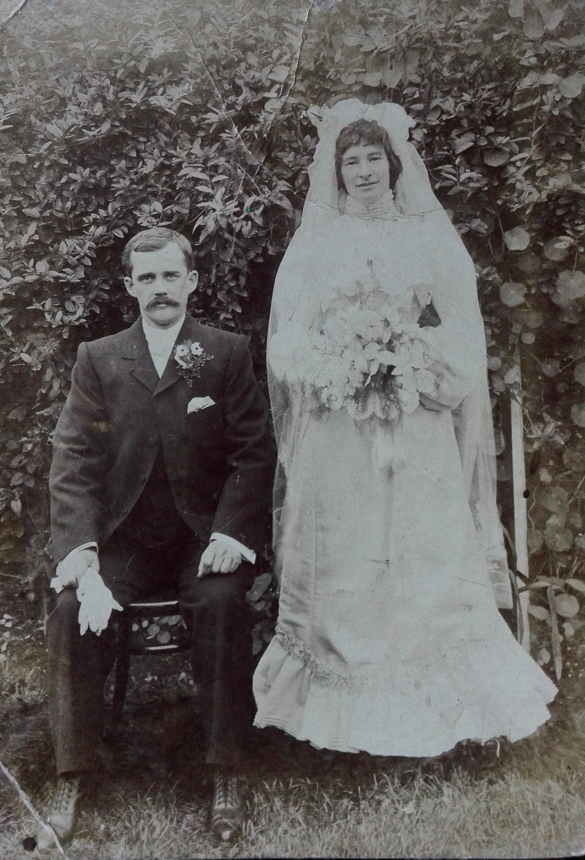
Robert’s Parents

The wedding of Henry Ellis and Edith Butterfield
30th March 1904, Christchurch NZ

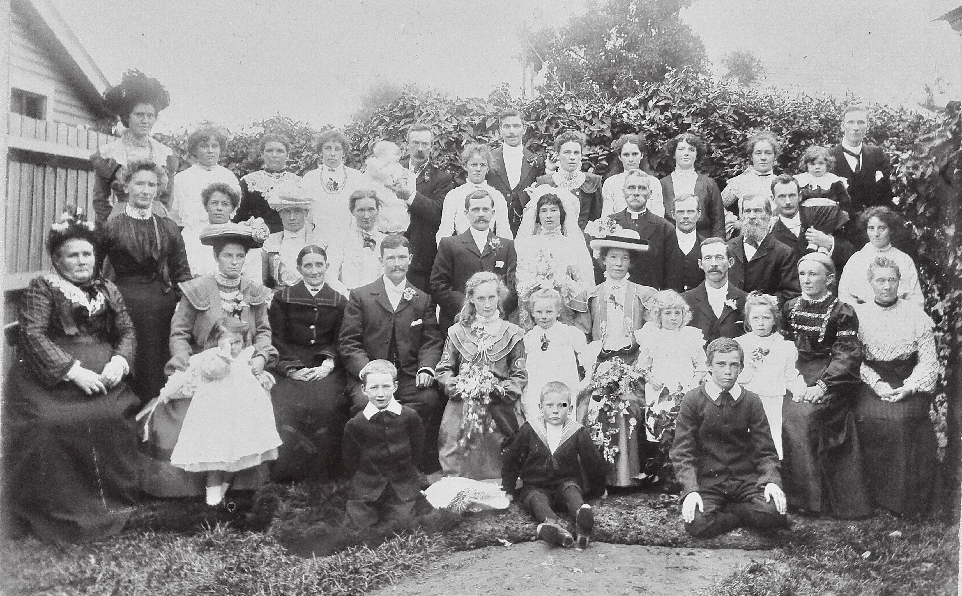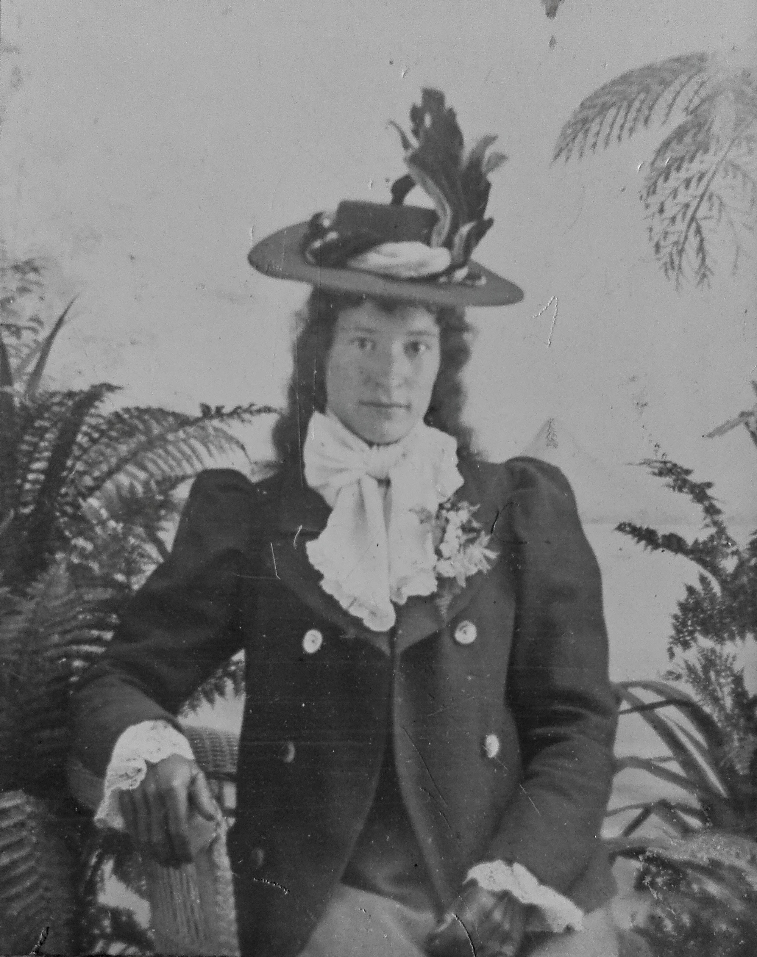

Edith Cutler Butterfield, Robert’s mother,
photo taken before her marriage in 1904

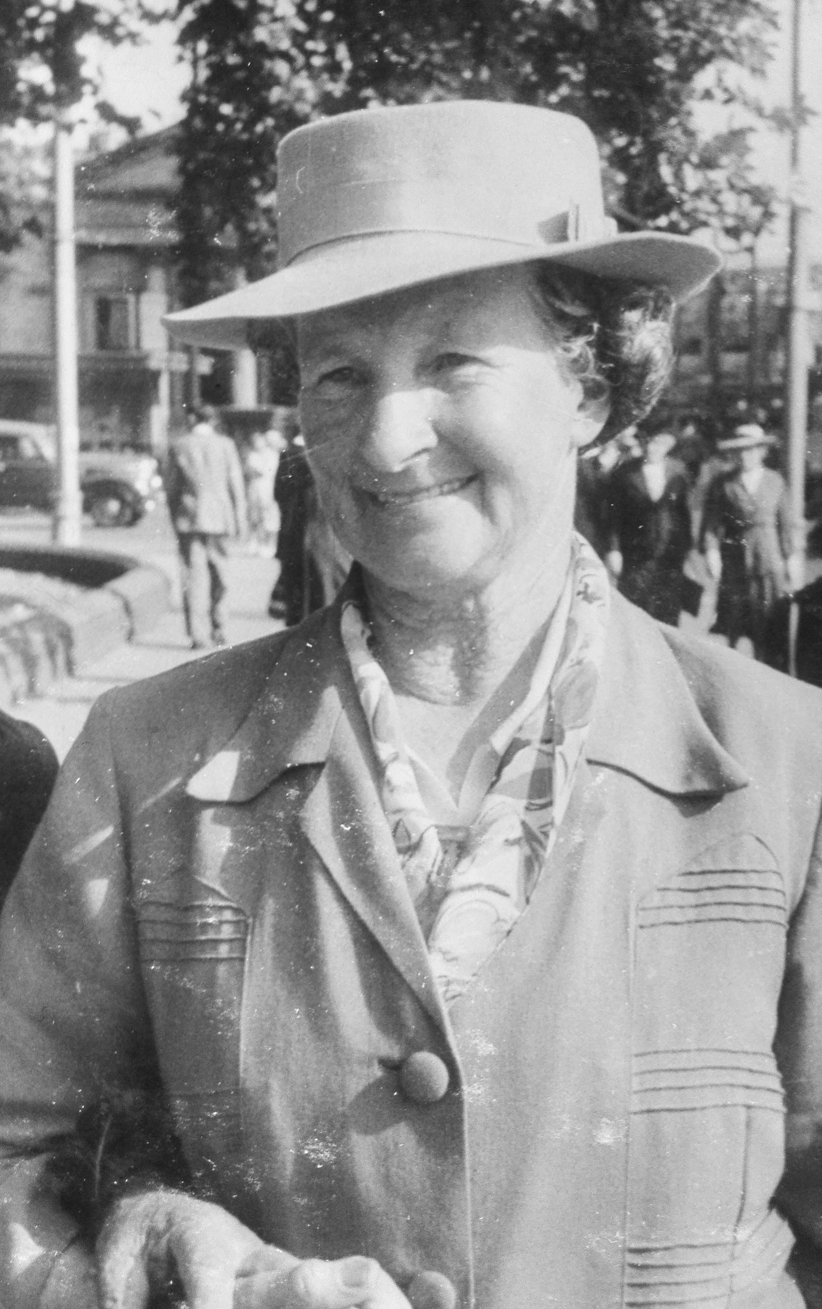
Edith Cutler Butterfield, (6/1/1881 – 9/8/1959)
Robert’s mother,
photo taken in Christchurch city by a professional street photographer
1949, age 68
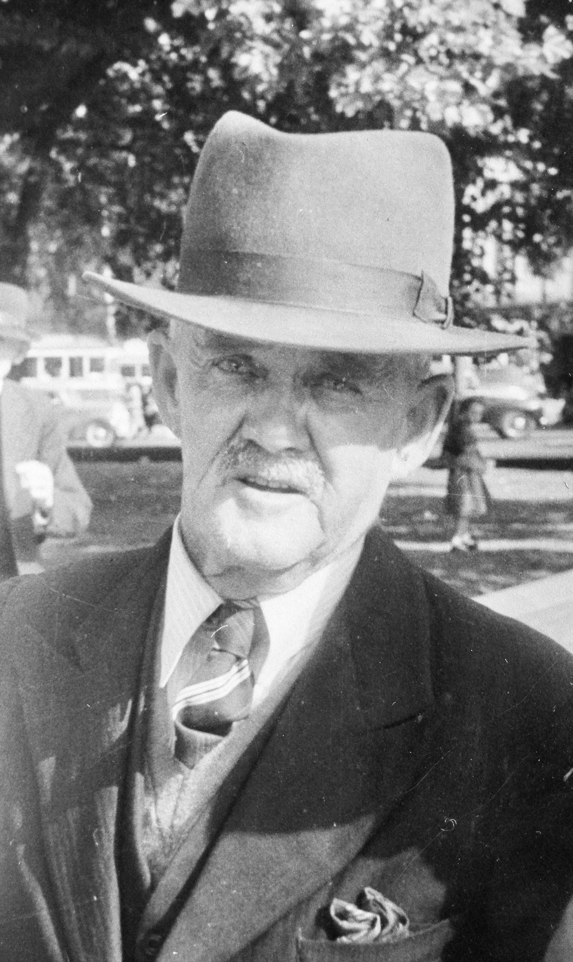
Henry Ellis, born in 29/3/1876 and died in 14/11/1950
Photo taken in 1949 – age 73

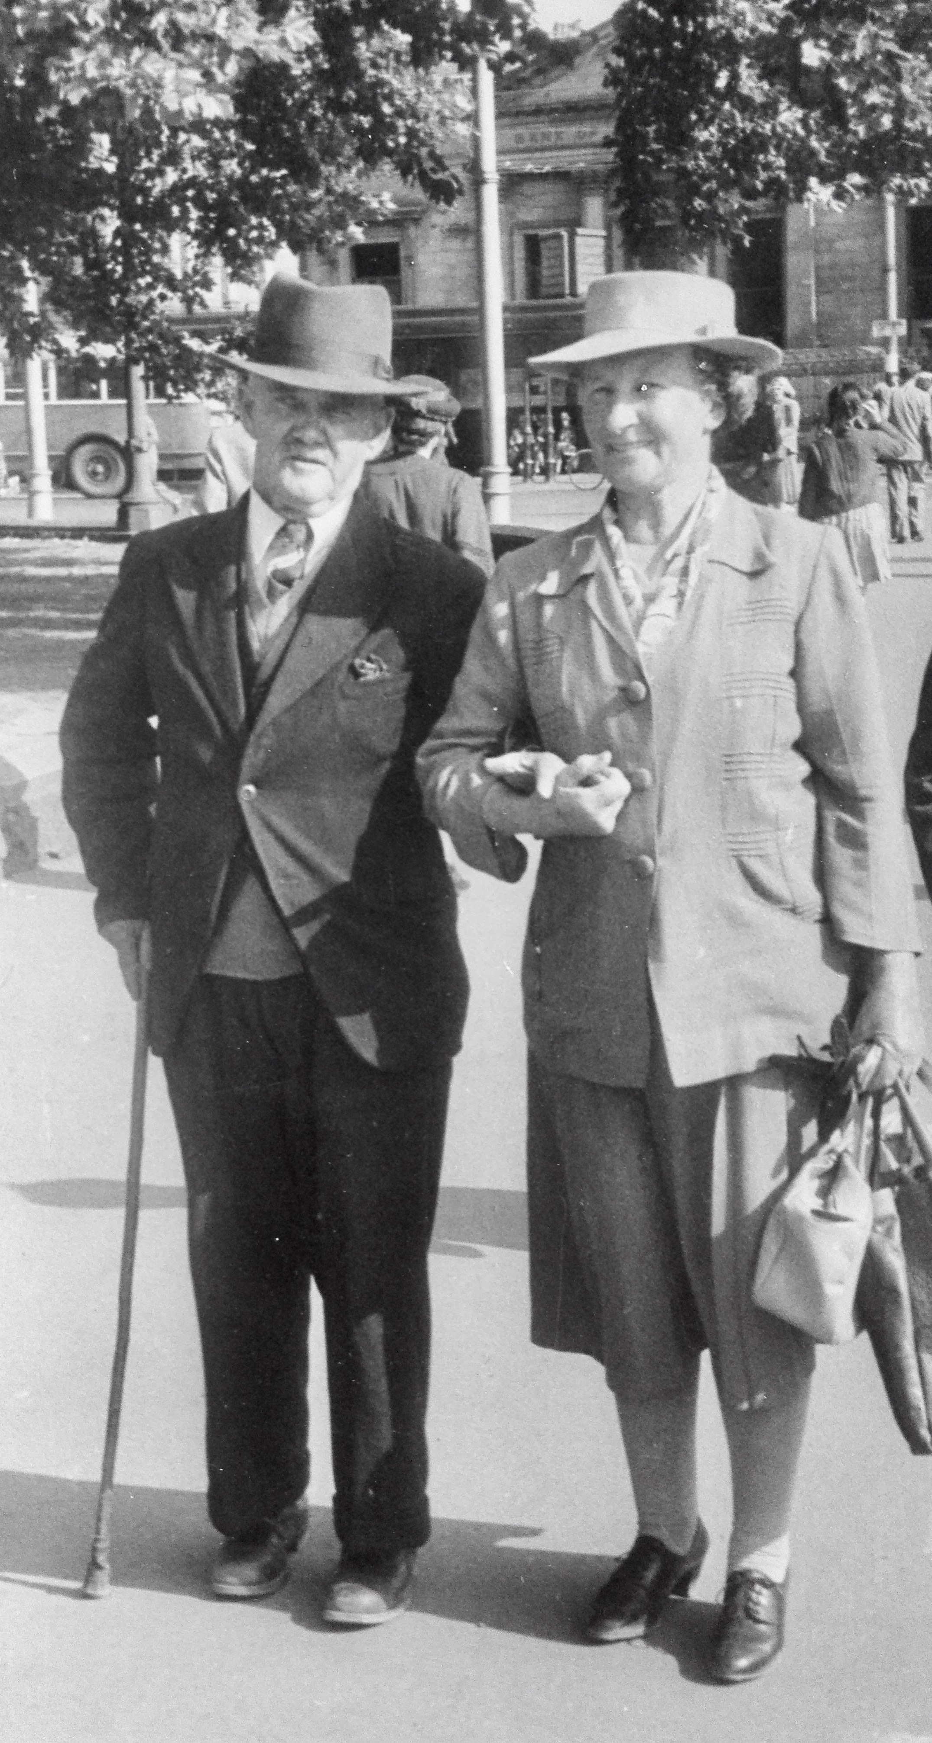

Henry & Edith Ellis in 1949

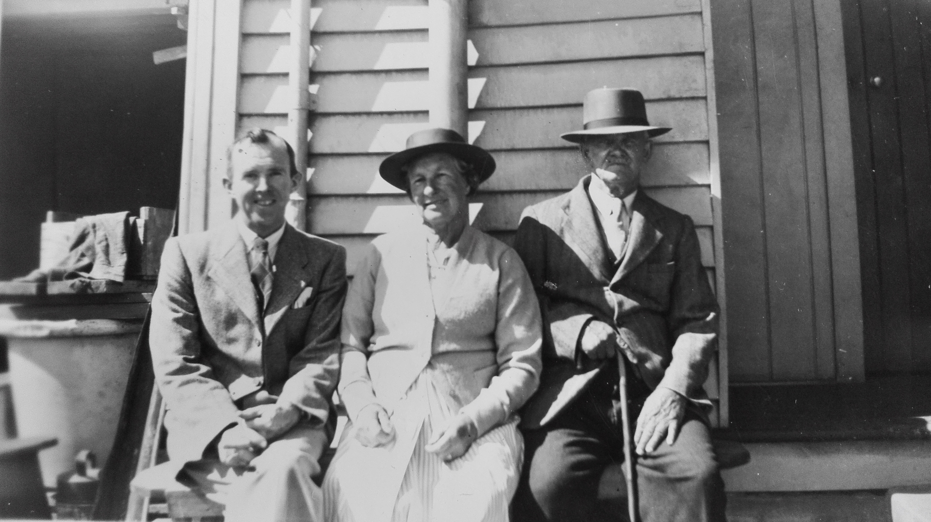

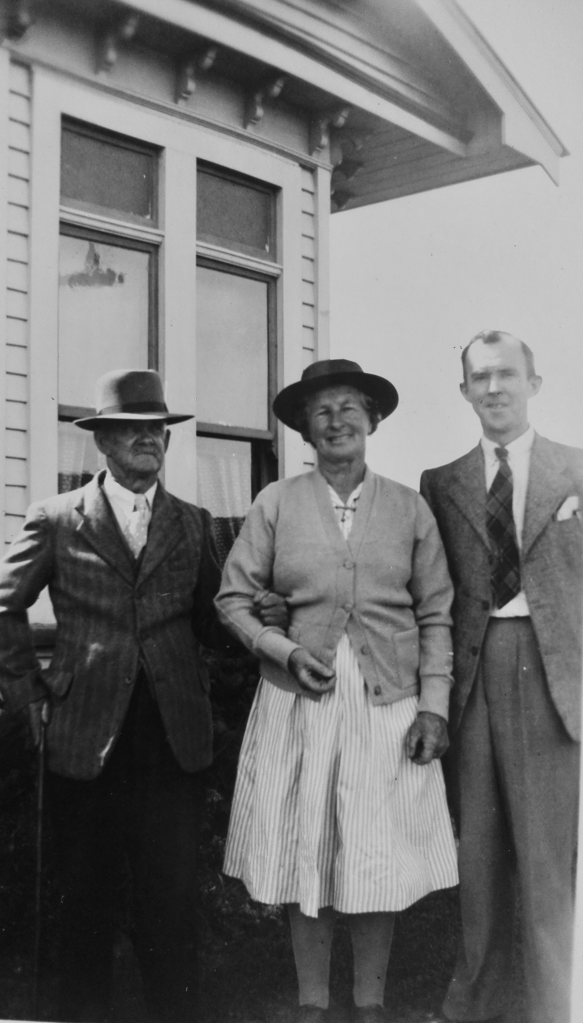
Robert Ellis with his parents Edith and Henry, at their New Brighton bach, in 1950 before Henry died.

Henry Ellis before he died, in wheelchair.

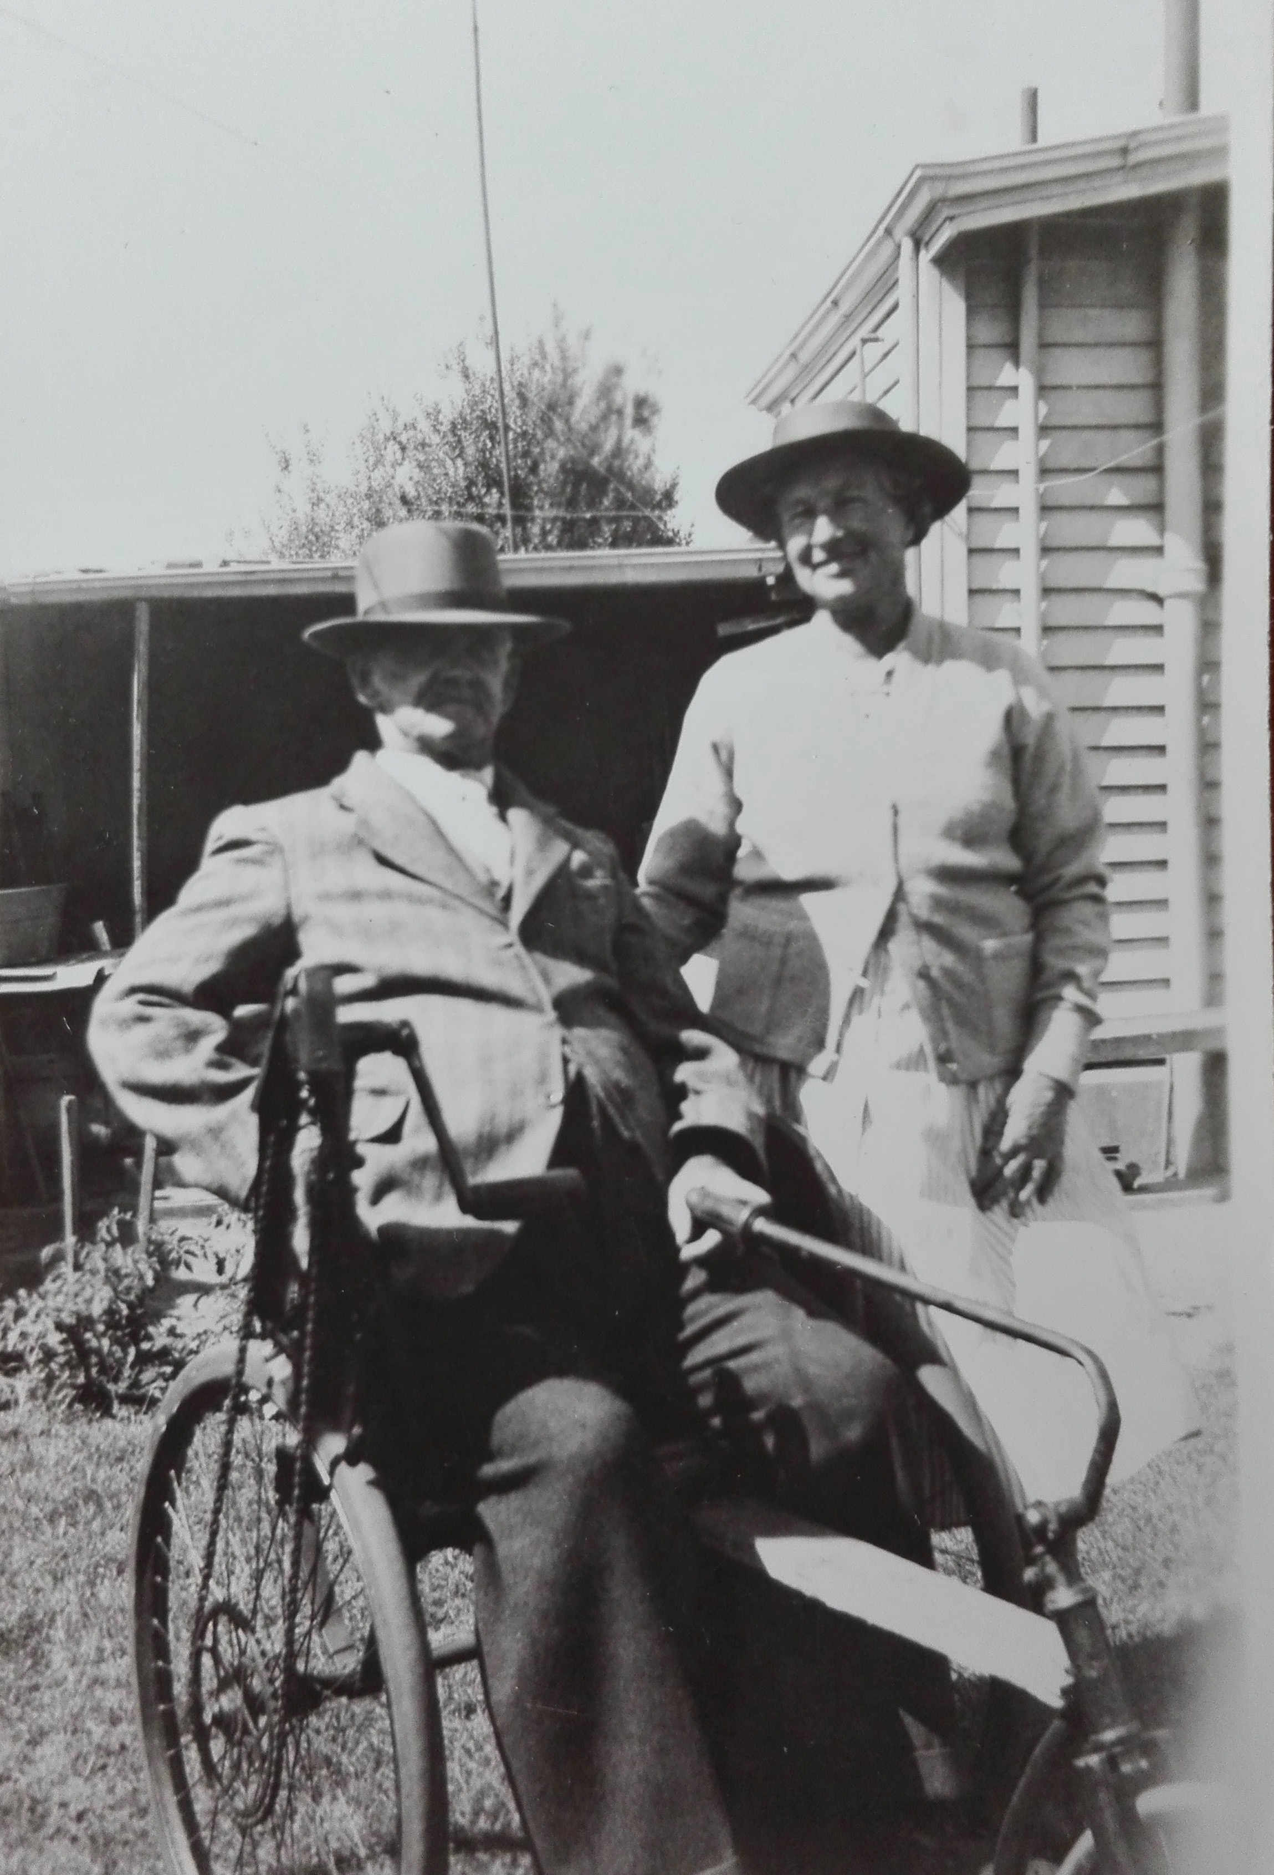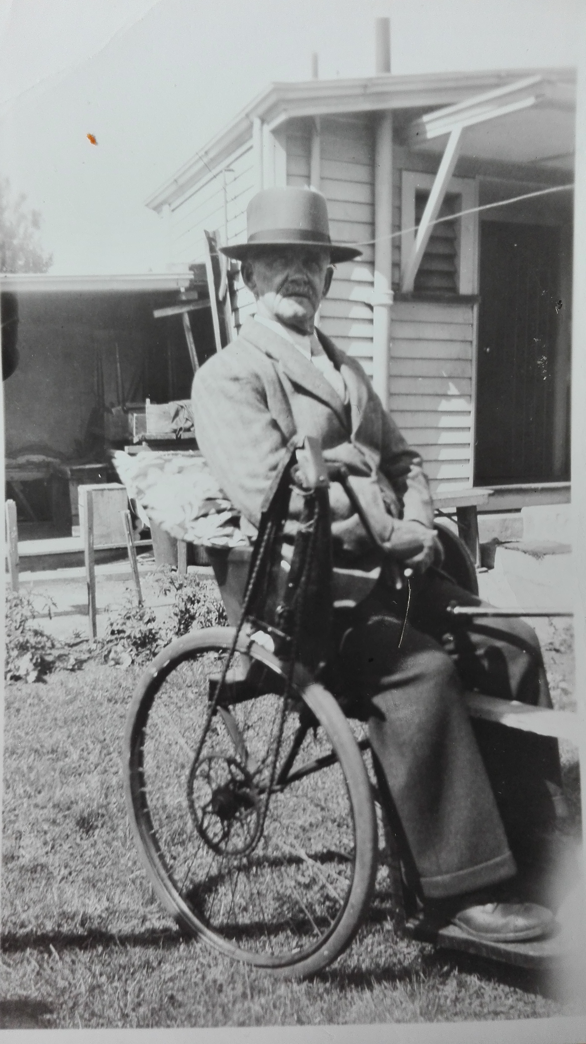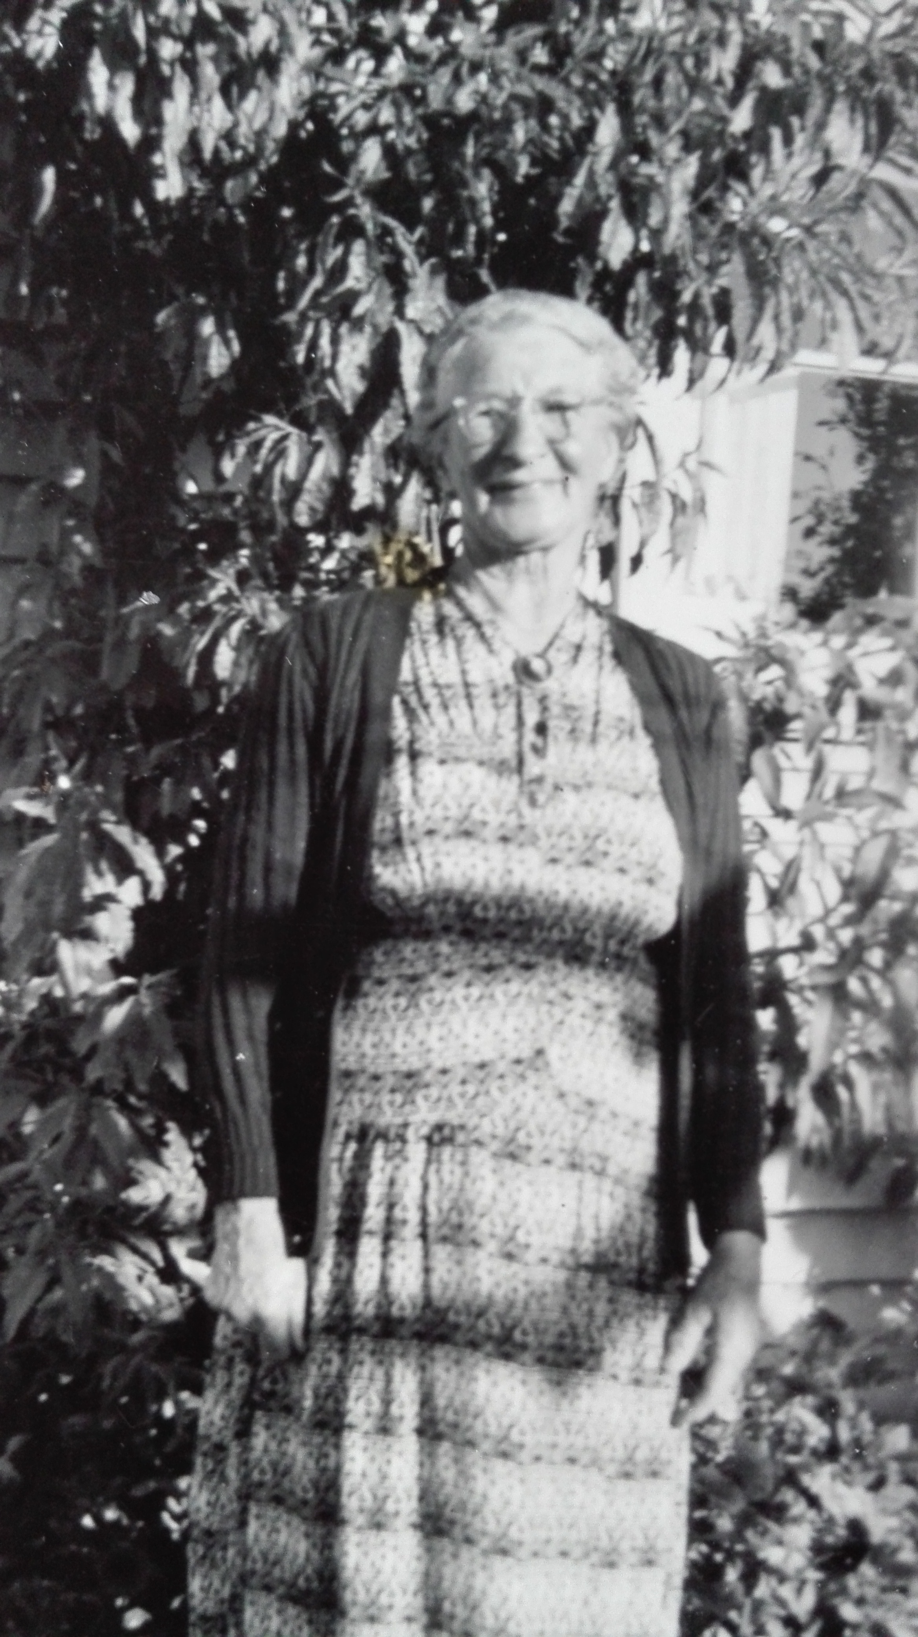

Edith Ellis
Photo taken at Vivienne & Robert’s house in Taita, Lower Hutt, after Henry died – Christmas 1950.
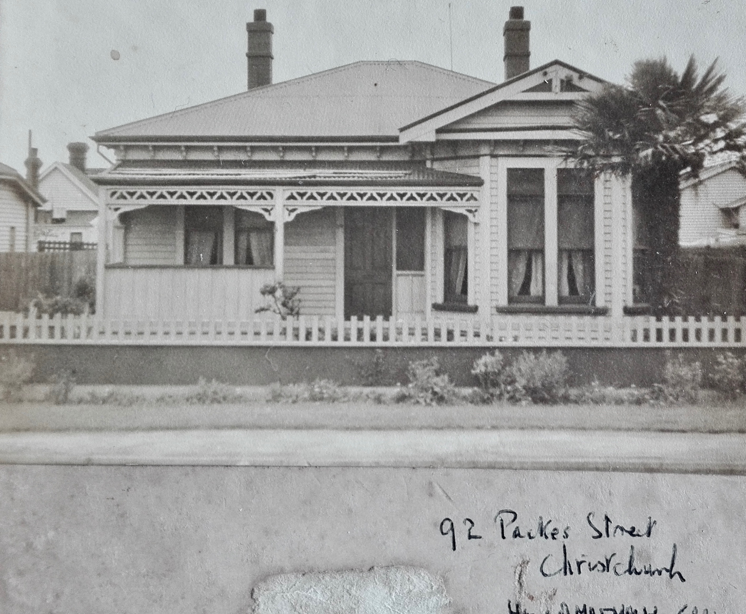

Henry & Edith Ellis’s house – where Robert grew up
92 Packes St, Christchurch
Ellis Family

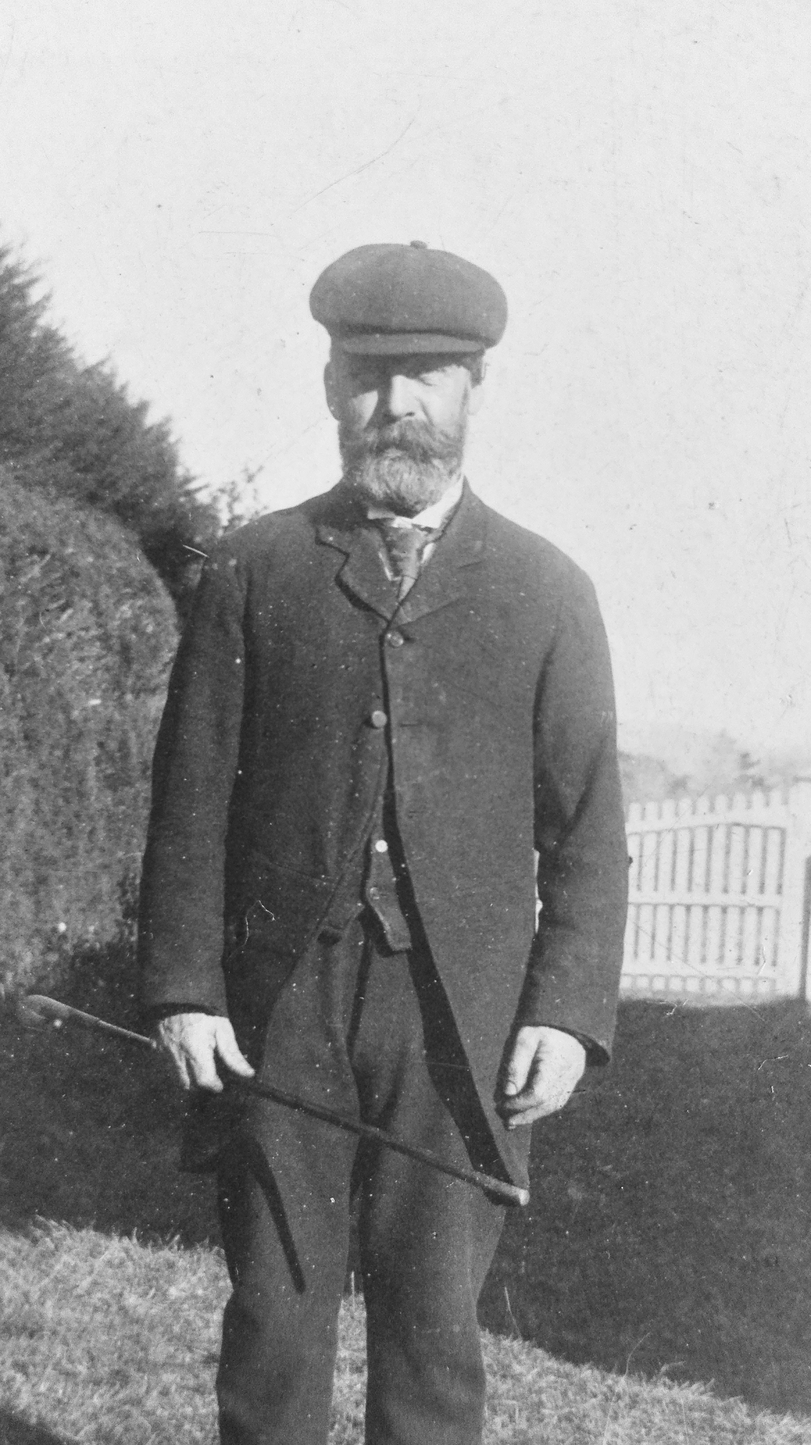

Stephen Henry Ellis (1847-1922)
photo taken about 1906
(Robert’s grandfather)

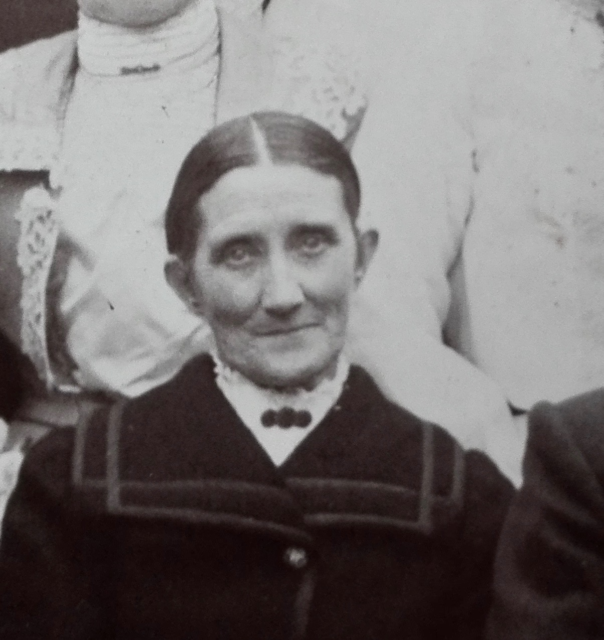

Frances Margaret Ellis (ne Saxby)
at her son’s wedding
(Henry & Edith), 30 March 1904
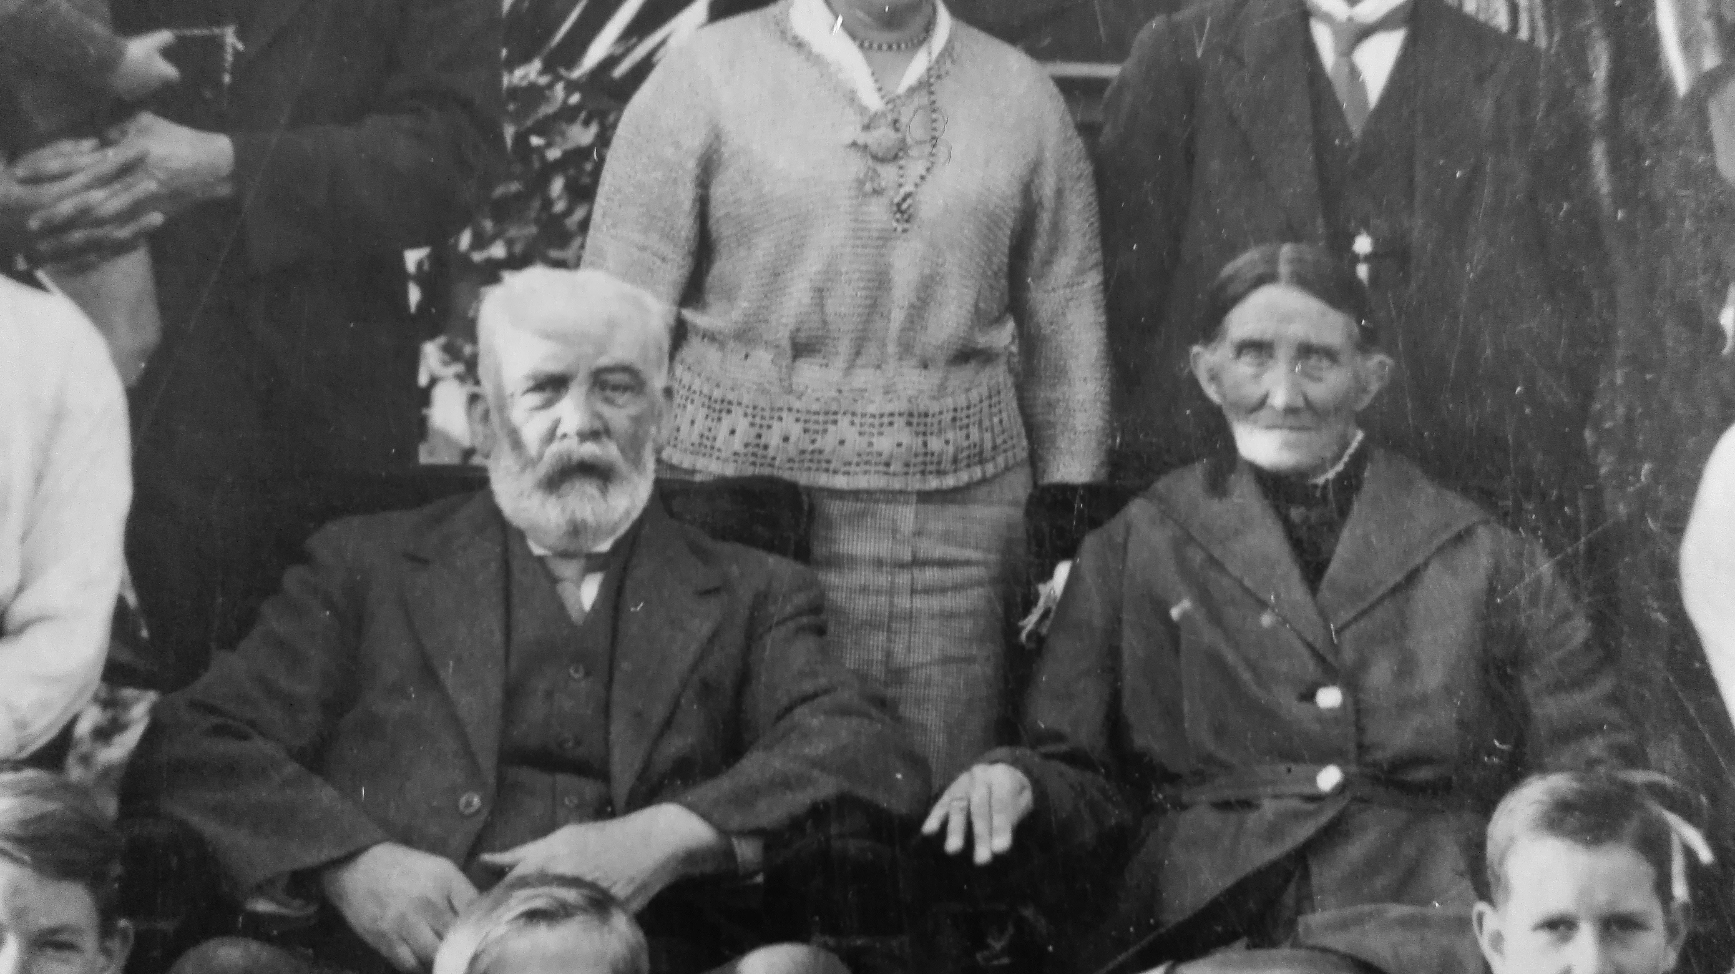

Stephen and Frances with family at their Diamond wedding, June 1922.
Stephen died 4 days later.

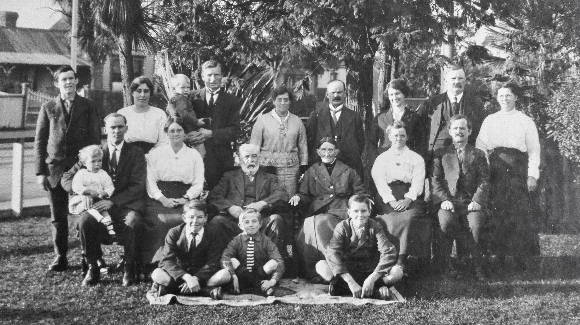
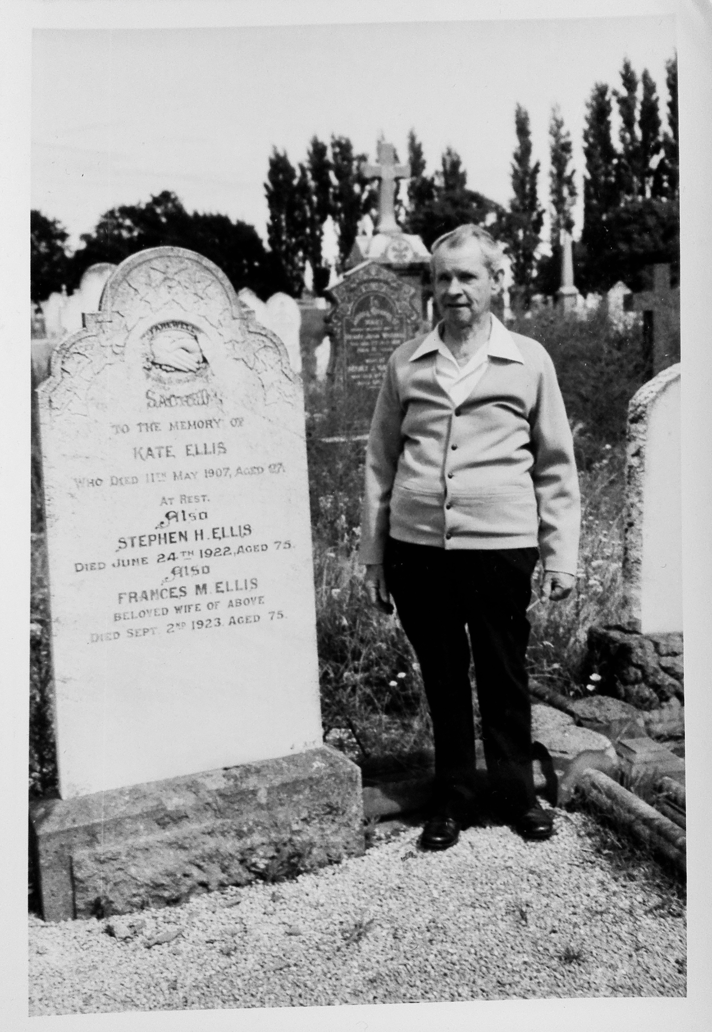

Bert (Albert) Ellis at the grave of
Stephen and Frances Ellis
(Parents of Henry Ellis)
Linwood Cemetary, Christchurch,
Block 35, Plot 143

Stephen H. Ellis, Died June 24th 1922, aged 75

Frances M. Ellis, Beloved wife of above
Died Sept 2nd 1923, aged 75

Also Kate Ellis, Henry’s sister
who died 11th May 1907, aged 27

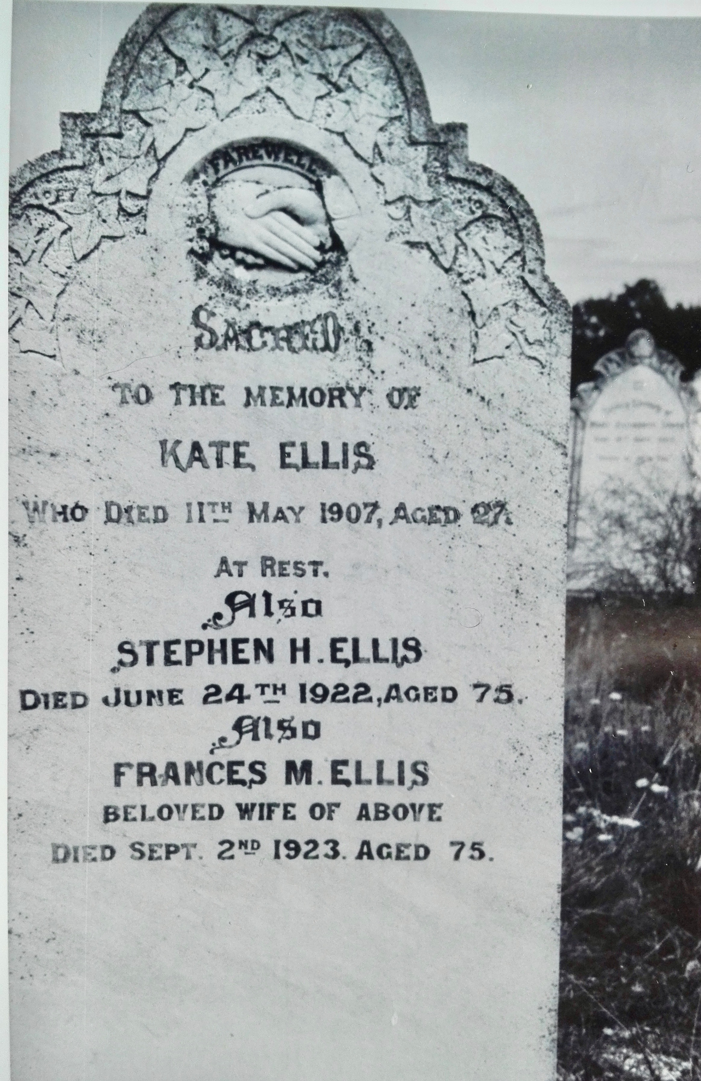

Robert’s Mother’s Family

Robert’s mother, Edith Culter Butterfield (before she married Mr Ellis), was given her mother’s maiden name as one of her middle names.
Her parents were Robert Butterfied = Sarah Ann Cutler

Cutler family

Sarah Ann Cutler’s parents were John and Mary Ann Cutler. They were married in 1845, and lived in Kennington, Surrey then Brighton, Sussex.
John Cutler was a shoemaker and lay preacher. (Born 9/7/1821, Died 20/5/1889)
They journeyed to NZ on the ‘Huntress’, arriving in Lyttleton 27 April 1863.

This photo was taken before they left England. The children eldest to youngest: Susannah (16), Sarah Ann (13), Rechab John (9), Sophia (far right, 7), Eliza Ann Judkins (5), Mary Lees (2)
John is 41 and Mary Ann is 40.

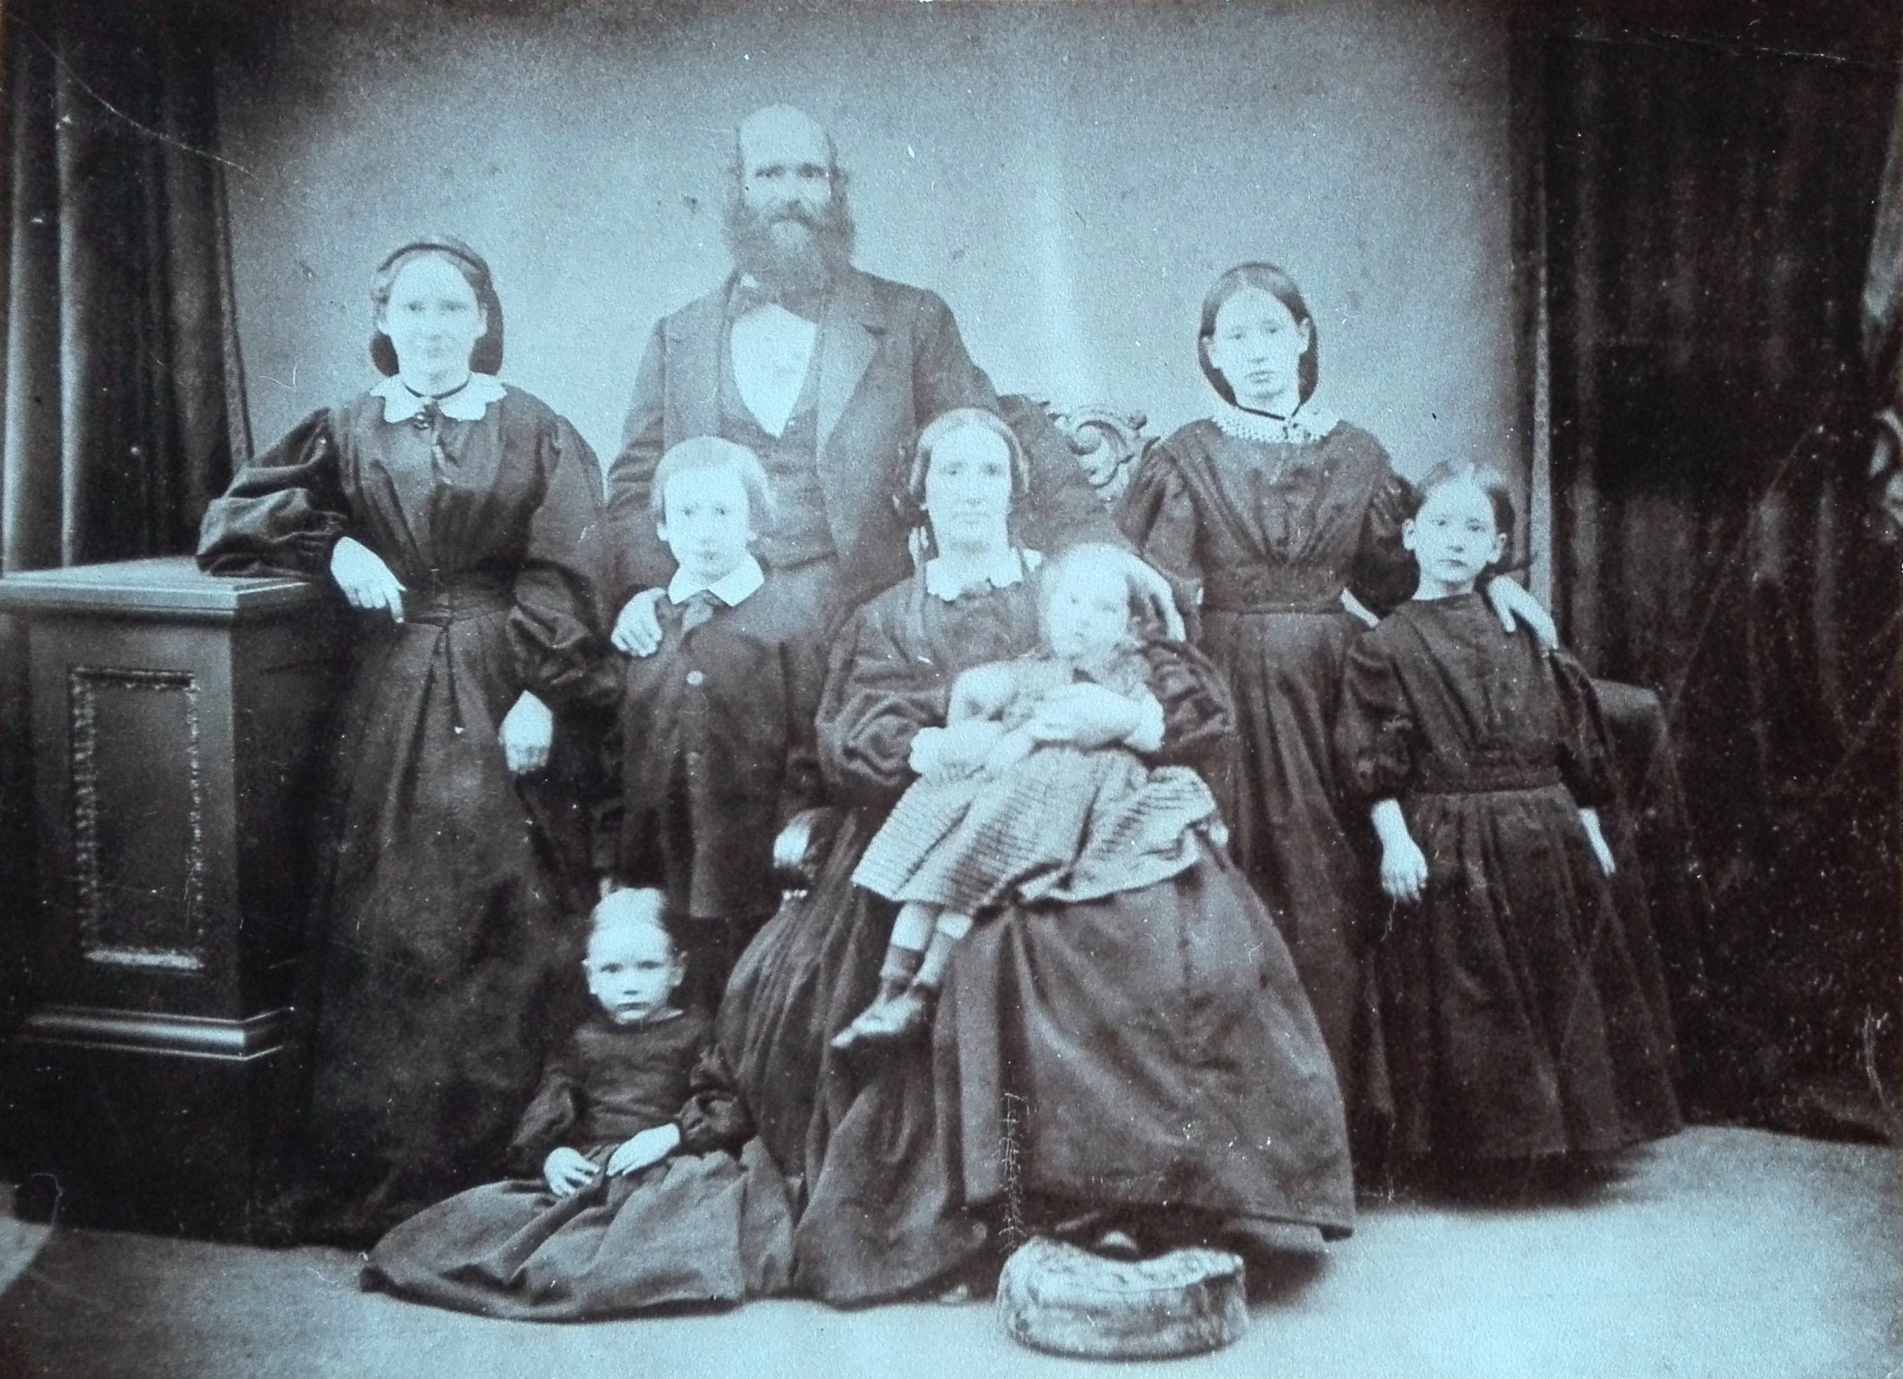

John Cutler’s father was George William Cutler, a Cordwainer (one who works with goatskins), from Fordingbridge, Hampshire. (Born 1792)
His mother was Susannah Cann.

George William’s parents were William Cutler (born 1758) and Ann.
William’s parents were Giles Cutler and Elizabeth Read (married 27/11/1757), Fordingbridge, Hampshire.

Sarah Anne Cutler (age 13 in the family photo) married Robert Butterfield
Sarah Anne Cutler, born 1849 in Brixton, died 1929

Robert Butterfied, born 1833, died 1904
They had 11 children, one of whom died as a baby.

Our ancestor is Edith Cutler Butterfield, born 8th in line in 1881, died 1959

These documents are records of the leadership of John Cutler in the NZ church and community:
A public notice advertising John speaking on Temperance in Christchurch in which he is described as “one of the ablest Temperance advocates in Canterbury”
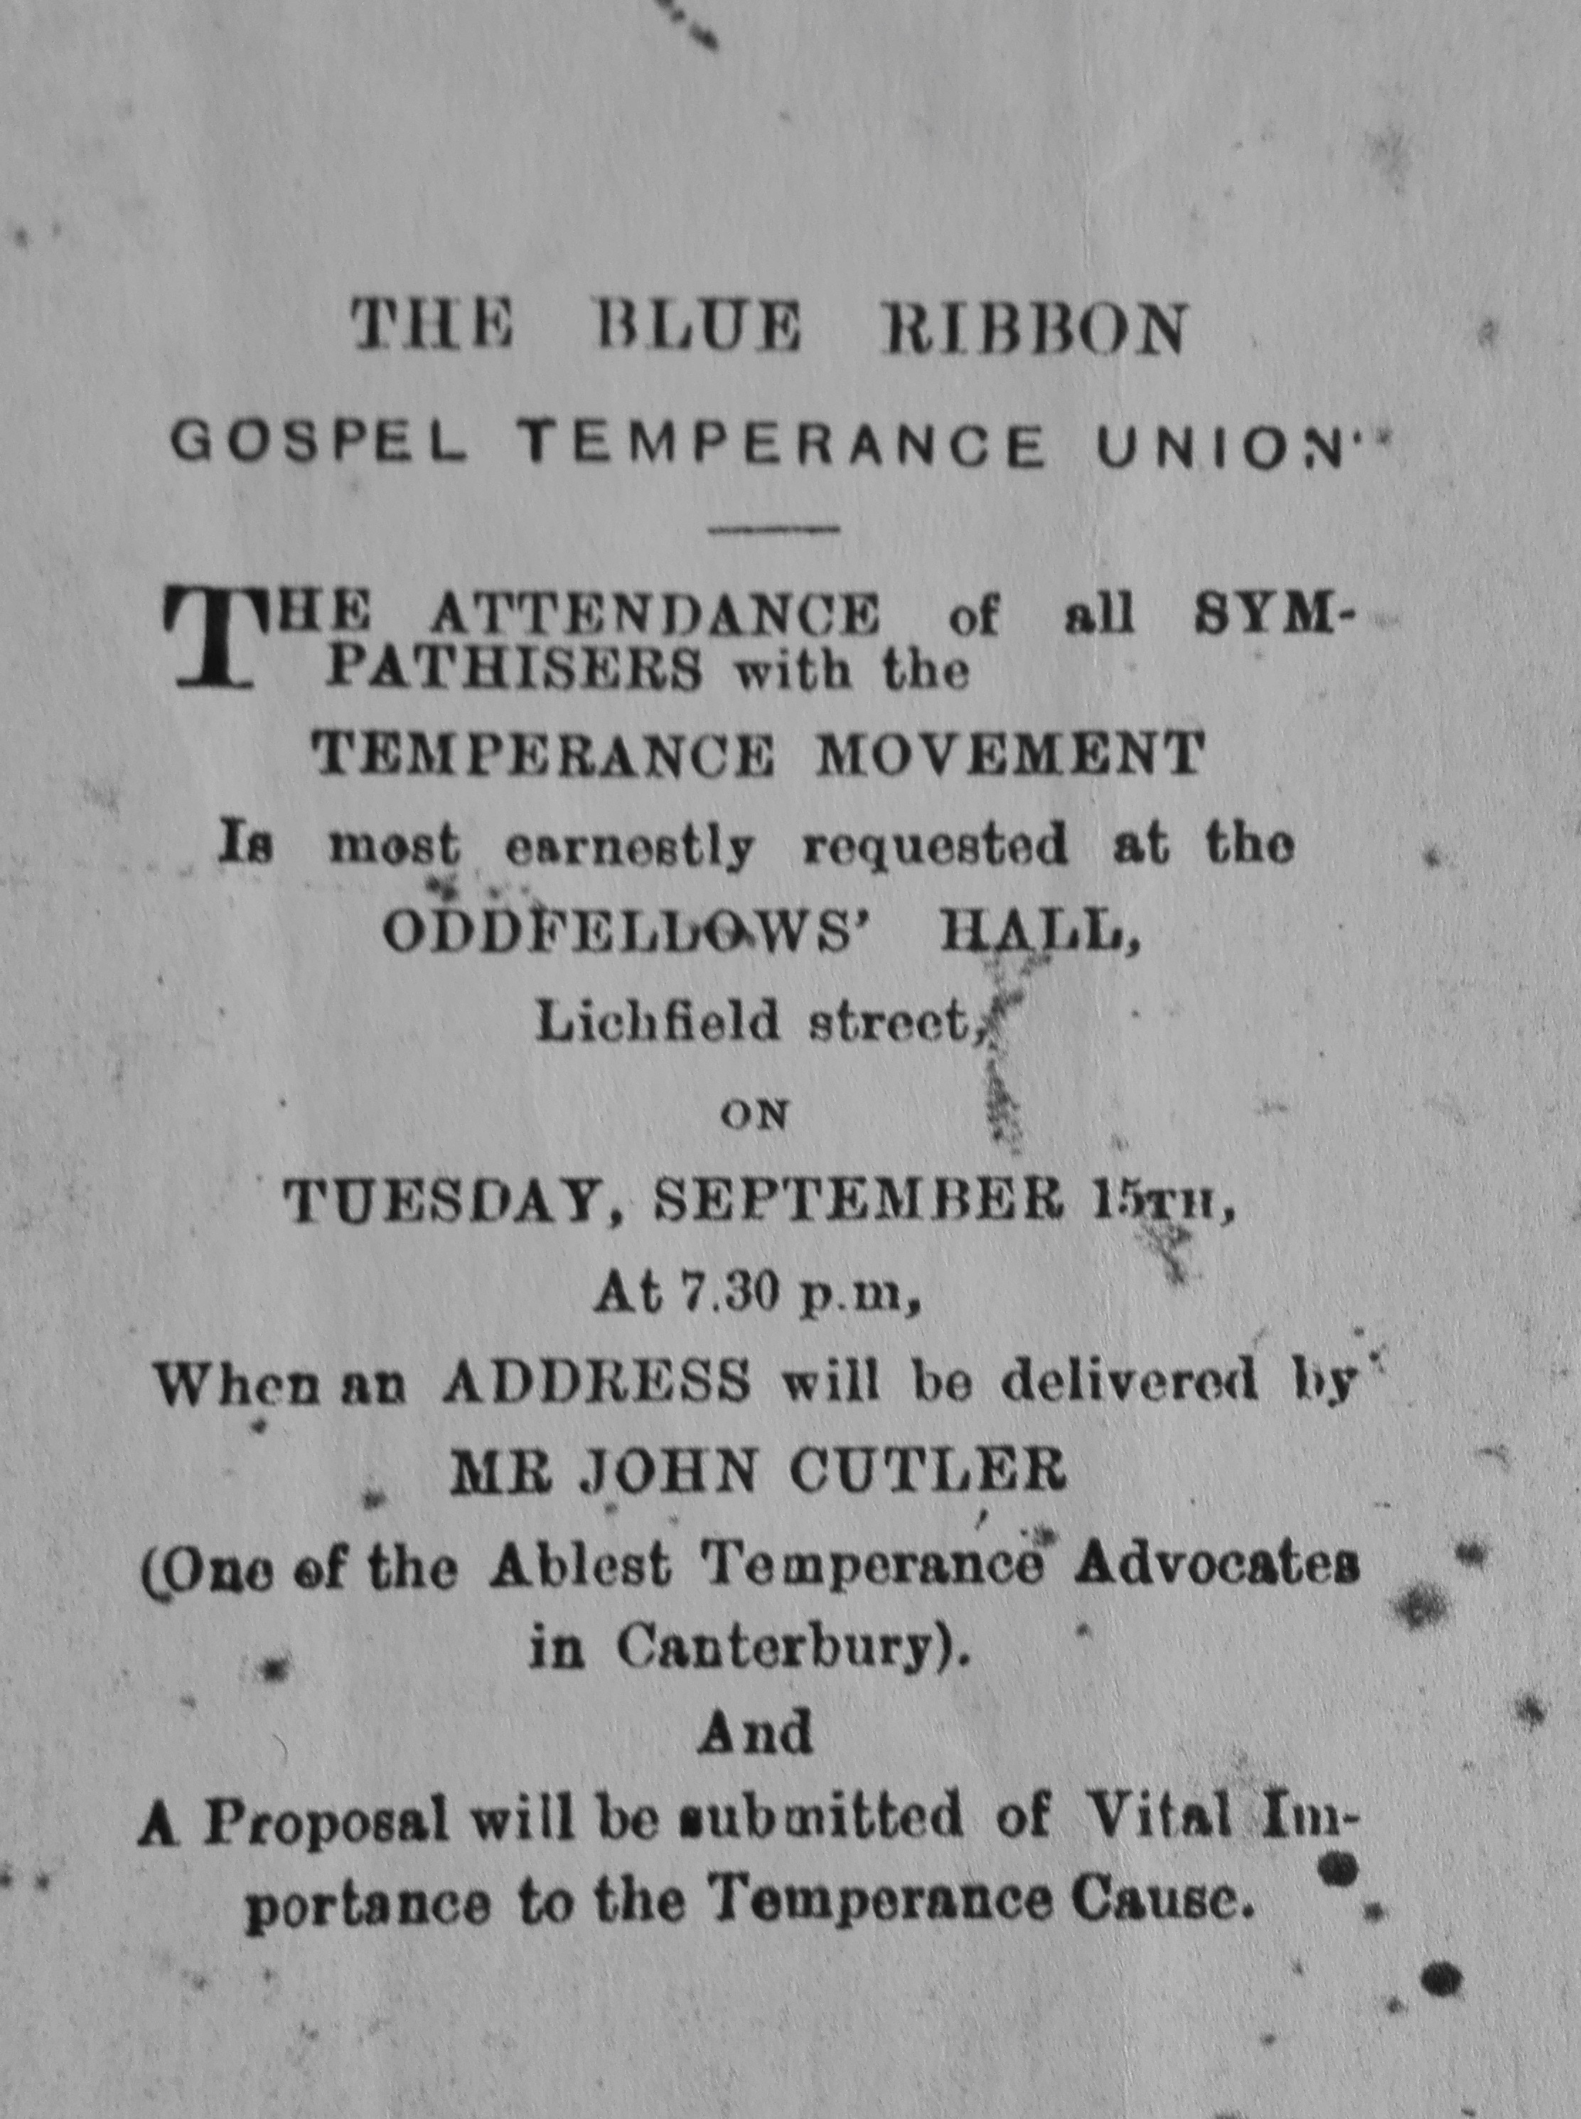

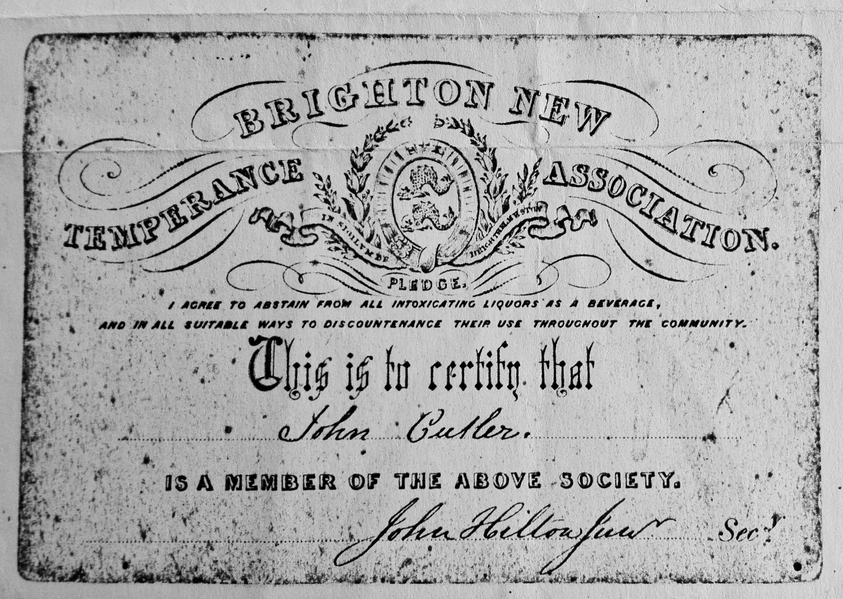
And his membership certificate for the New Brighton branch of the Temperance Society.
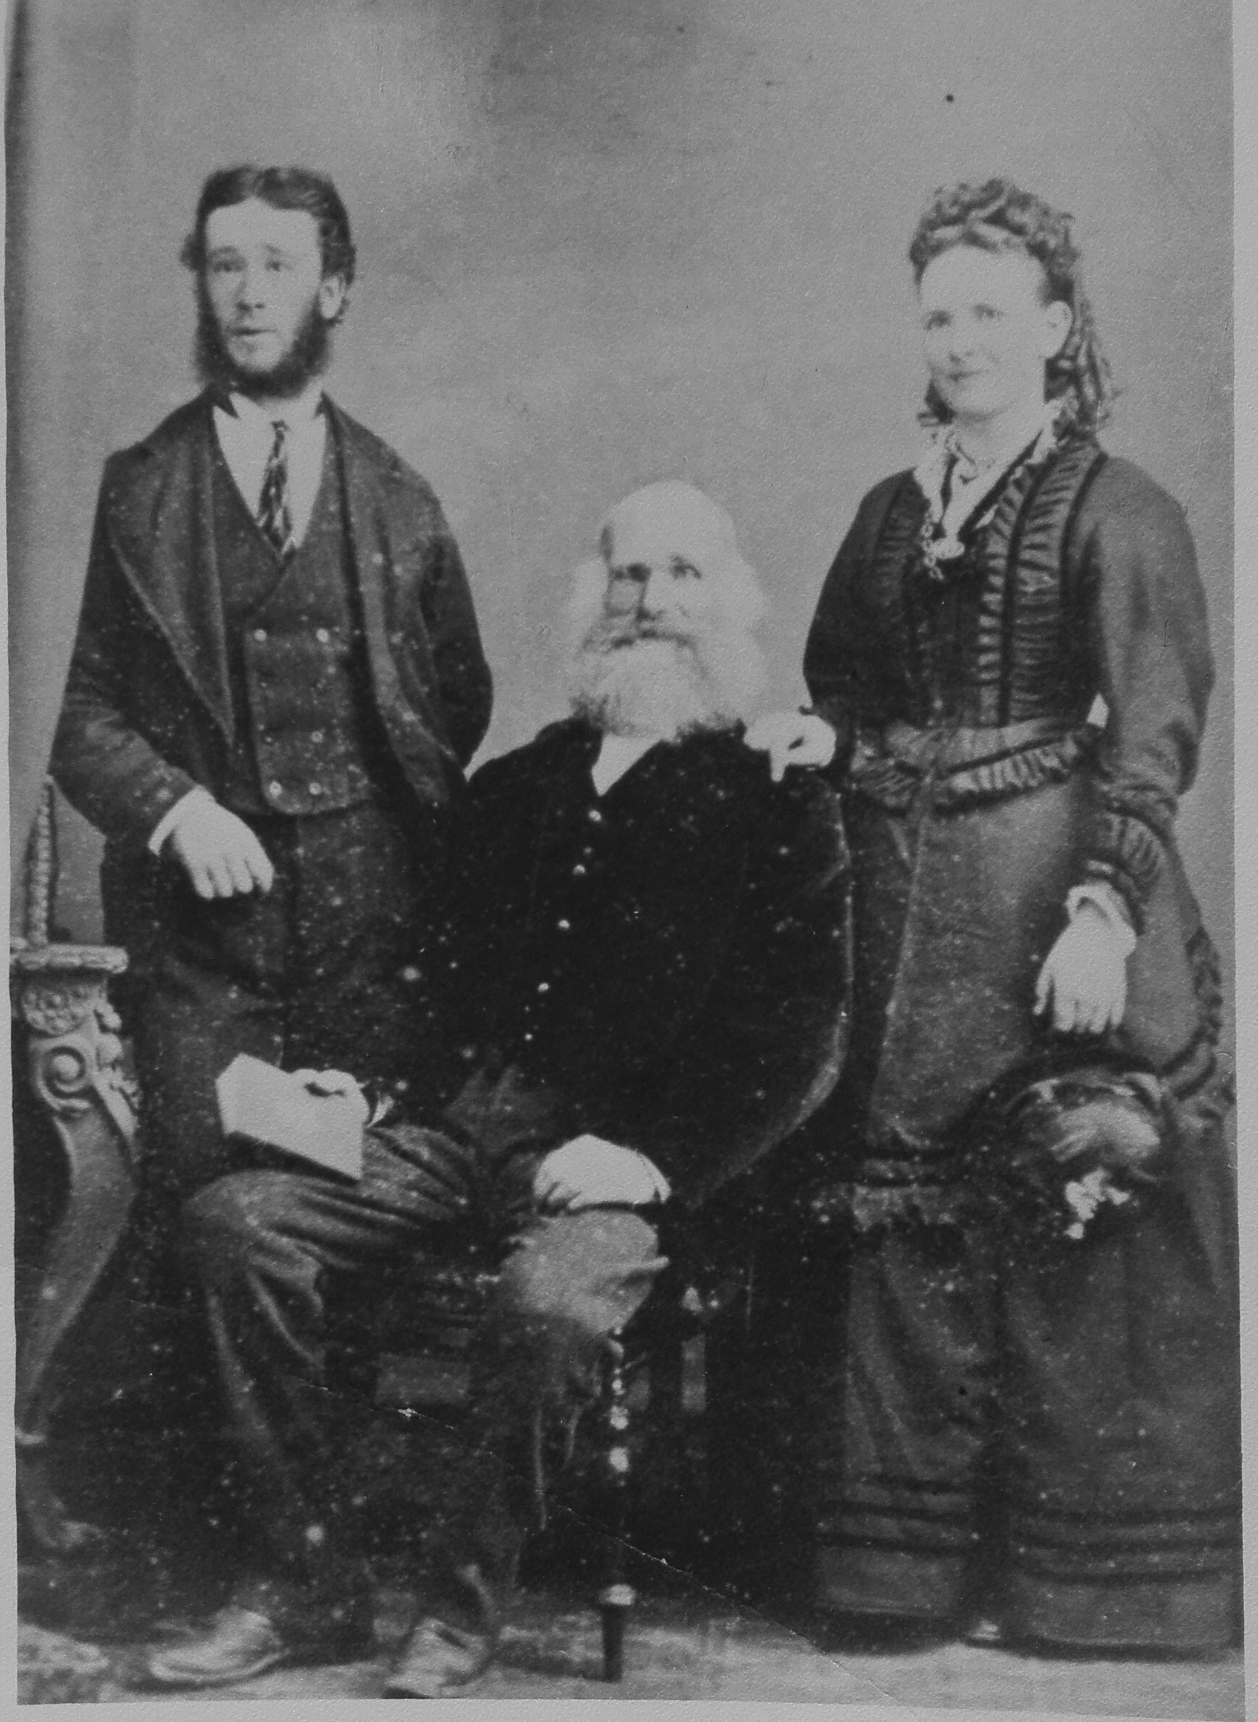

Rechab John and Eliza Ann with their father John Cutler

This house was the home and shop of George William Cutler, in Fordingbridge
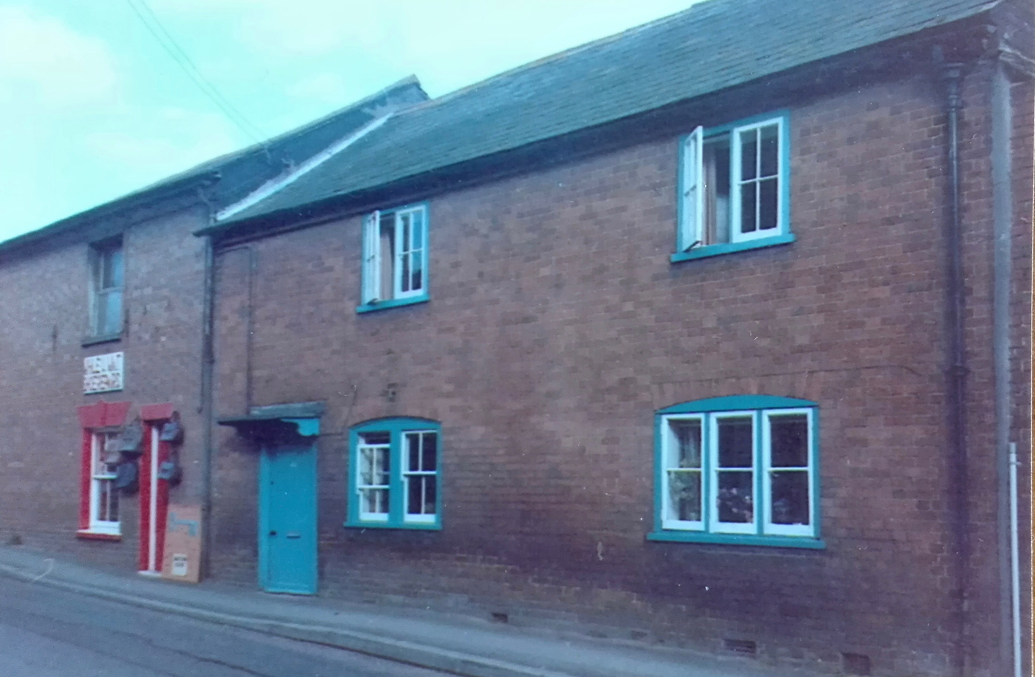
Mary Ann Buckland (became Cutler), born 13/10/1822, died 9/2/1889
daughter of William (or Robert) Buckland, stonemason, and Charlotte
of Andover
Mary Ann was baptized 19/5/1823 in the Parish of Andover, County of Southampton

Married John Cutler in 1845 at the Parish of St Mary, Whitechapel, Middlesex.
They traveled to Christchurch in 1863 with their 6 children.

This gorgeous portrait of her is one of our oldest photographs.

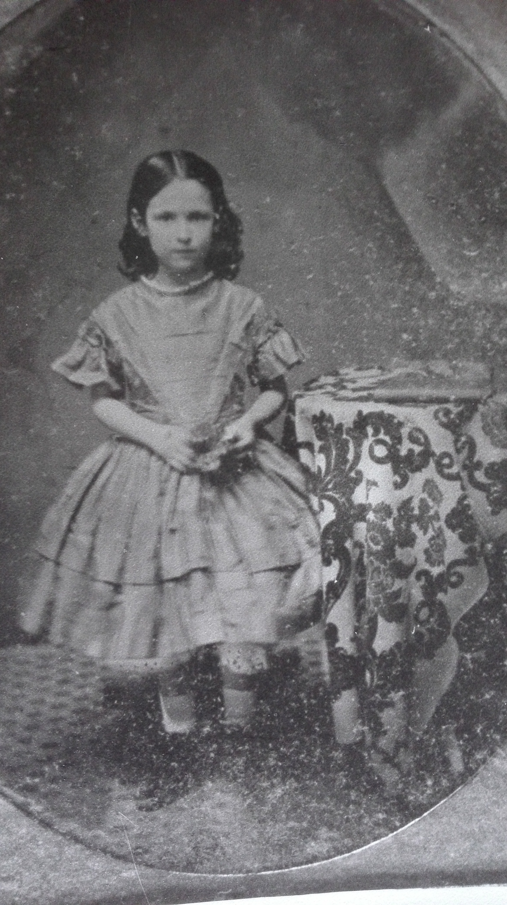

Butterfield Family

Matthew Butterfield of Keightly, Yorkshire was born in 1774 and died in 1843
He married Mary Whittaker, the daughter of Timothy Whittaker and Mary Blough

One of their 9 children was Robert Butterfield. Born 1833, died 1904.
When he was 28, in 1861, he emigrated to NZ. He was a carpenter.
He married Sarah Anne Cutler in 1869.
He was a conscientious objector to fighting Maori in the Land Wars. He lived in hiding for a while and so did not claim his property.

Their 8th child was Edith Cutler Butterfield, who married Henry Ellis.

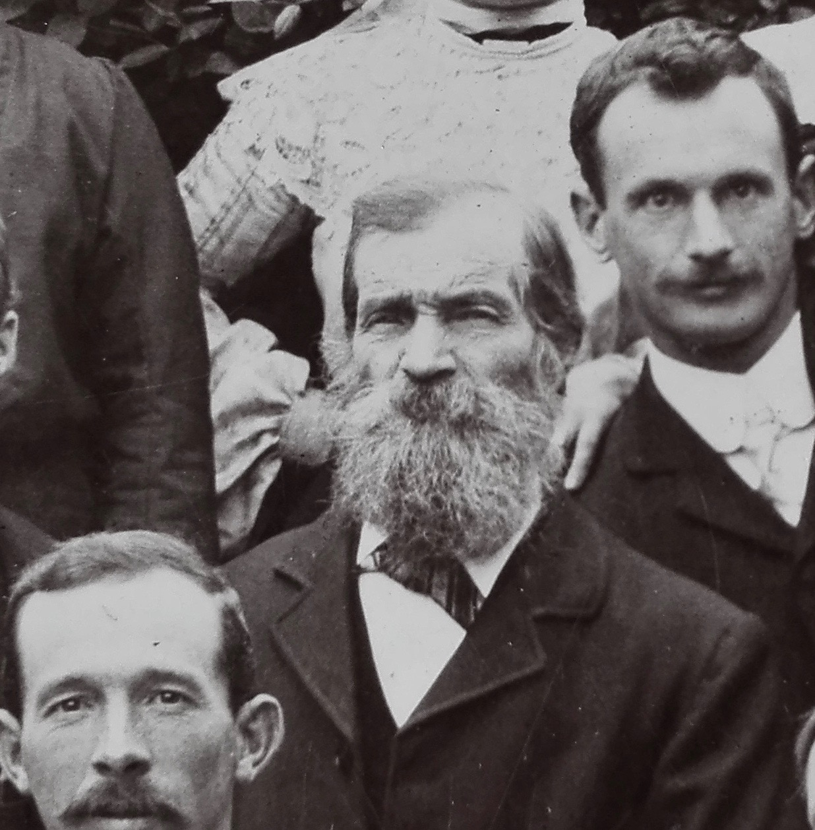

Robert Butterfield, at his daughter Edith’s wedding in March 1904.

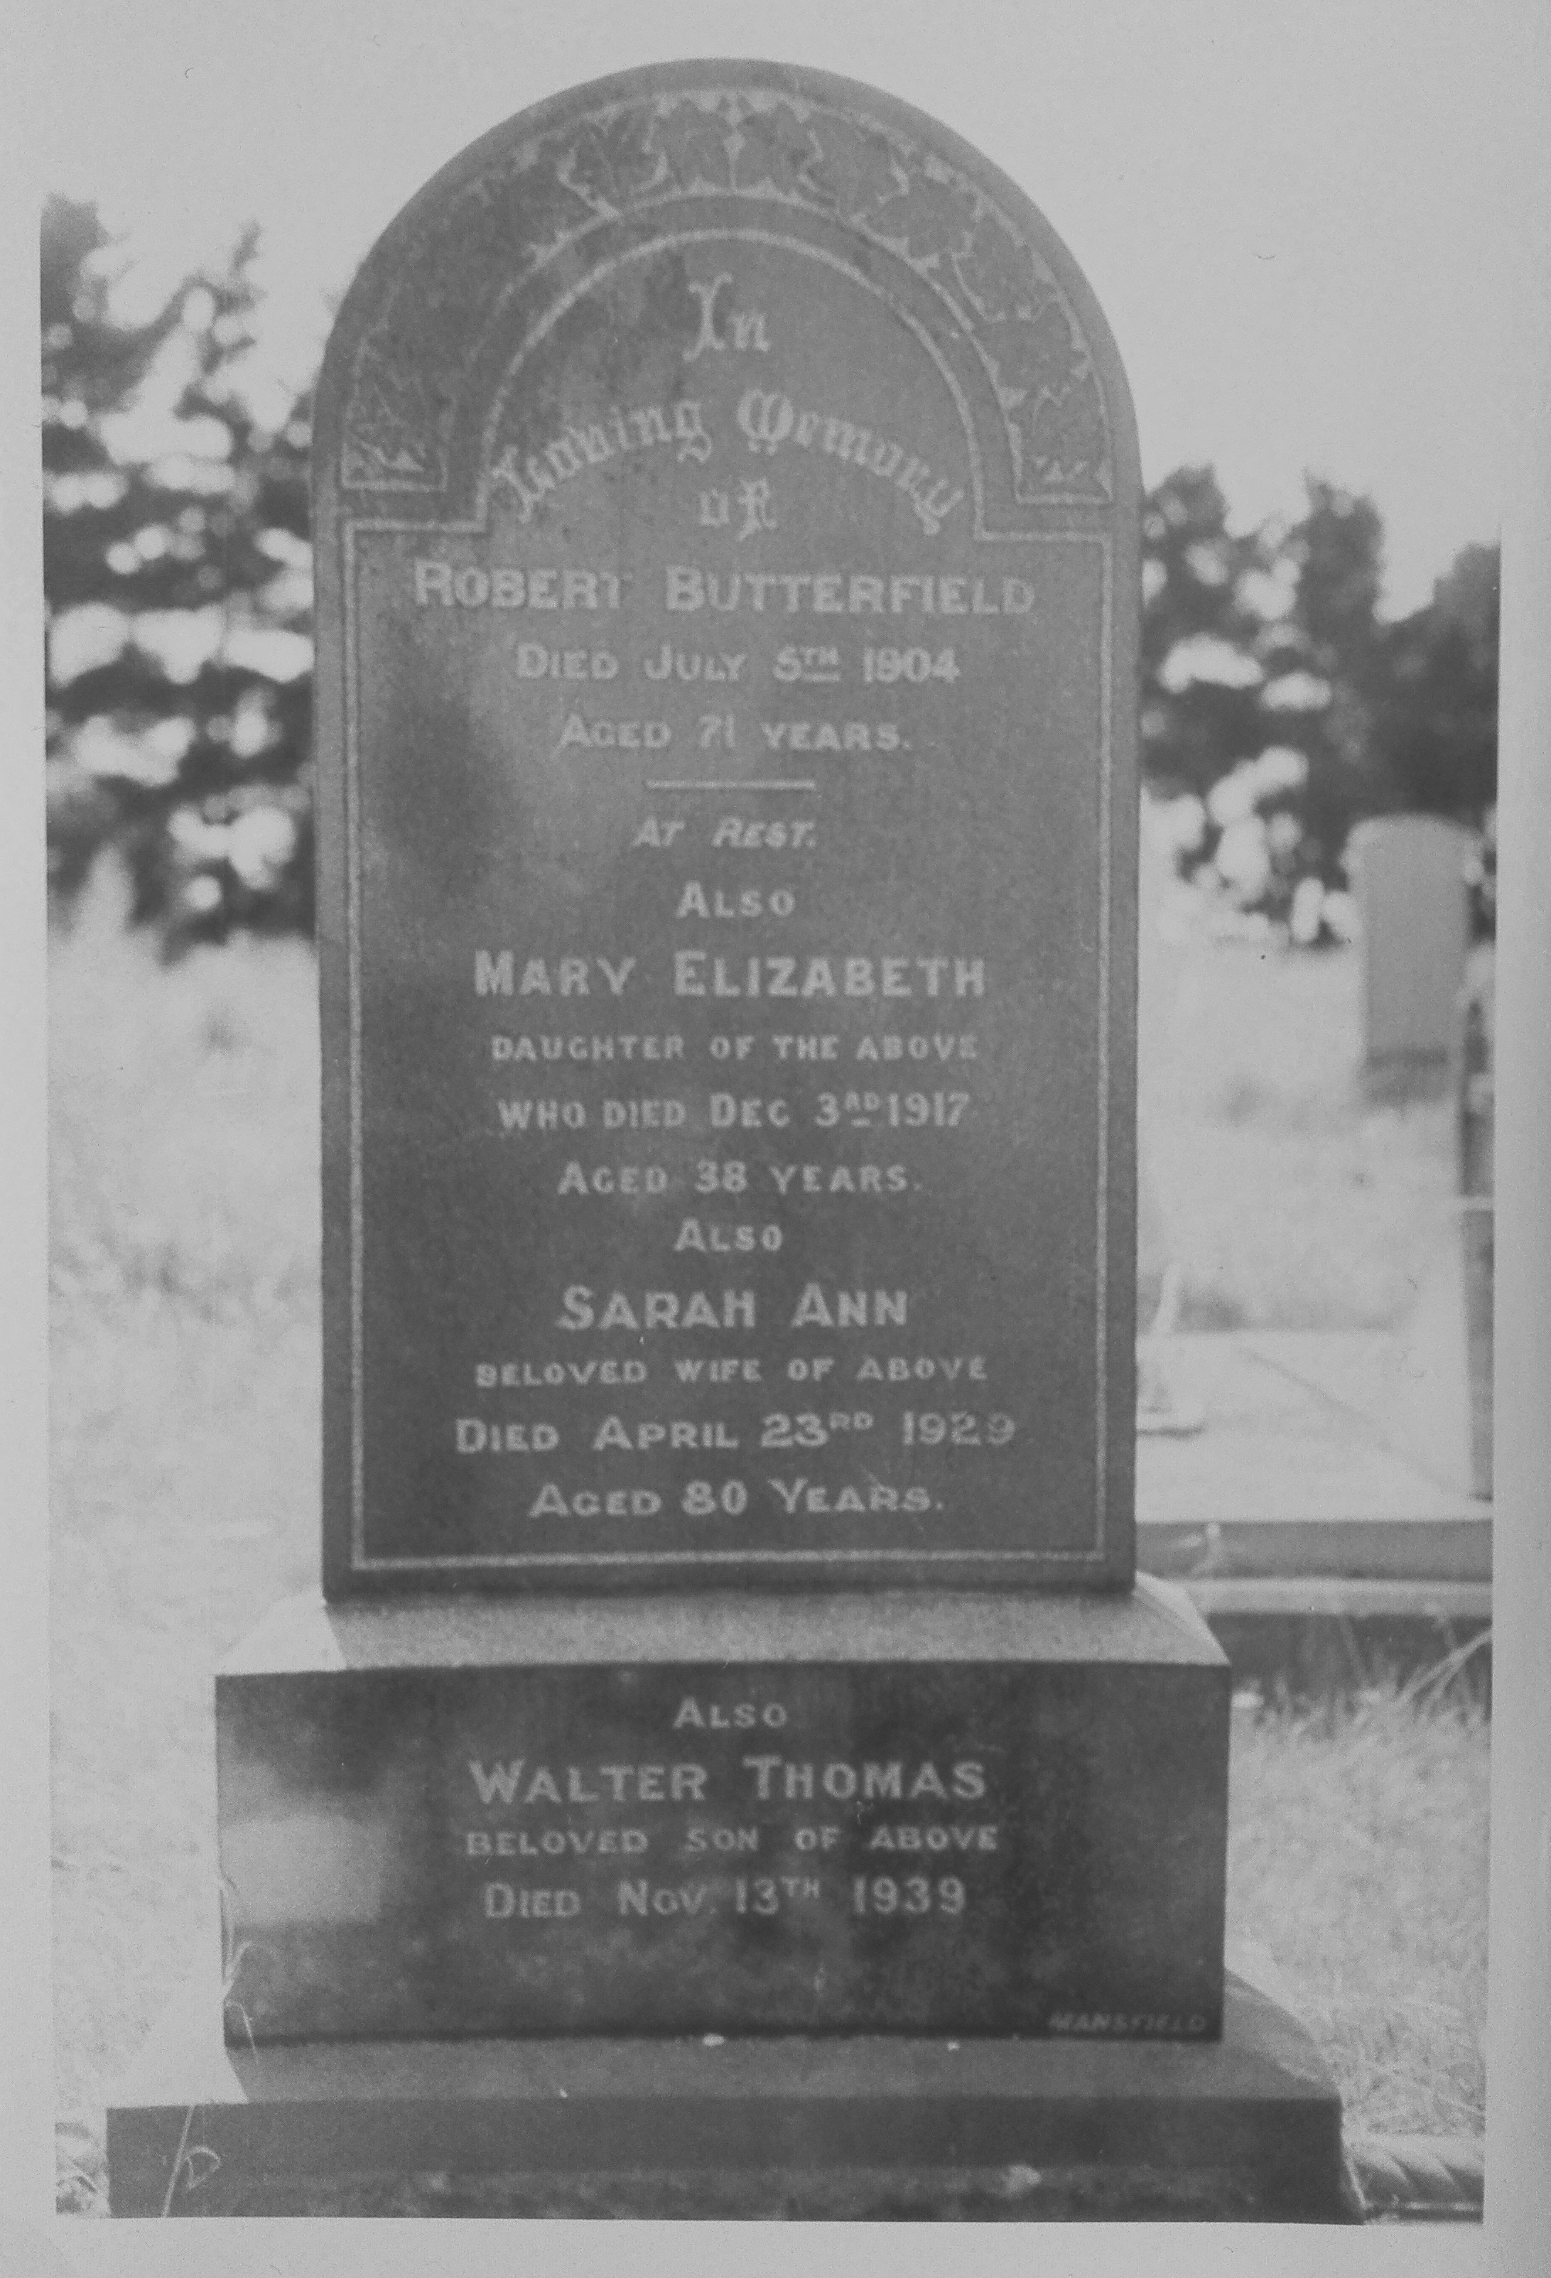

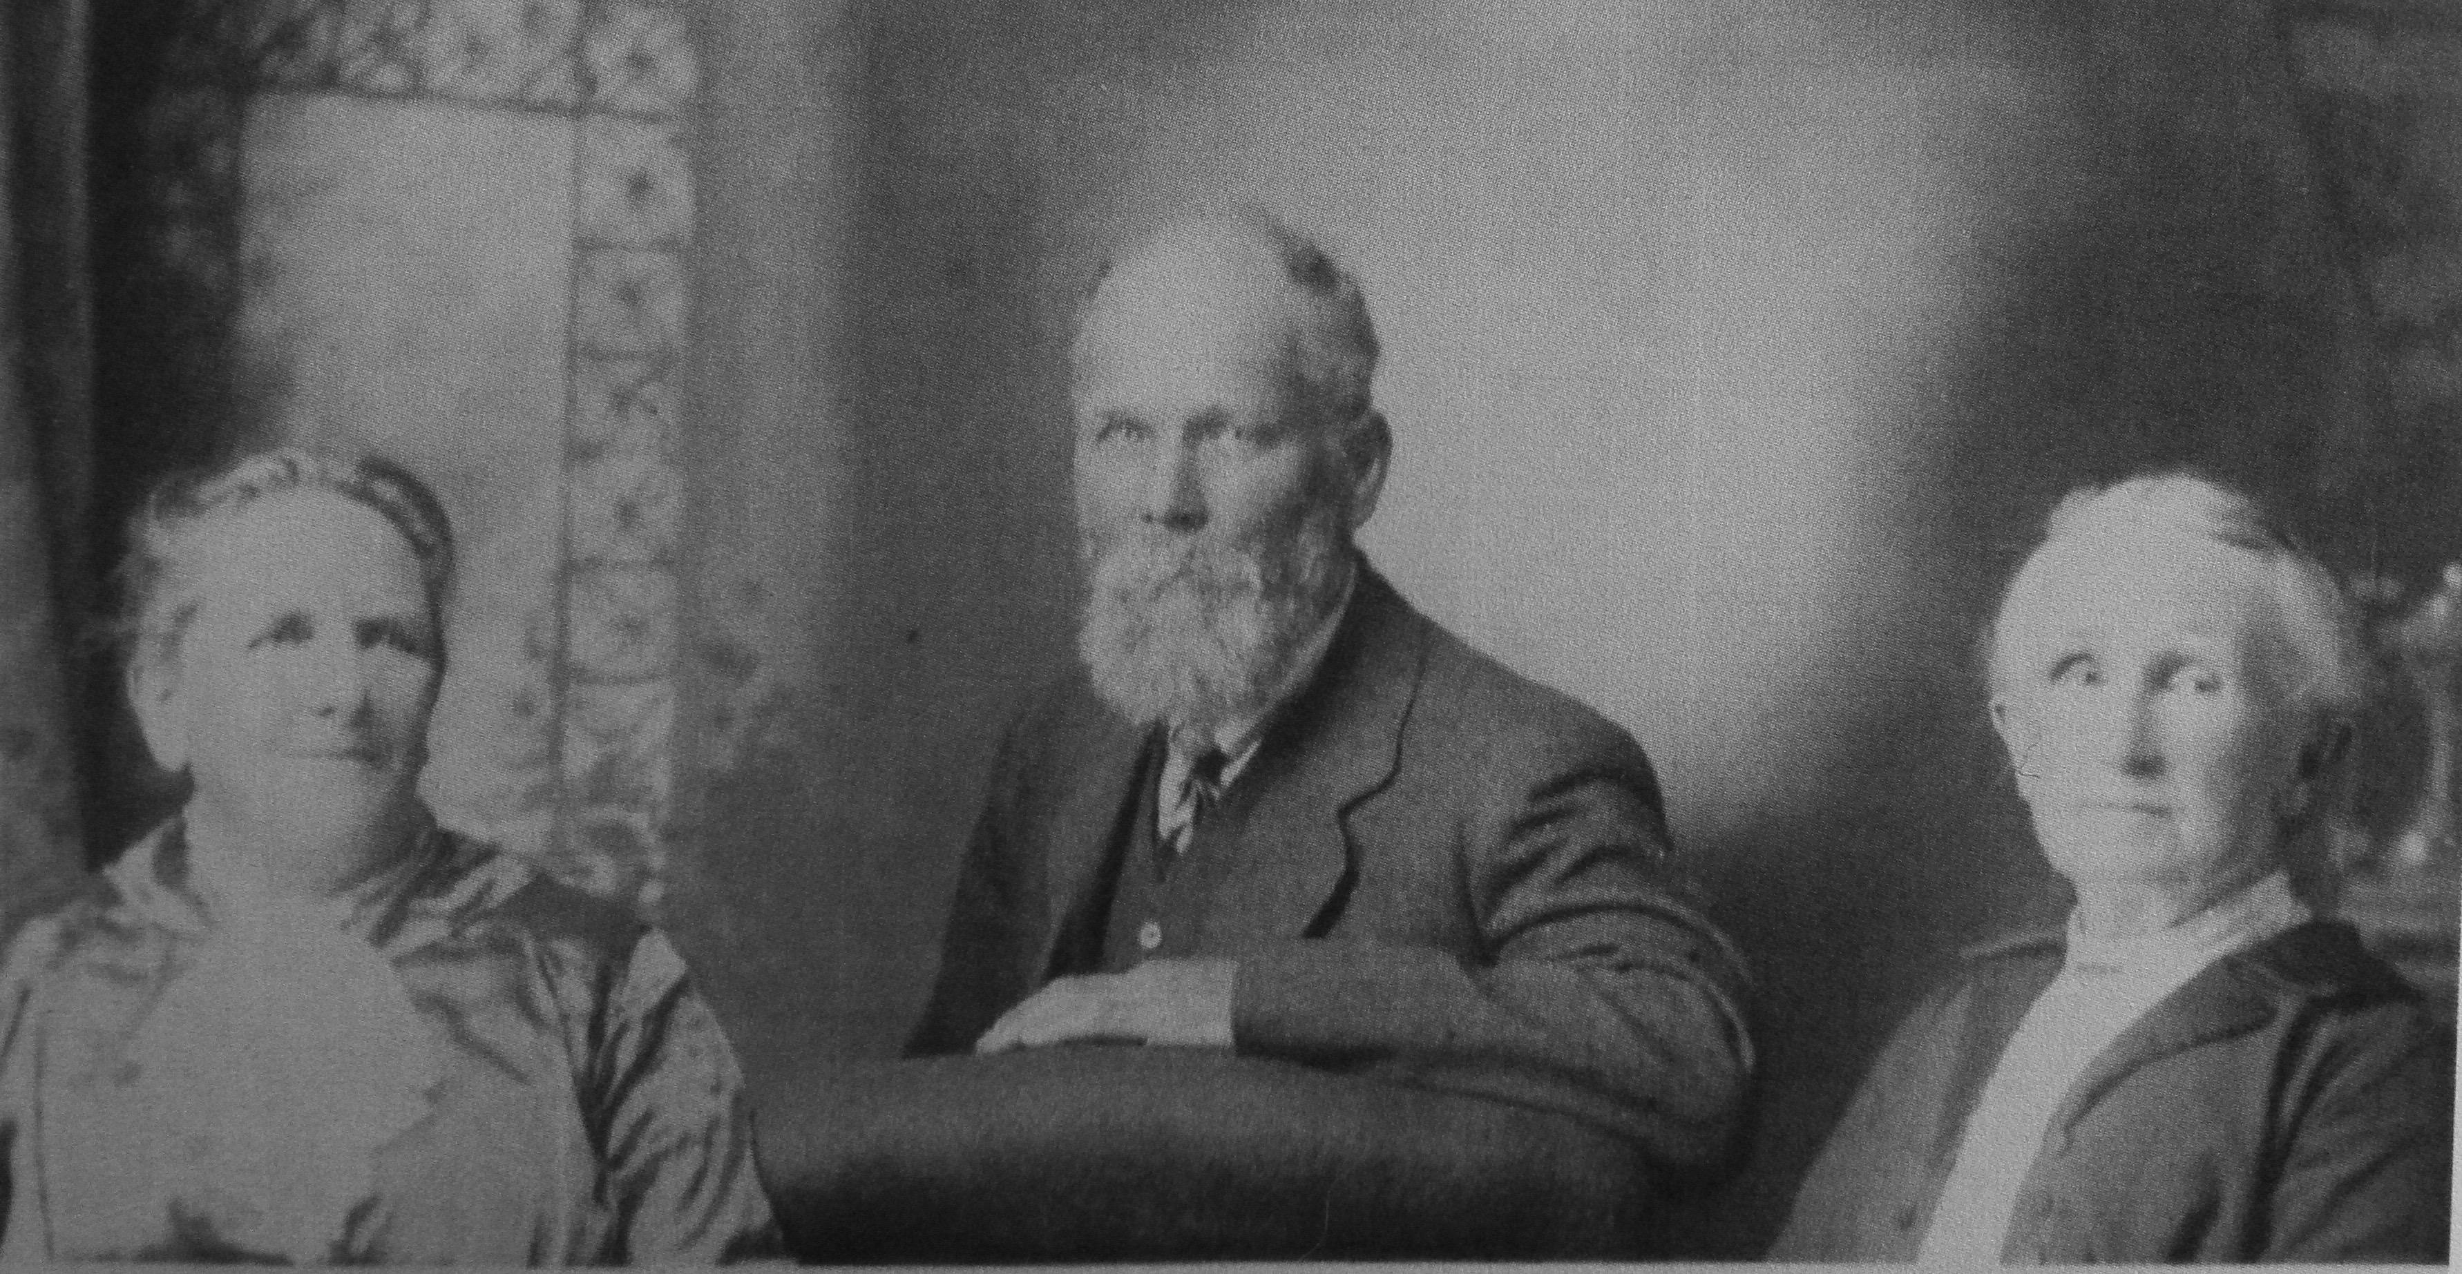
This photo is of Eliza Ann & her husband Joseph Moore, with her sister Sarah Ann Butterfield (died in Christchurch 1929, aged 80)

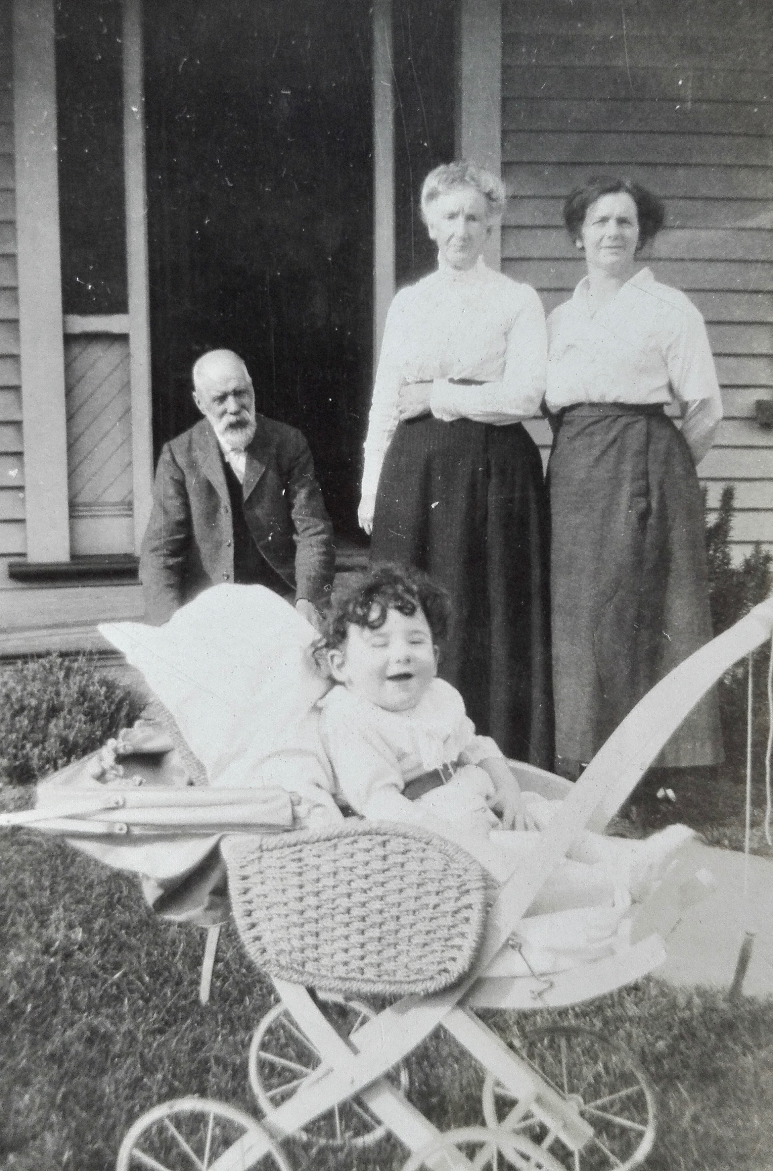

A gorgeous family photo but we’re not sure who the people are

